**JNCIA**

1. **Course Introduction**

The Introduction to Junos Platform Automation and DevOps (IJAUT) course demonstrates how to automate the Junos OS using DevOps automation tools, protocols, and technologies. This course provides an introduction to basic DevOps principles, Junos APIs, and the Network Configuration Protocol (NETCONF). It focuses on using Python, Junos PyEZ, Ansible, and the Junos Representational State Transfer (REST) API to automate Junos platforms. Extensible Markup Language (XML), JavaScript Object Notation (JSON), and YAML Ain't Markup Language (YAML) are introduced as data formats that facilitate Junos automation.

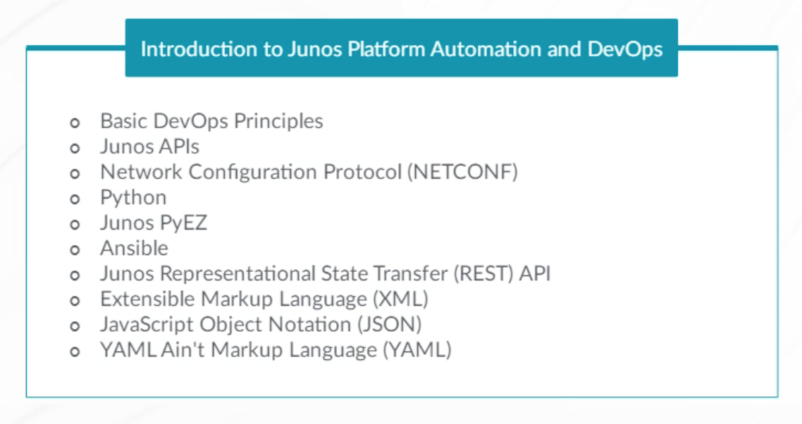

This course benefits individuals responsible for configuring and monitoring devices running the Junos OS.

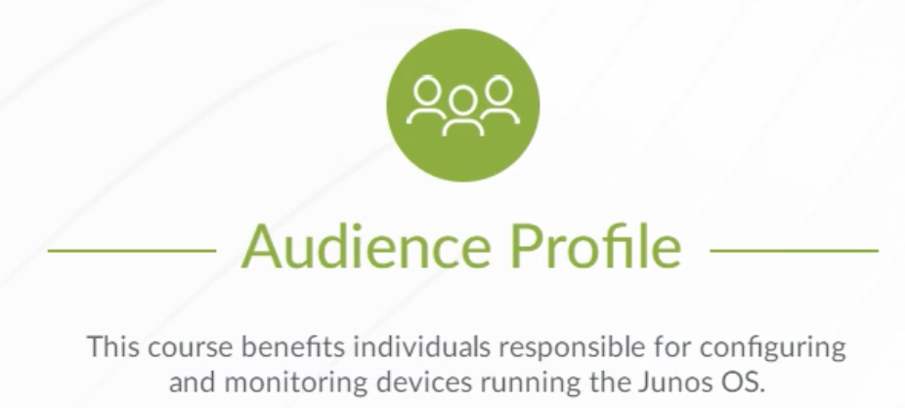

IJAUT is an introductory-level course.



You should have a basic understanding of the OSI model, the TCP/IP protocol suite, and computer networking concepts.

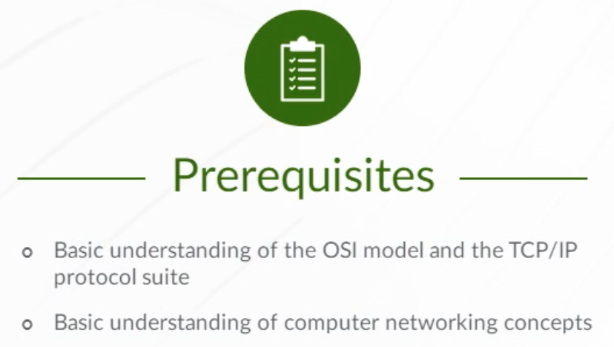

1. **Introduction to DevOps**

**Network Operations**

Traditional computer networks were designed and operated as a set of individual components and services. This traditional structure was used, regardless of whether the networking domain was a service provider WAN or an enterprise data center.

Using a traditional approach to network operations, new customer services are implemented using manual processes, often using a device-level CLI. Implementing new types of network services requires installation of new equipment and connections.

Many of today’s networks lack the flexibility and scalability required to run modern applications. This means network operations becomes a bottleneck as new applications and services are brought online, and the network grows larger and more complex. Traditional network operations also rely on manual failure remediation processes that increase service downtime and negatively impact the customer experience.

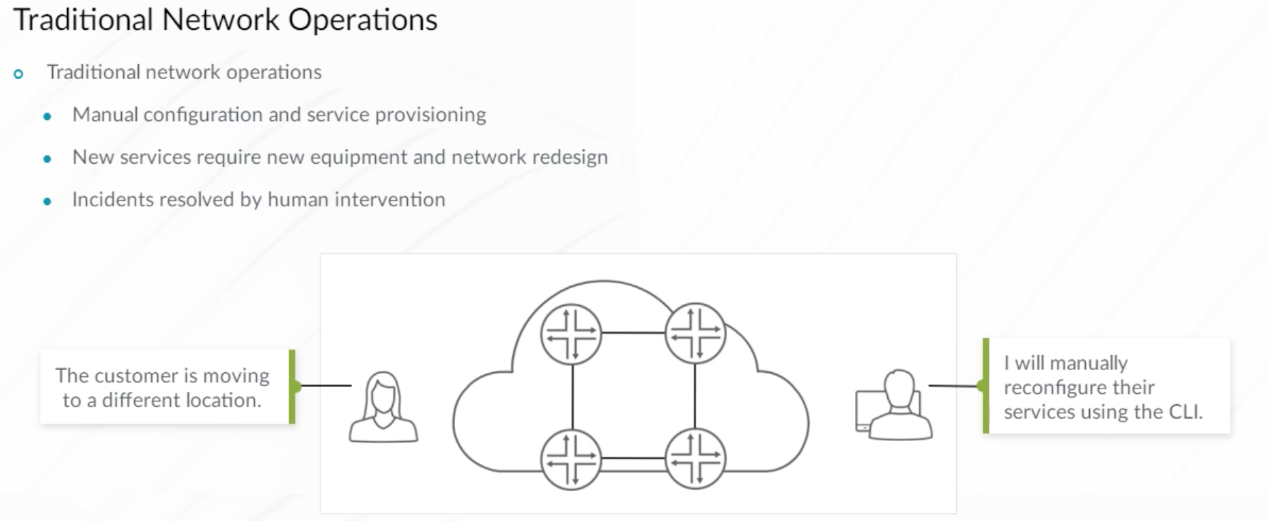

Changes to the way modern applications run, require the network to keep pace. To deploy applications at scale, network and service configuration must be automated. Applications running in virtualized environments, such as private, public, and hybrid clouds, require networking to be virtualized as well. Instead of deploying and managing physical hardware devices, software-based virtual switches, routers, and firewalls are used. Modern networks are also able to dynamically adjust and optimize traffic flow based on the analysis of network telemetry data.

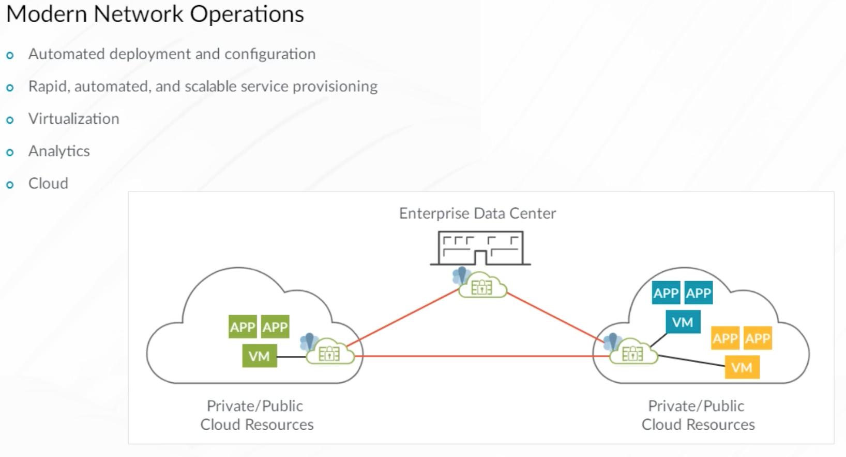

The primary reason for changing the traditional approach to networking comes from the fact that computer networks often exist as parts of larger projects, and must evolve in unison. Consider these examples:

* An application running in a public cloud, where large pools of compute, storage, and networking resources are being shared by many customers (or tenants).
* Scaled Web services accessed by millions of users requiring multiple tiers of a Web application to be dynamically connected.
* A traditional telecom operator choosing to evolve their business model and become a content delivery operator. The network must be adapted to deliver different, ever-changing content (for example, video, data, gaming, and so on) to millions of subscribers.
* In environments like public clouds, networking may be completely virtualized and run in software.

Because of these trends, networking is now being treated more like a software project, with corresponding characteristics like version control, code reviews, test before deploy, and so on.

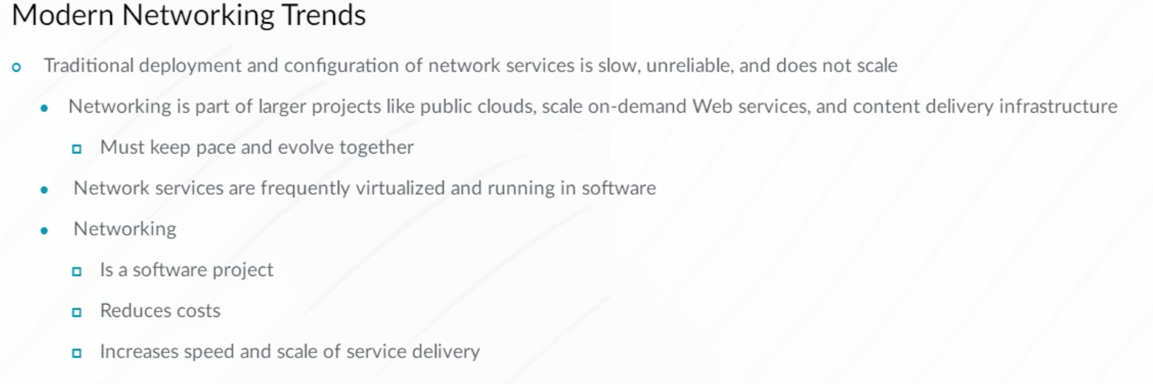

Because networks are now being treated like software, you will learn about some software development methodologies. The classical approach to software development is summarized by what is called the waterfall model. Its formal description was first given by W. Royce in 1970, while the actual term ‘waterfall’ was introduced by T.E. Bell and T.A. Thayer in 1976.

Based on this software development model, you first collect requirements for the new software before the software design process begins. After the design process is complete, then the design is implemented in code. Finally, you can test and deploy the new software. Each phase of the development process begins only after finishing the previous one.

The waterfall model works if you know your requirements very well in the beginning of the development process. When requirements change during the development process, and a need to develop new functionality arises, the waterfall model shows some weakness. It is not the most flexible development model, and requires more time before new application functionality can be deployed to production.

Additionally, the waterfall model takes into account there is a significant interval of time between releases of software. Each new release contains a large volume of code changes because multiple features are typically released at the same time. This increases the probability of issues at the deployment time.

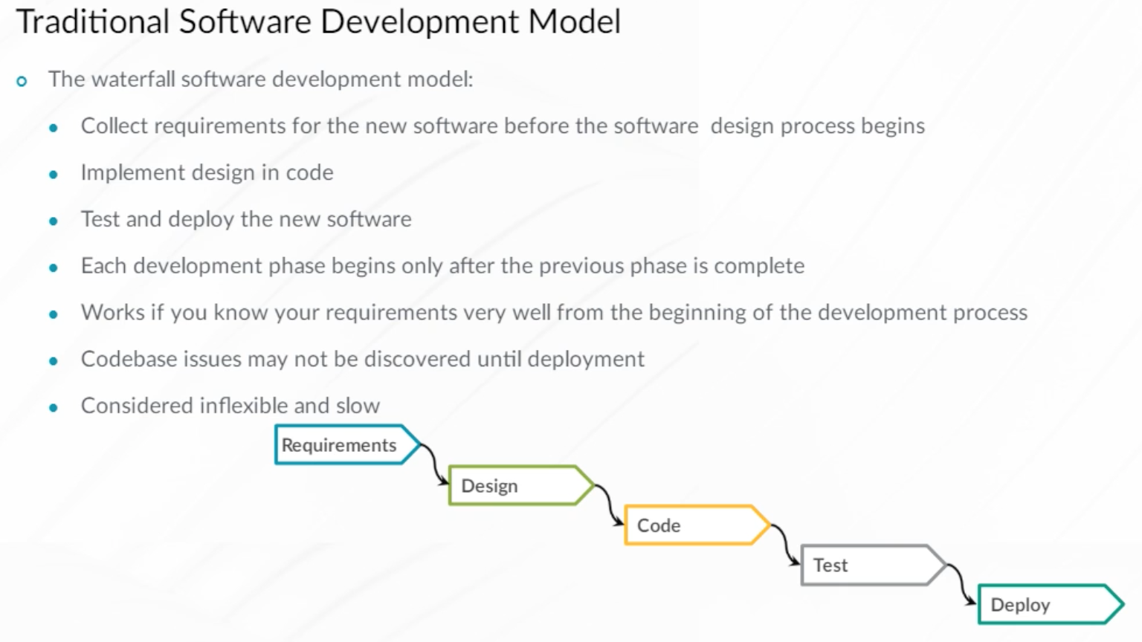

Agile is an umbrella term for multiple software development practices that began appearing in the past few decades. These practices permit a much more iterative and incremental development process compared to the classical waterfall model and its variants.

In 2001, leading software developers came together to create the ‘Manifesto for Agile Software Development’, stating these 12 main principles:

* The highest priority is customer satisfaction through early and continuous delivery of software.
* Welcome changing requirements, even late in development. Agile processes harness change for the customer’s competitive advantage.
* Frequently deliver working software in time frames ranging from a couple of weeks to a couple of months, with a preference to the shorter timescale.
* Business people and developers work together daily throughout the project.
* Build projects around motivated individuals. Give them the environment and support that they need, and trust them to get the job done.
* The most efficient and effective method of conveying information to and within a development team is face-to- face conversation.
* Working software is the primary measure of progress.
* Agile processes promote sustainable development. Sponsors, developers, and users should be able to maintain a constant pace indefinitely.
* Continuous attention to technical excellence and good design enhances agility.
* Simplicity by maximizing the amount of work not done is essential.
* The best architectures, requirements, and designs emerge from self-organizing teams.
* At regular intervals, the team reflects on how to become more effective, then adjusts its behavior accordingly.

The Manifesto for Agile software development is available at the **Agile Manifesto**website. You can access the website from the Reference Links document.

The Agile Software Manifesto formulated the main values of Agile such as:

* Individuals and interactions over processes and tools,
* Working software over comprehensive documentation,
* Customer collaboration over contract negotiation, and
* Responding to change over following a plan.

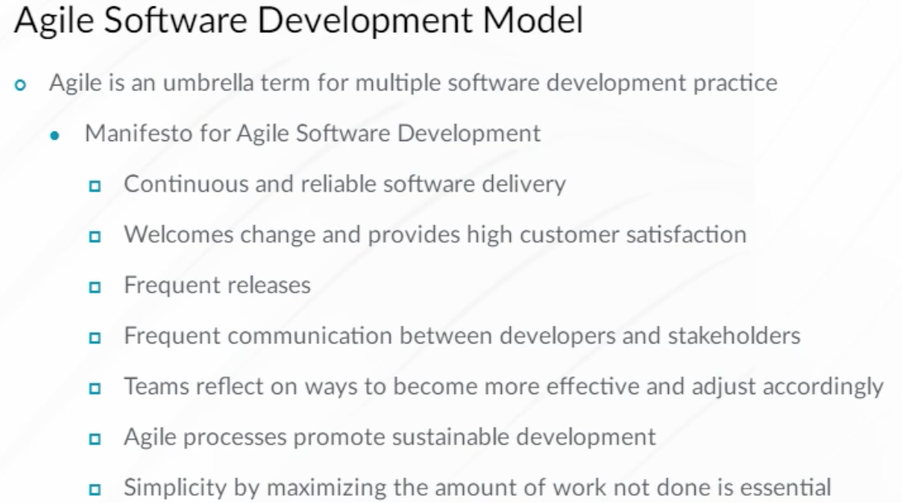

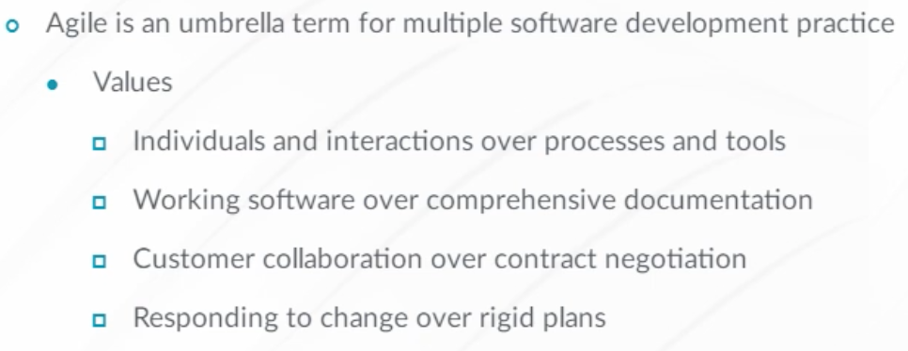

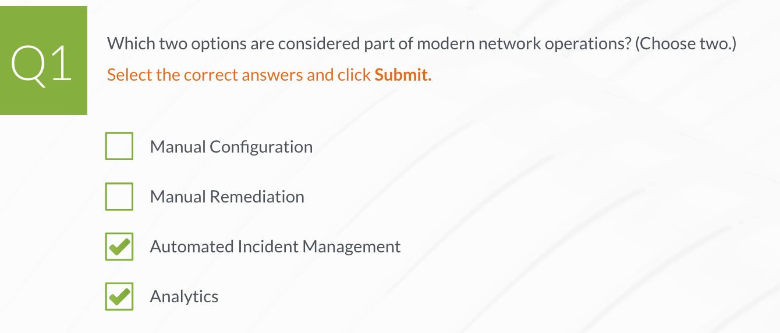

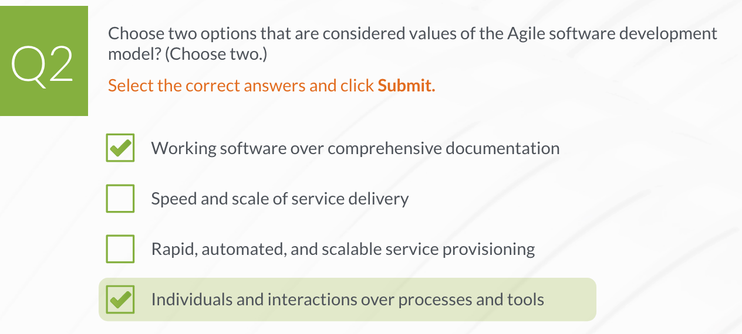

**DevOps Principles**

DevOps is a combination of technologies, design concepts, mentalities, and ideals that enable high-performing IT teams to move quickly while maintaining stability.

DevOps aims to unite development, operations, and other teams in your organization to improve communication, collaboration, and integration. DevOps creates a tight loop between product release and feedback, with the ultimate goal of decreasing the time to market while increasing organizational performance and customer satisfaction.

DevOps philosophies originated within the software engineering culture, as well as within the lean manufacturing revolution that began during the 1980s. The main principle of lean manufacturing is eliminating everything in the production chain that does not help to create the final product.

Using DevOps, changes in functionality can happen frequently, and are moved to production quickly. Automation and orchestration play a critical role, and if errors are encountered, a system can be quickly rolled back to a known state.

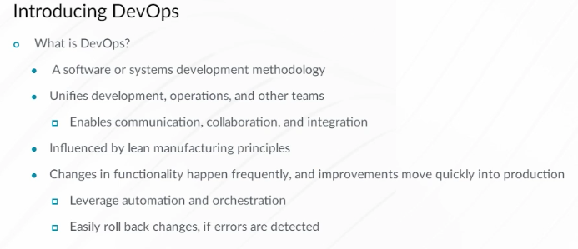

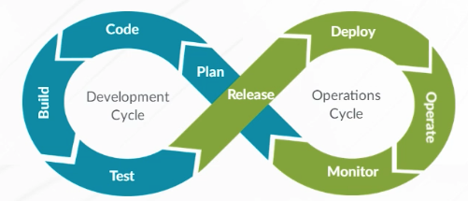

DevOps enables quicker integration of new software, especially software upgrades and patches. It enables developers to deliver software in smaller portions using a faster cadence. The overall result of adapting DevOps practices is faster time to market for new functionality, and an overall increase in organizational performance, product quality, and security. The DevOps practice of maintaining identical development, testing, staging, and production environments creates confidence that the new software will deploy successfully.

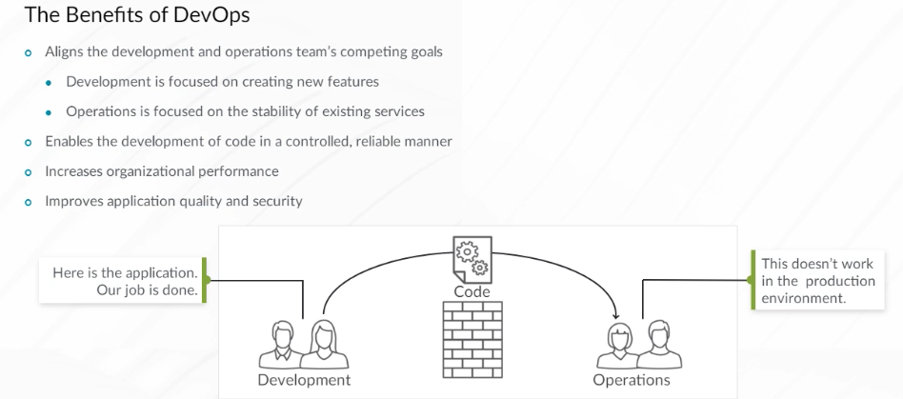

Traditionally, networks have been managed on a device-by-device basis. Deploying simple changes, such as adding VLANs to ports in medium to large networks, causes considerable strain on network operations. At the same time, compute infrastructure operators have adopted DevOps tools and processes that enable them to move quickly.

DevOps aims to align technology, design, and processes. While software development teams and compute infrastructure teams have embraced these methodologies, network operations is just starting to come on board. Junos automation solutions enable network engineers and operators to move at the rapid pace demanded by the DevOps community. Juniper embraces various automation and orchestration tools such as Ansible, Puppet, Chef, Salt, and so on. Junos enables network engineers to use common DevOps tools for full orchestration of large-scale service deployments.

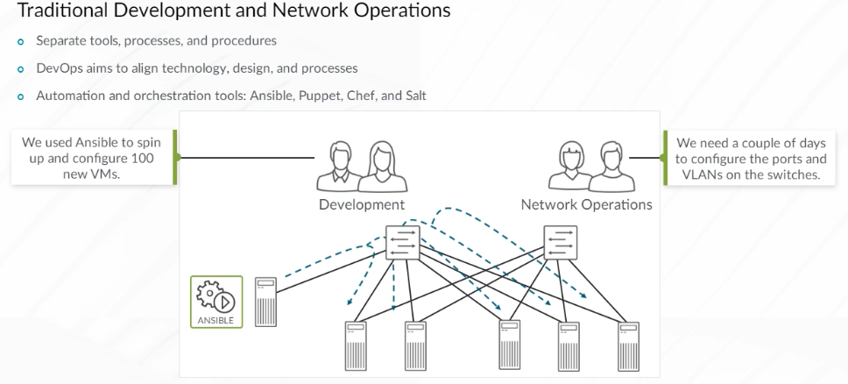

DevOps brings automation to the network resulting in increased speed, reduced cost, and a decrease in the number of configuration errors. Junos devices are completely programmable. Every capability baked into the Junos CLI is exposed to developers, making the platforms completely automatable.

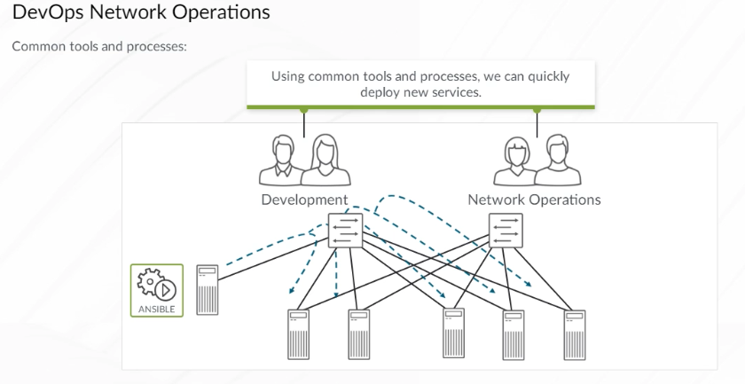

As you investigate automating your network, you might encounter the term Infrastructure as Code (IaC). This term is used both, inside and outside of DevOps circles. IaC is a very popular method to manage cloud-based resources because it provides complete infrastructure life cycle management. All infrastructure is managed and provisioned using code. This generally includes deploying new virtual servers, applications, and networking, and also terminating those resources when they are no longer needed.

Using code, you can create a new virtual router, switch, firewall, or any other virtualized network function (VNF). You can then configure and monitor the virtual device using code, just as you would a physical device. Virtual devices are also easy to move and duplicate when needed. This makes it possible for your development, test, staging, and production environments to be identical. Juniper’s vMX, cSRX, and vSRX are examples of virtual network devices.

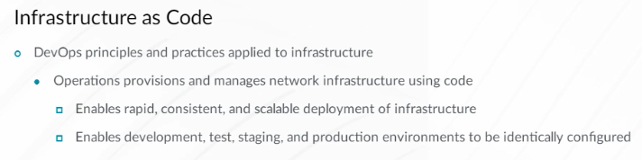

A typical IaC workflow is shown here. Code is created and then stored in a version control system (VCS). Next, the device code goes through an automated code review process, is integrated back into the primary code branch, and is deployed. You can see how closely the IaC project workflow resembles the workflow of a typical application development project. Management of your infrastructure is now a coding project.

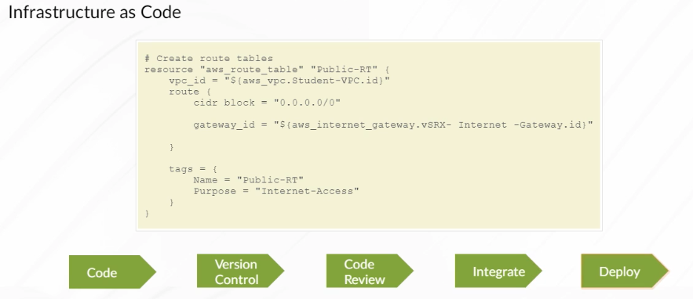

The practices of DevOps are an outcome of its culture. Adopting the practices without the culture, creates a short-lived experiment too shallow to stick. Understanding and internalizing the DevOps ‘Three Ways’ principles help you develop a DevOps mindset.

The DevOps ‘Three Ways’ are basic principles which all DevOps practices naturally follow. They are:

* Flow,
* Feedback, and
* Continuous experimentation and learning.

Work flows from developers to operations. Feedback is returned to the development team, and adjustments are made. Continual experimentation and learning is a frequent, reoccurring process.

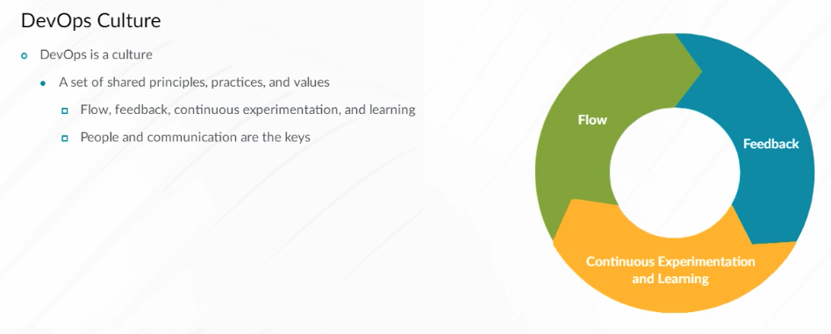

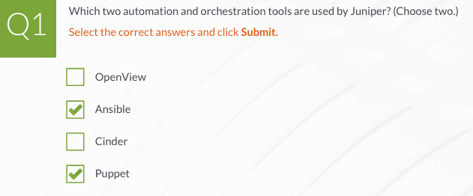

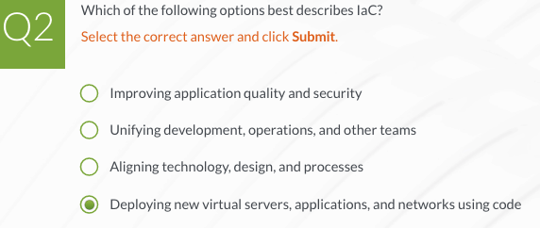

**DevOps Practices**

With any production system, there is a process flow from beginning to end. In manufacturing, the process flow begins when an order is placed and ends once the product is delivered to the customer. In an application development environment, the flow begins when a new software product, feature, or change is requested, and ends when the software, feature, or change is delivered to the customer. The goal in both manufacturing and software development is to shorten the time to deliver.

One of the first things an organization can do to improve process flow is to stop doing things that are going to hurt those downstream in the production process. All participants need to understand the production flow and how what they do affects others in the organization later on. Common problems include poor documentation, sloppy code, or implementing new features without sharing that information with others in development and IT.

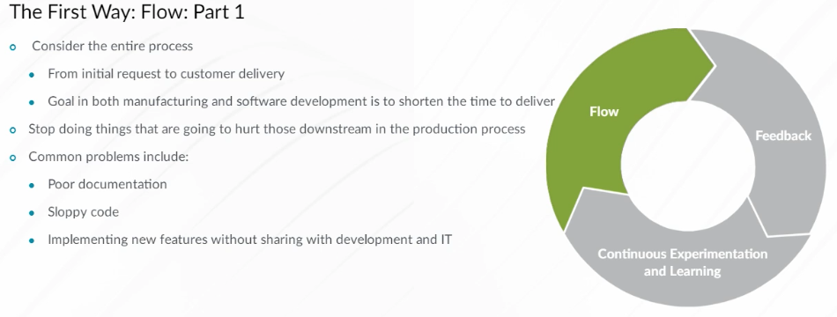

Sometimes, a local improvement in the code or in IT operations may improve the function of an individual code module or network function but degrade the system as a whole. Always keep the health of the entire system in mind when working on an individual part. If you have two options for doing the same task, focus on the one that increases the rate of flow in the long run. For example, it may take more time to implement automation than it takes to do the task manually. However, if you automate a repetitive task, the value of that automation far outweighs the value of getting the task done quickly one time.

Technical debt is something that occurs when you implement a short-term work-around to get a product out the door. You know that you should circle back to repair the work-around later. However, because you didn’t have time to do the task right the first time, it is unlikely that you will have time to revisit the work-around in the future and clean it up. Soon, you’ll find that you must create a new work-around to maneuver past old work-arounds. Like financial debt, technical debt also accumulates interest as time marches on.

Eventually, the house of cards comes crashing down and the pile of broken quick-fixes becomes the source of much pain. Make sure that you give enough time to implement the proper solution initially, so that you don’t enter into technical debt. Provide developers and IT operations teams the necessary time to avoid or clean up technical debt as an anticipated part of their workload.

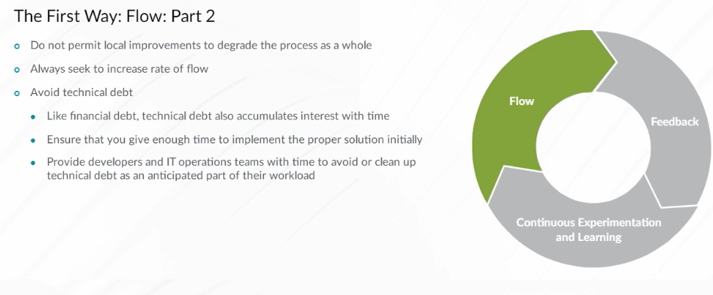

The second way is feedback—continuously gather feedback from each stage in the flow process. You utilize this feedback to know what is working, what is not, and what needs to improve. Collect feedback from developers, operations, customers, and anyone else who may have information that can help you improve the flow or quality of the product. You can collect feedback from people, as well as from automated monitoring and measuring systems. Feedback is a primary method for identifying ways to shorten and improve the flow.

Using feedback to shorten your process flow includes shortening the time it takes to collect and analyze feedback. Note that the sooner you get feedback, the sooner you can integrate positive changes into the system.

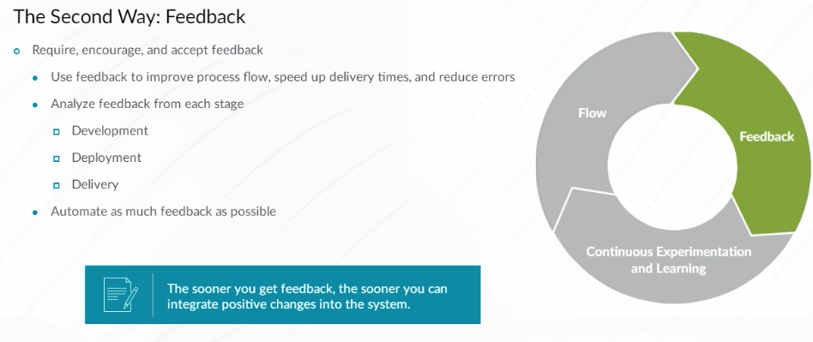

Set aside time to evaluate feedback and implement improvements. Feedback, process speed, and product quality metrics should be gathered over time to determine if a flow is improving. It is also important to give time in an employee’s workload to implement improvements. Some companies give up to 20 percent of a worker’s time to implement improvements. If everyone understands that the ultimate goal is to improve the flow, participants are unafraid to suggest improvements in their own processes that could improve the system as a whole. They begin to feel confident enough to take risks and try new things that can improve the flow even further. Individuals who are willing to take the risk of innovation should be rewarded for their efforts.

As much as you strive to make a system fault-tolerant, it is difficult to know just how tolerant a system is to failure until you test it. Finding and eliminating risk in a system is much easier when you are actively searching for points of failure as part of a plan to improve. Some companies purposely unplug devices or break processes temporarily to stress-test a system and observe how employees and systems deal with the problem. Testing a system helps to ensure that theoretical recovery plans work when it counts.

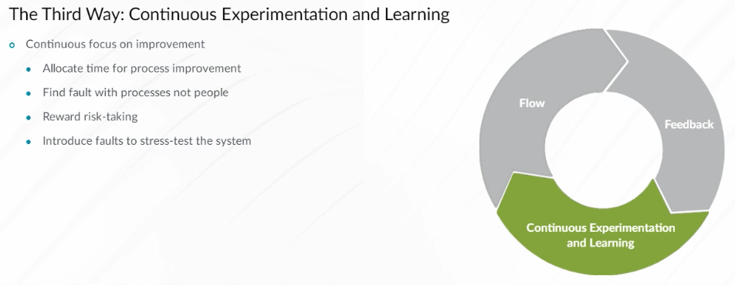

Continuous Integration (CI) is the practice of frequently committing the code to a shared central repository and automating the build and test process of the code each time someone pushes new code into the repository. The goal of CI is to provide rapid feedback. If a defect is introduced into the code base, it should be identified and corrected as soon as possible. For CI to work, a VCS, such as Git, is used. Some additional tools that automatically perform tests on the code might also be required.

A major aspect of CI is that developers are routinely reintegrating the code with which they are working back into the primary or main branch of code in the VCS. The longer developers wait to integrate their code with the main branch, the more likely it is that there will be incompatibilities that slow the flow of production. Submitting the code for integration at least once a day is recommended.

With continuous building and testing, the primary code is theoretically in a releasable state at any time. Quality, compliance, and security testing are performed at each step of the process. Reserving extra time for testing at the end of the process is unnecessary since testing occurs throughout the process.

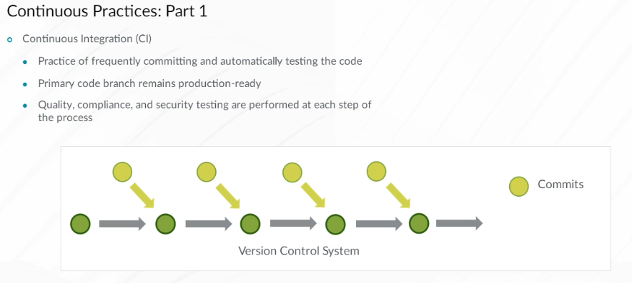

Continuous delivery and continuous Deployment are natural extensions of CI. These terms are often used to describe the DevOps model. The difference between the two is that Continuous Delivery makes sure that the code is ready to deploy at any time, while Continuous Deployment is a way to automate the code deployment. The most important aspect of Continuous Delivery and Continuous Deployment is that operations, security, and compliance teams are brought into the conversation much earlier than before. Being a part of the process early on enables these teams to give valuable input and visualize the process from beginning to end.

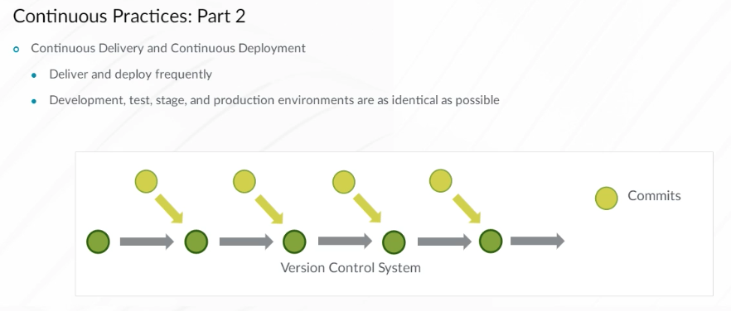

Depending on the size of your organization and the exact field of activity, DevOps principles can be implemented differently.

Google’s Site Reliability Engineering (SRE) started as a software engineer’s way to manage repetitive tasks, and is now an extended set of principles, practices, and incentives, which helps to manage large and complicated services at scale. One can view SRE as a specific implementation of DevOps with some extensions. DevOps can also be thought of as a generalization of several core SRE principles to a wider range of use cases.

Network Reliability Engineering (NRE) can be thought of as a DevOps implementation for networking. It has its own specifics and yet, still uses many of the common DevOps ideas, approaches, and tools.

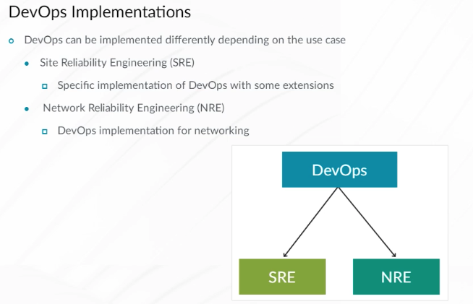

Traditional network operations are a bit like fire fighting, with fire disguised as randomly appearing network failures that require manual intervention to resolve. NREs employ DevOps principles to ensure reliable network operations.

It focuses on customer satisfaction and service availability. Networking is inseparable from connected systems and applications. NRE embraces failure as a way to ensure the same error does not happen again, relies on proactive testing, and is a continuous journey.

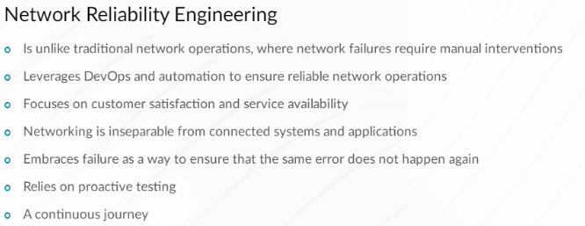

The main NRE behaviors can be summarized as:

* Codify: Beginning with the acquisition of network software and hardware systems (commonly called day 0), an NRE codifies the network software artifacts, secrets, and configuration into source-code repositories similar to a software developer.
* Automate: Using a DevNetOps pipeline, an NRE automates development, testing, staging, and production deployments. NREs use this pipeline to provide reliability, scale, efficiency, and optimization for dynamic provisioning of networking resources for its consumers, and systems integration.
* Test: Through automation, staging, and stress testing, an NRE ensures that the deliveries are reliable enough to meet service-level objectives and agreements.
* Monitor: An NRE monitors service-level indicators, both manually and automatically, and using analytics, triggers automatic responses and alerts for anomalous and statistically meaningful events. Logs and telemetry are collected and analyzed to derive insights used to optimize network performance.
* Measure: The NRE culture values truth and transparency, and uses indicators to measure their effectiveness in meeting reliability goals, such as mean time between failure (MTBF) and mean time to resolution (MTTR).
* Improve: Permanently improve the stability of the system, visibility, and incident reaction time.

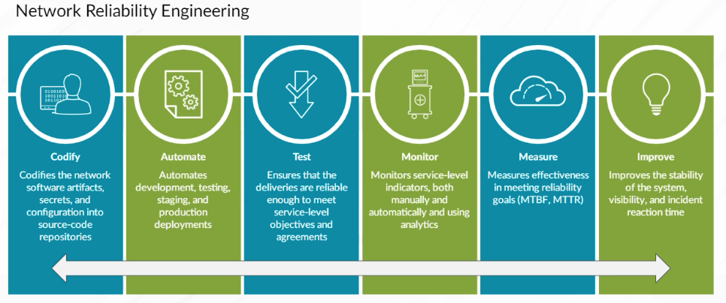

Network DevOps is the application of DevOps philosophies, principles, and behaviors to network operations (NetOps). Network Reliability Engineers put it into practice. DevOps principles counter the waterfall methodology where extended planning, building, and testing cycles occur in long sequential stages. Research has shown that for the IT and manufacturing industries, smaller and more frequent deployments result in improved operational speed, agility, and quality.

By working in shorter and faster cycles with smaller deployment deliverables, a Network DevOps pipeline reduces the time between design changes and production deployment. All network changes go through the same pipeline to ensure consistency.

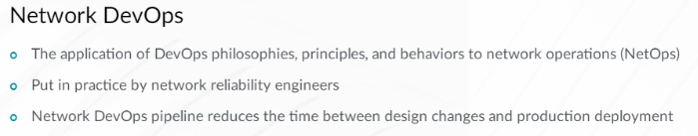

Although the stages can vary in different implementations, the Network DevOps pipeline stages are common:

* In the design change stage, the network architects and engineers, based on business needs and customer feedback, decide what change is needed in the network
* In the commit change to VCS stage, the change, in the form of code, is committed to a VCS
* In the notify and peer review stage, the team is notified of the proposed change, and team members review and approve or reject the change
* In the automated testing stage, the tests run automatically, ideally in separate testing and staging environments
* In the automated deployment stage, the change is deployed (committed) to production. The team is notified about deployment success or failure. Failed deployments can be rolled back
* In the continuous monitoring stage, the network telemetry is collected and analyzed to provide real-time network performance indicators. The telemetry is compared to service-level indicators, and is used to make reactive or proactive adjustments to the network
* Finally, in the continuous improvement stage, the failure is viewed as an opportunity to improve. Feedback is encouraged, and is used to optimize the overall system performance.

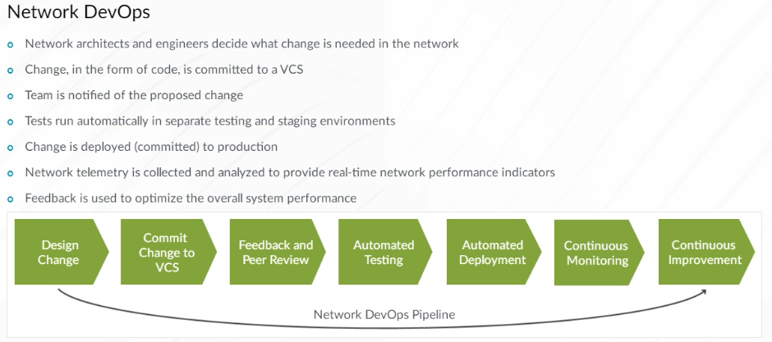

DevOps advocates a specific culture and suggests practices that emerge as a result of that culture; it does not recommend specific tools. These are some popular tools used for various development processes. The selection of tools varies depending on the use case.

A few tools are selected to demonstrate how DevOps practices can be used with Juniper software and hardware platforms. Each tool represents one of many that could be used for a particular task.

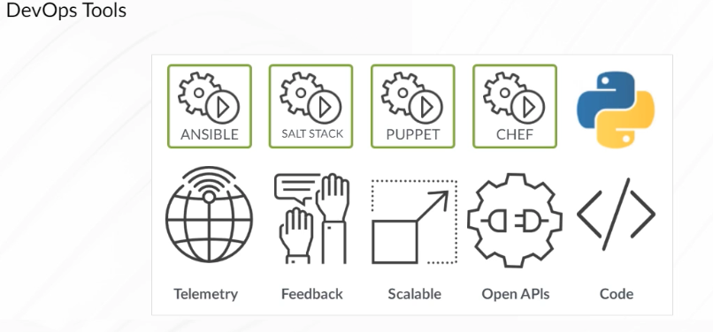

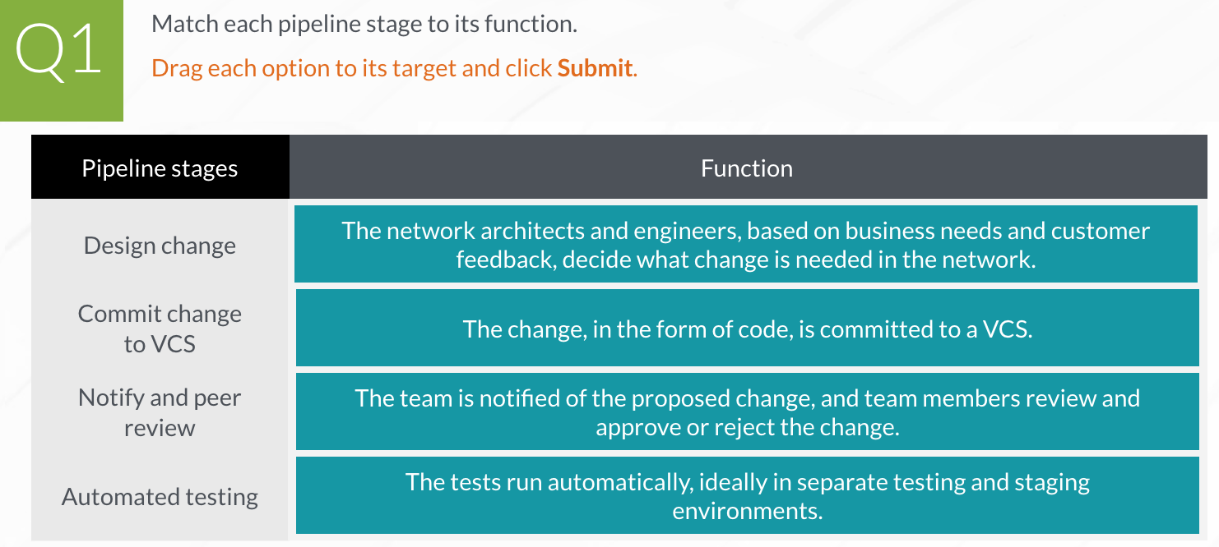

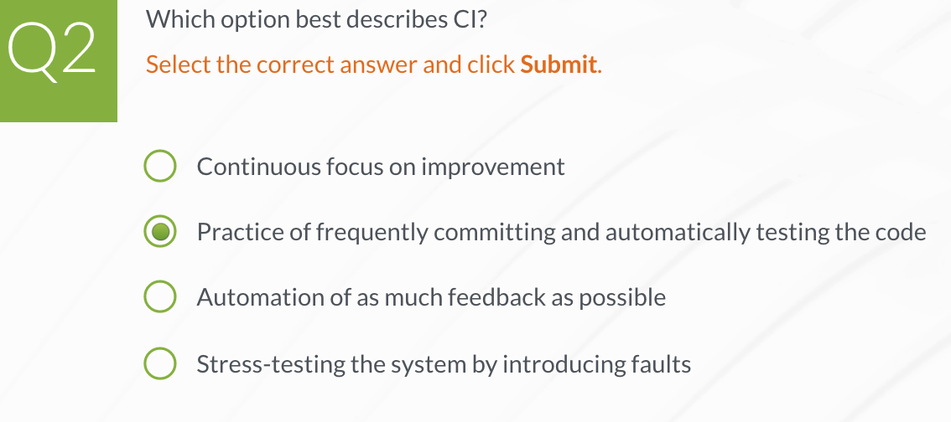

1. **Junos Automation API Overview**

**Junos Automation API Overview**

Automation has been a part of Junos since its inception. Over the past 25+ years, the Junos OS has developed rich automation capabilities and supports multiple APIs, libraries, tools, and programming languages. The different layers of the Junos automation stack and the protocols, and languages that the Junos OS supports for automation is provided.

Just above the Routing Engine and the Packet Forwarding Engine layer sits the Junos OS. The Junos OS includes the kernel that provides infrastructure for the Junos processes. These processes carry out the core functions of the Junos OS. When you automate a Junos device, it is these processes that eventually execute the automation commands.

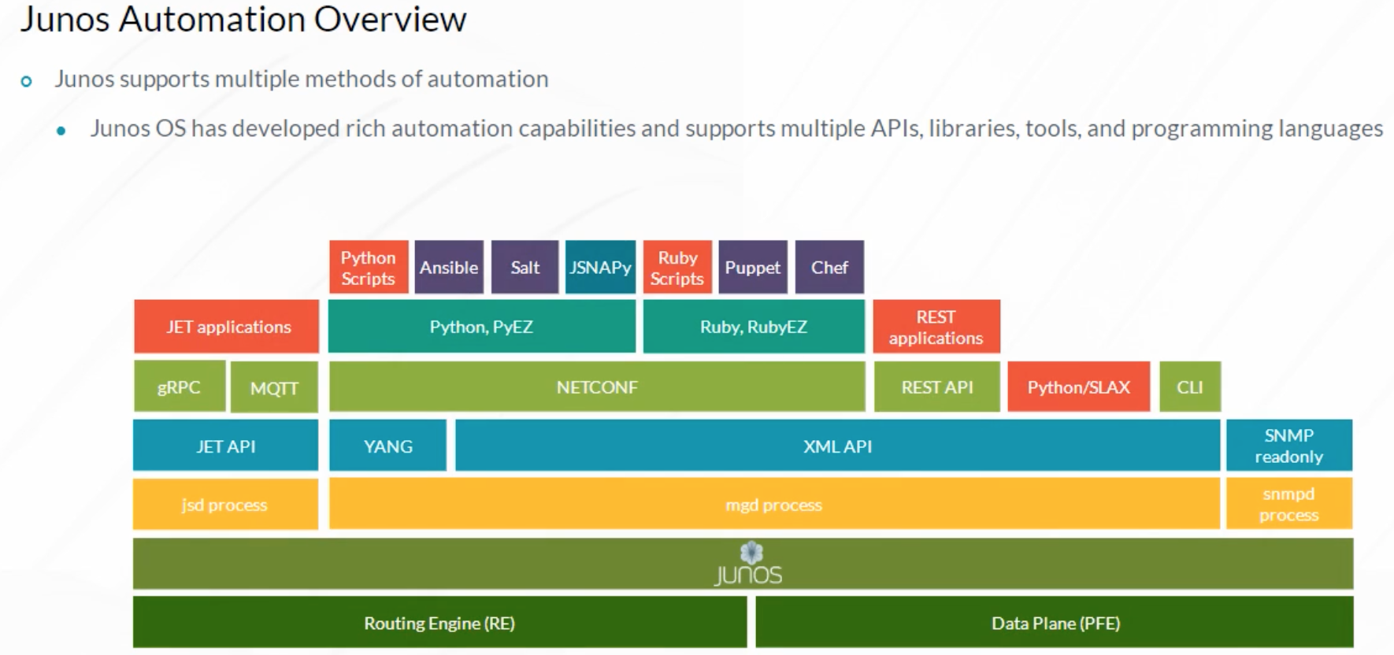

The main Junos processes responsible for automation are the management process (mgd) and the Juniper Extension Toolkit (JET) service process (jsd). The mgd handles automation requests received using the Junos XML, Yet Another Next Generation (YANG), and Representational State Transfer (REST) APIs, as well as some functions. For example, Ansible executes locally stored Python modules and accesses the Junos device using the Network Configuration Protocol (NETCONF) and the XML API. Junos forwards the received Ansible commands to the Junos mgd process for execution. The jsd service handles automation requests that use JET API.

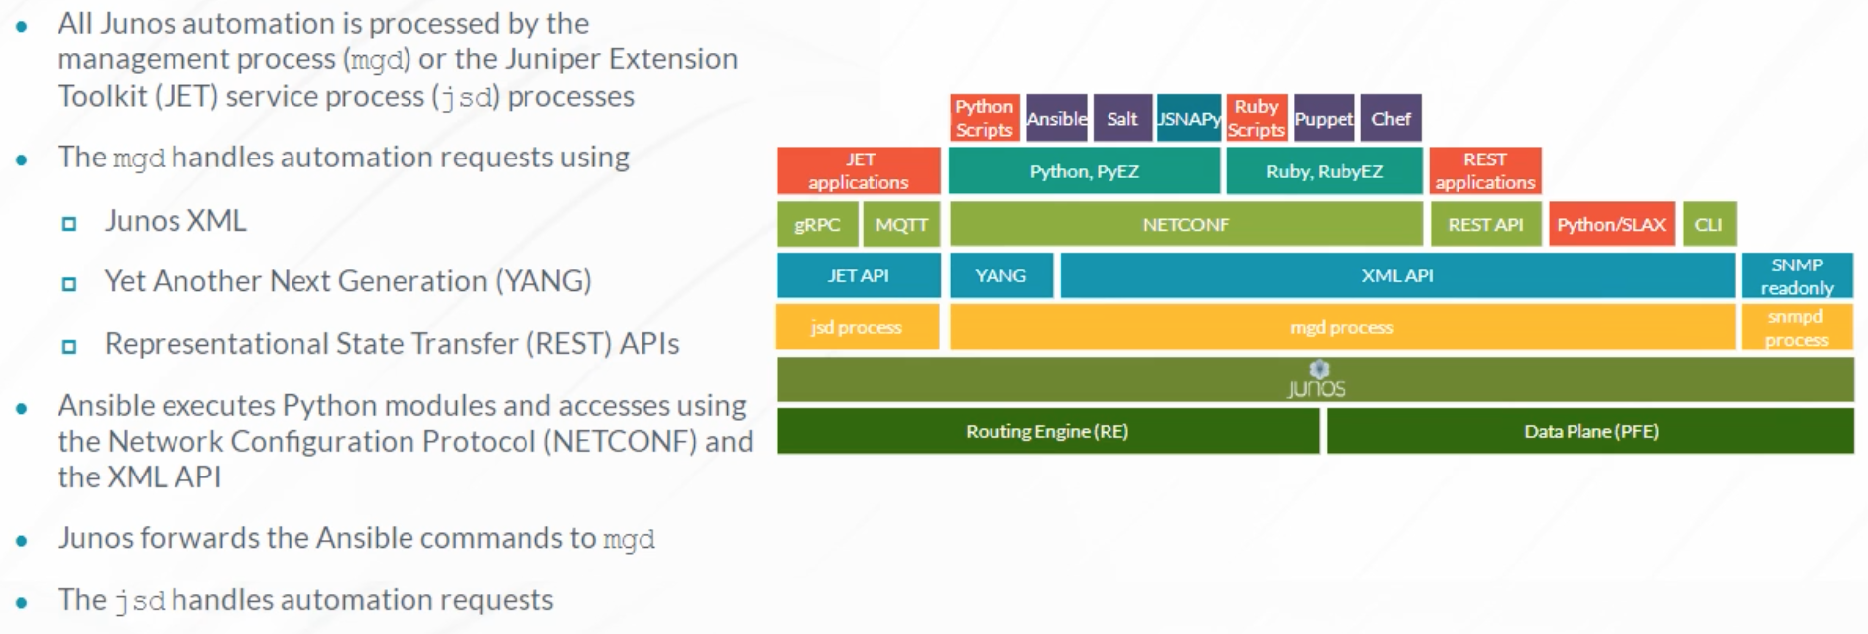

Junos works well in DevOps environments for these reasons:

* Junos has a rich set of APIs.
* Junos uses transactional configuration updates (the Junos commit model).
* Junos configuration and operational data are based on a consistent XML data model.
* Junos supports popular IT automation and configuration management systems such as Ansible, Salt, Puppet, and Chef.
* In addition to remote management through APIs, Junos supports on-box scripts and applications.

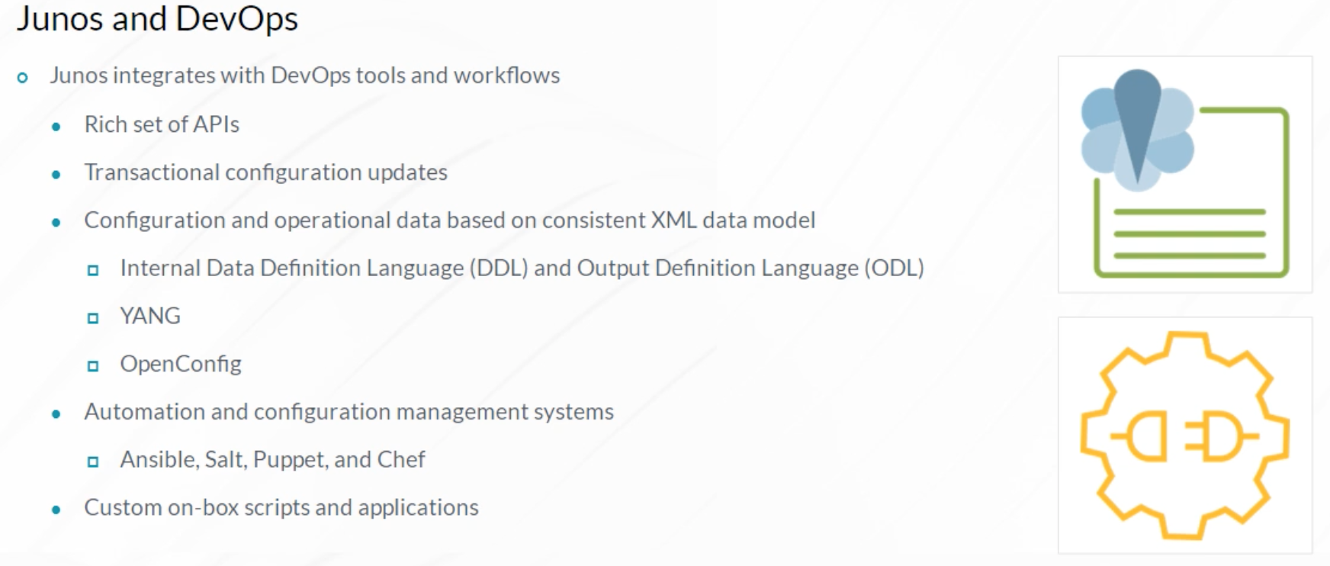

The Junos XML API provides on-box automation (operation, commit, event, and SNMP scripts), as well as off-box automation using third-party automation tools. To retrieve data from the Junos XML API, off-box solutions must leverage a protocol to transmit XML documents. One protocol used for Junos off-box automation is NETCONF.

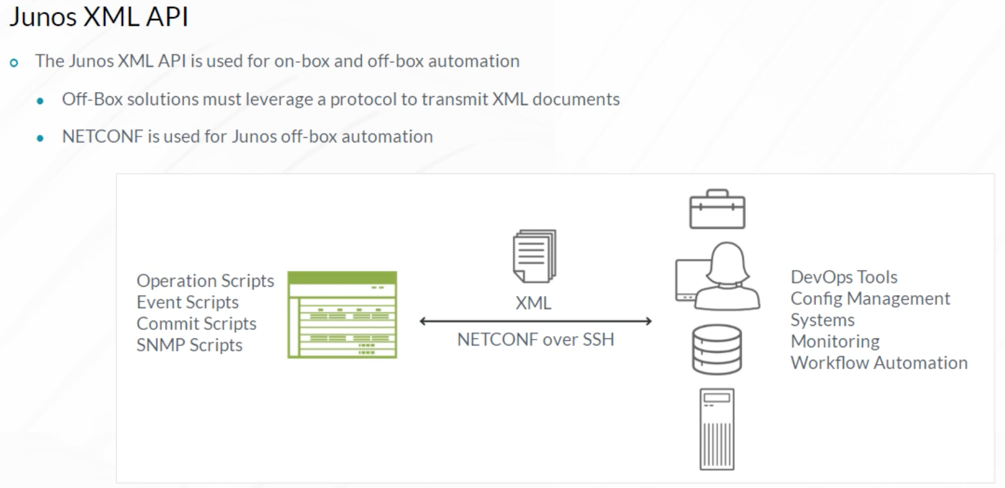

NETCONF is an open, standards-based protocol (RFC 6241), and is used by multiple vendors. NETCONF contains mechanisms that provide full programmatic access to Junos devices. Using XML documents and remote procedure calls (RPCs), you can transport configuration data and operational commands to network devices. NETCONF has been Juniper’s automation protocol of choice for many years, and is supported on all Junos devices.

It is the foundation upon which many Juniper automation technologies are built including, Junos PyEZ, YANG, and OpenConfig. In most cases, NETCONF uses SSH as the transport protocol, although RFC 6241 enables other options (for example, Transport Layer Security (TLS)).

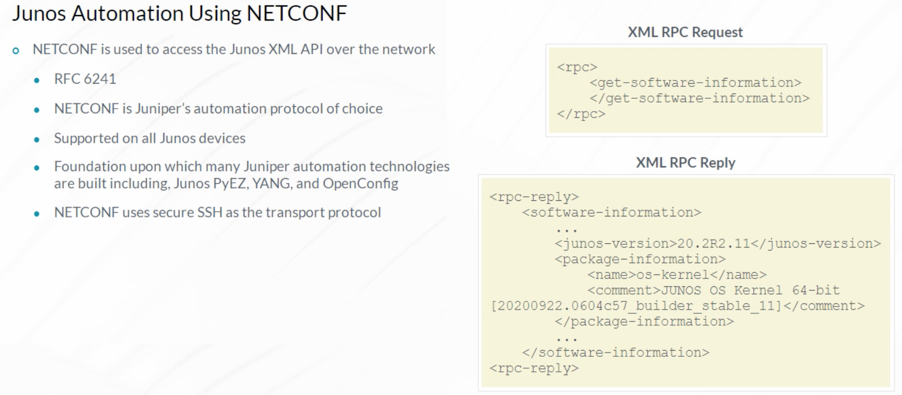

Libraries that make automating your network easier are available for multiple programming languages. These libraries provide simple and flexible options for connecting to Junos devices using NETCONF, and leverage the Junos XML API for management.

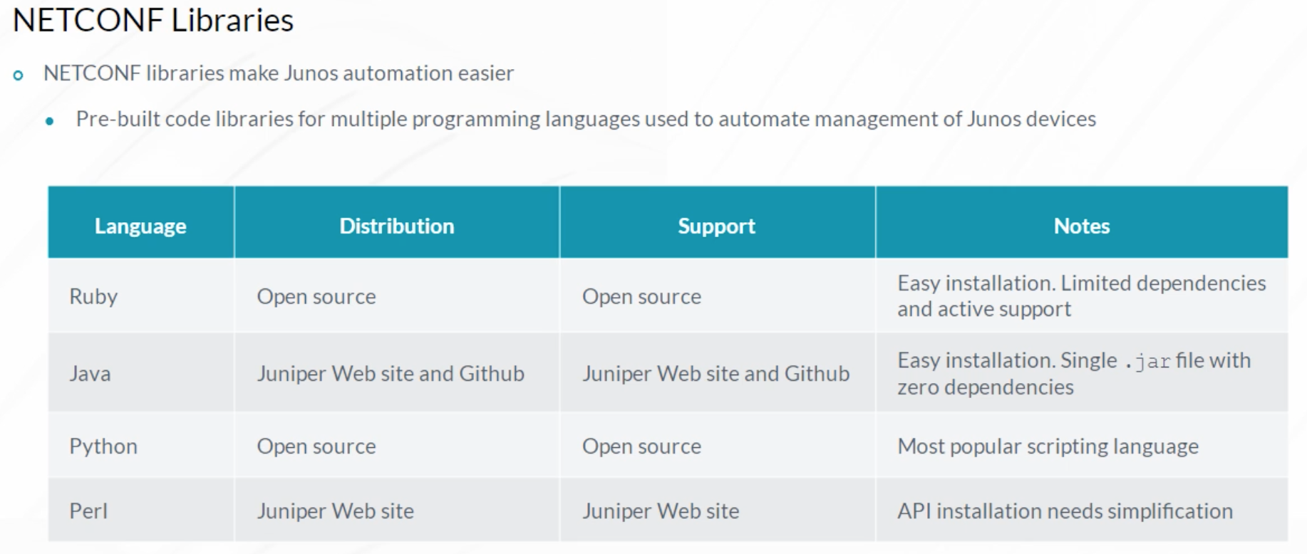

A REST API provides HTTP clients access to objects that correspond to unique URLs on a REST server. REST clients use HTTP methods, like GET, PUT, and POST, and data in the request body to perform actions on the REST server. REST is considered stateless because no client context is stored on the REST server. All session state is maintained on the REST client.

Each request from a REST client contains all the information necessary to process the request. A REST API can be accessed using any program or programming language capable of generating HTTP commands. Tools like Postman or cURL are commonly used for testing. For actual programming, libraries have been developed for many programming languages, like Python, that simplify the generation of REST API requests.

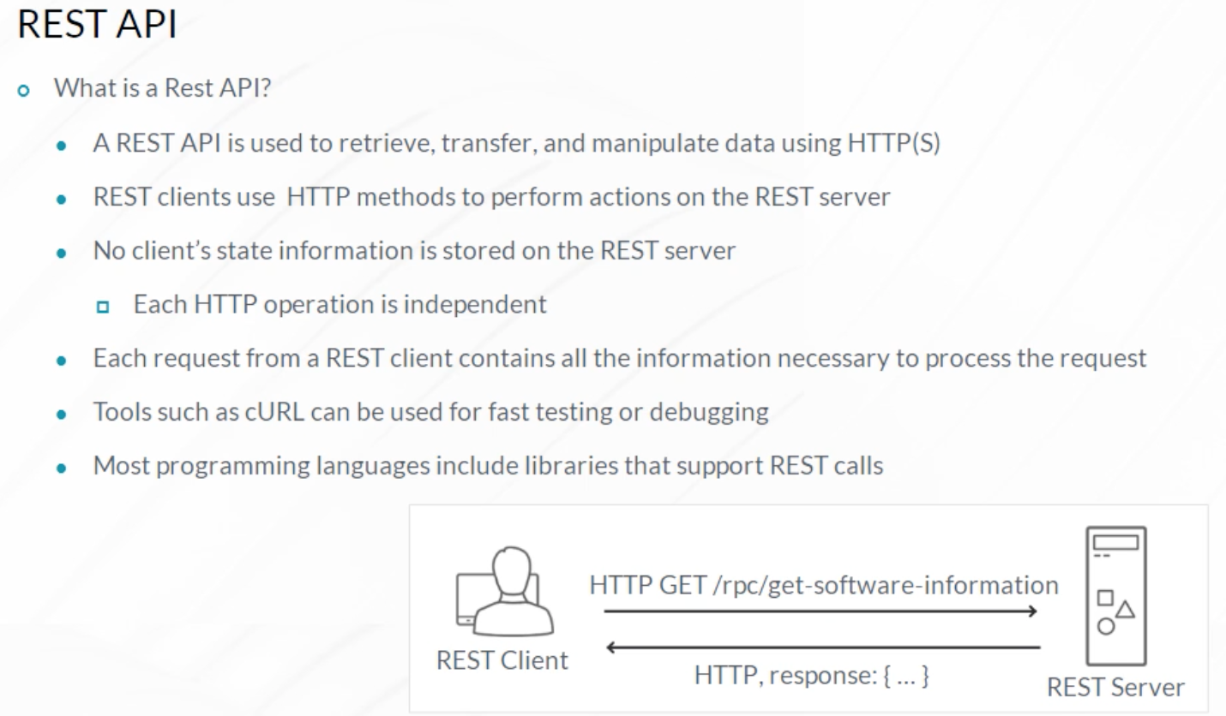

Junos provides a REST API on MX, PTX, QFX, T, and SRX Series platforms including the vMX and vSRX. It exposes Junos configuration and operational mode capabilities to REST HTTP clients.

The example demonstrates using the cURL utility to execute a get-software-information RPC on the 192.168.1.1 host and the XML response. This output is equivalent to a Junos CLI **show version** operational mode command.

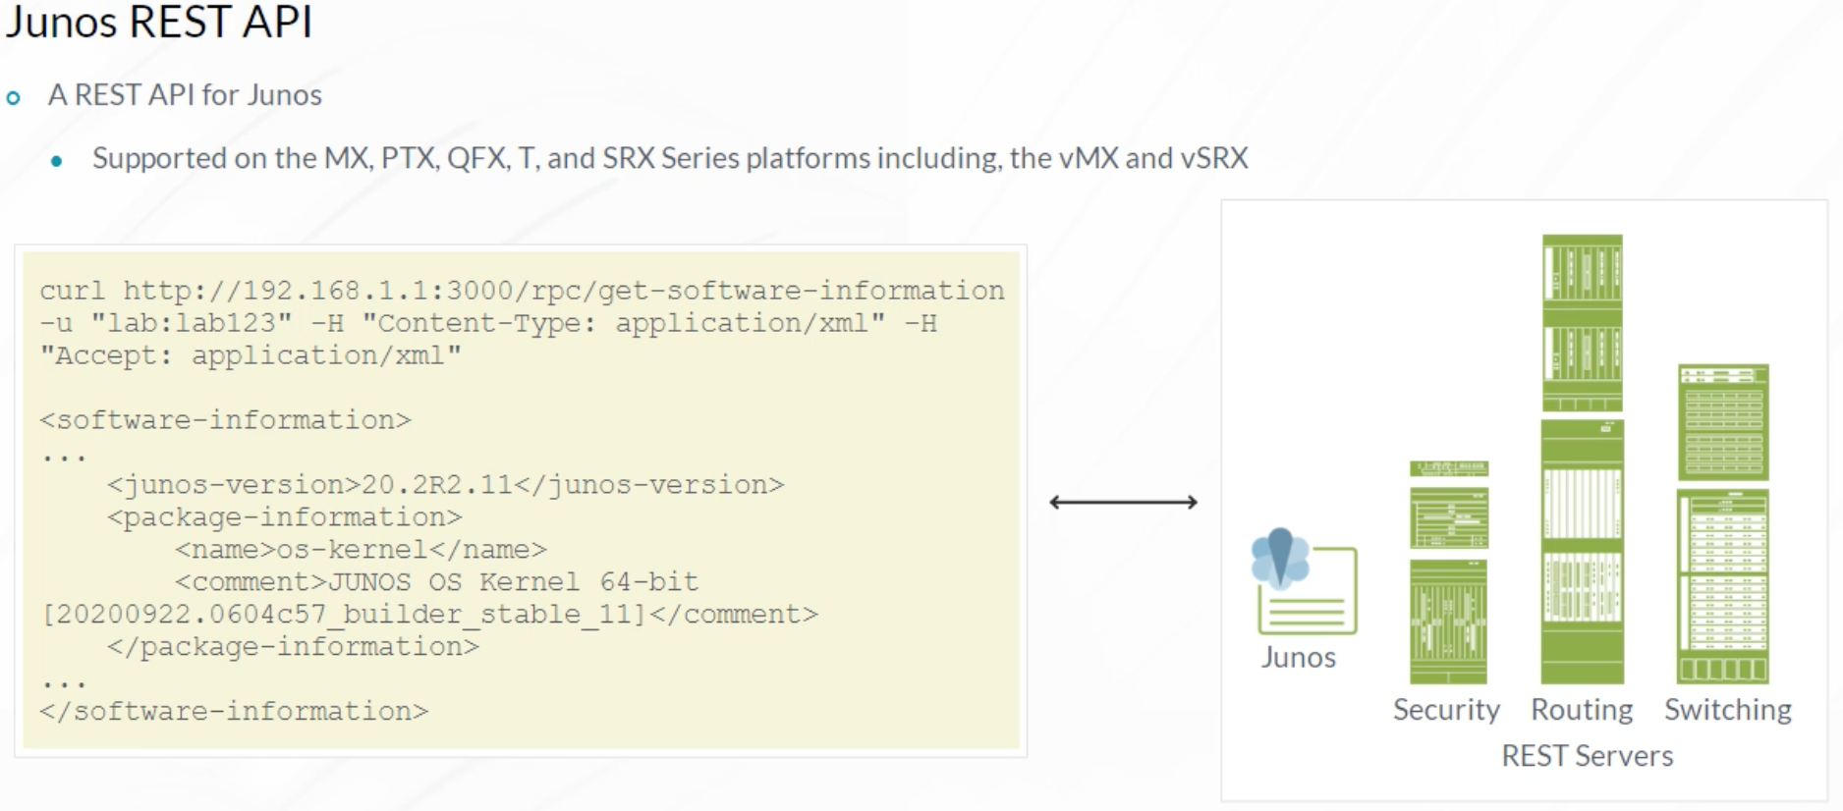

Organizations using management or monitoring systems based on REST can easily integrate Junos platforms. Other benefits of the Junos REST API include ease of configuration, no need to enable or use NETCONF, the ability to retrieve data in multiple formats, the availability of a REST API explorer, and support for Secure Sockets Layer (SSL).

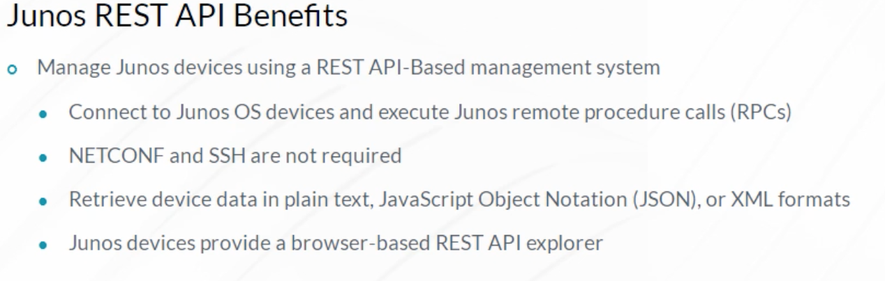

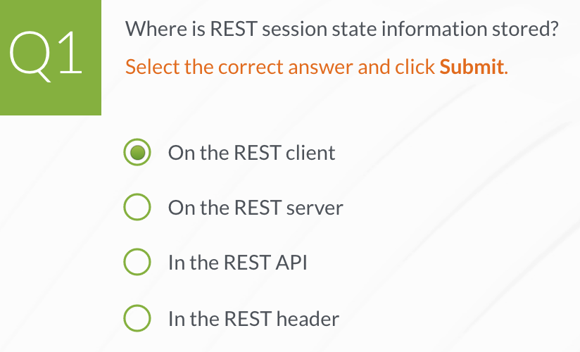

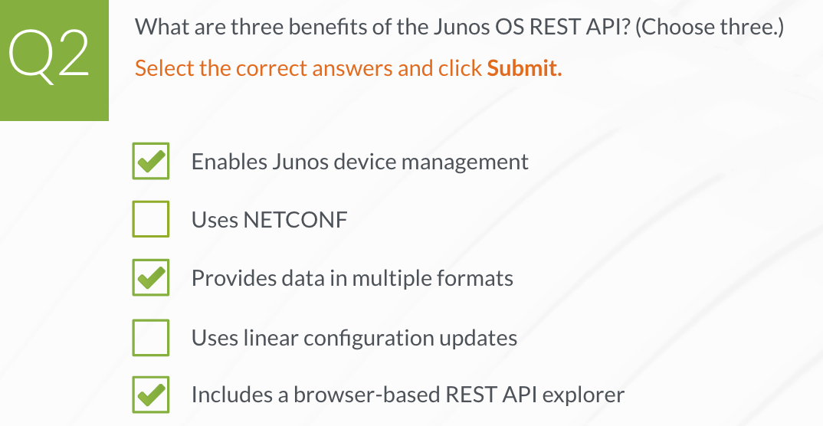

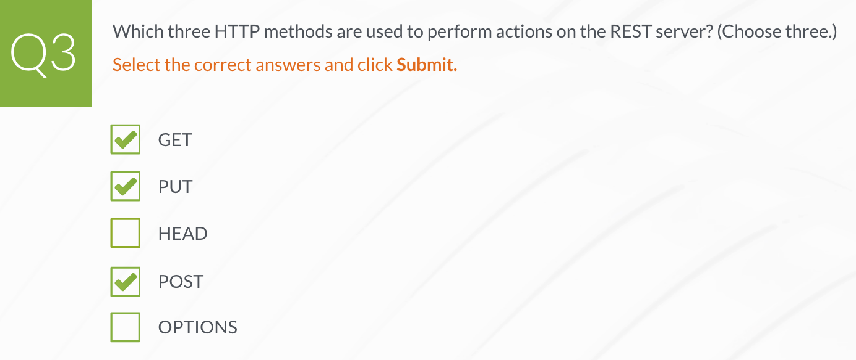

**Overview of Junos Automaiton Tools**

The Junos OS enables you to customize the behavior of a device with commit, operation, event, and SNMP scripts that run on the Junos device. These scripts take XML input, process it, call the Junos functions specified in the script, and output the instructions to Junos. The type of input accepted and the information returned is different for each of the different script types.

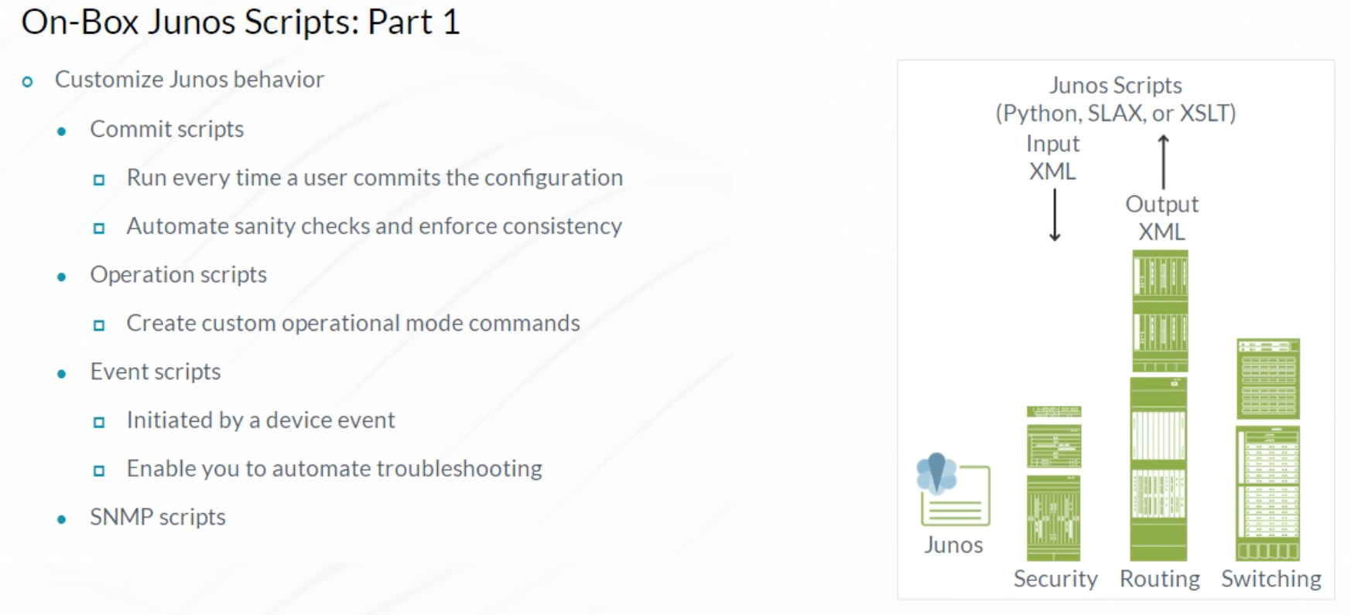

The programming languages used for Junos on-box scripting are Extensible Stylesheet Language Transformations (XSLT), Stylesheet Language Alternative Syntax (SLAX), and Python.

XSLT is a standards-based language for processing XML data. XSLT was developed by the World Wide Web Consortium (W3C).

SLAX is an open-source language that mimics the semantics of C and Perl languages. SLAX is a pre-processor that converts its SLAX syntax to XSLT. Therefore, scripts written in SLAX are executed the same way as scripts written in XSLT.

The Junos OS supports Python on-box scripting starting with Junos 16.1. This also includes support for the Junos PyEZ library on-box.

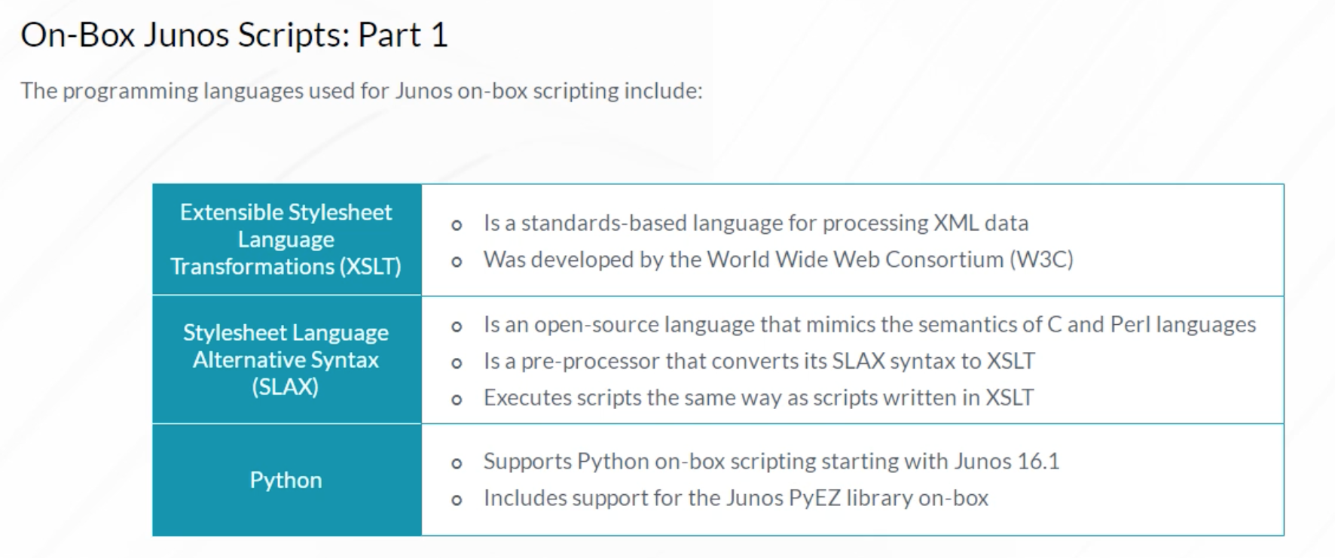

The types of the Junos scripts that you can develop, and use are:

Commit scripts that run every time a user commits the configuration. They can be used to automate configuration tasks, enforce consistency, catch common mistakes, and more.

Operation scripts can be run from the command line, essentially working as custom operational commands. Among other things, they enable you to automate troubleshooting, either by having the Junos OS attempt basic troubleshooting or by having it automatically display the information that you specify, thereby helping to streamline the troubleshooting process. Operation scripts can also change configuration.

Event scripts are similar to Operation scripts, except that they are initiated by an event policy. This feature enables you to have the software automatically respond to events that it logs, such as interface state changes or BGP neighbor state changes.

SNMP scripts provide the flexibility to create custom MIBs that are not available in the Junos OS. They are triggered automatically when the SNMP manager requests information from the SNMP agent for an object identifier (OID) that is mapped to an SNMP script for a non-Junos OID.

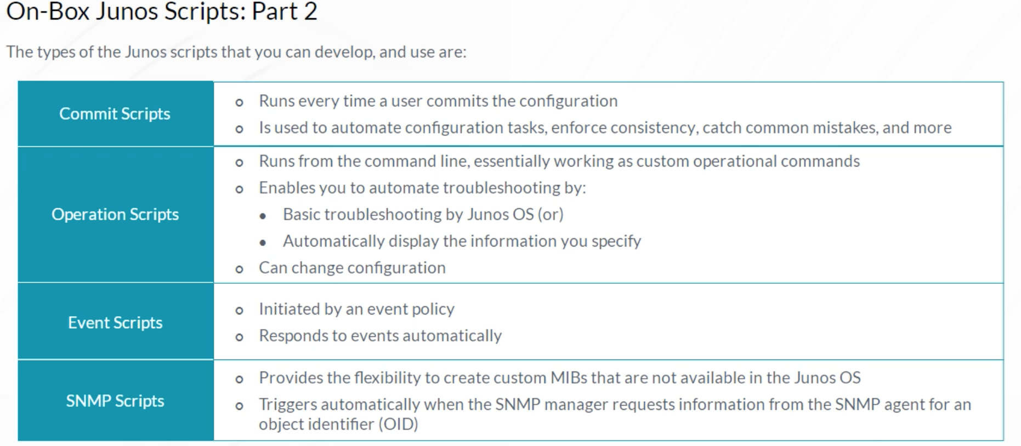

Junos PyEZ is a powerful open-source Python library that is easy to learn and use. It enables you to automate all aspects of Junos device management including configuration, monitoring, software upgrades, file system maintenance, and so on using Python.

Junos PyEZ enables you to read and upload device configuration in several formats including text, XML, JavaScript Object Notation (JSON), or Junos set commands. It parses all XML remote procedure call (RPC) outputs automatically. Multiple utilities are also included to help with maintenance tasks.

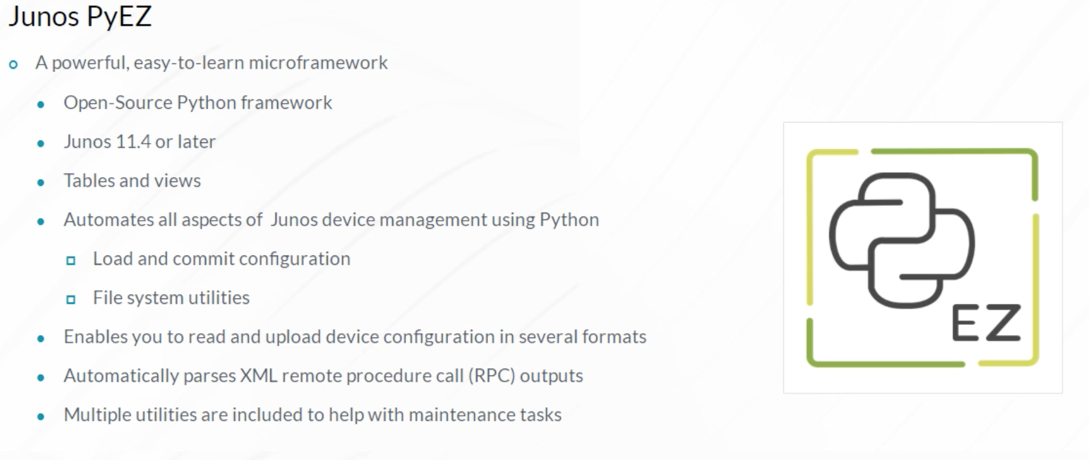

Automation management systems, also known as IT automation platforms or configuration management systems, refer to software used in DevOps environments. Junos integrates with some of the most widely used automation management systems in the industry including Ansible, Salt, Puppet, and Chef.

An automation management system provides multiple benefits:

* Manages hundreds or thousands of devices.
* Enables you to take a declarative approach to configuring your network.
* You define the desired final state of the system, and the automation management system performs the low-level configuration.
* Most automated management systems support some type of configuration templating. The automated management system renders the templates to create the actual configuration that is uploaded to managed devices.
* Operations like software upgrades, file uploads, file downloads, and so on, are also typically available.
* Platforms such as Salt enable you to react to events, and take actions based on the event type and severity.

Note that all automation management systems use the Junos XML API and Network Configuration Protocol (NETCONF) over SSH to manage Junos devices.

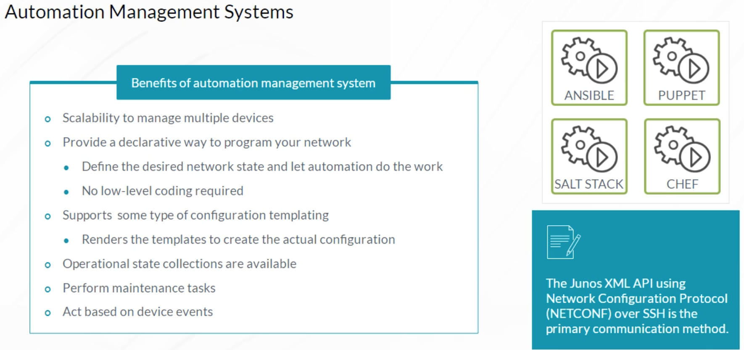

Ansible is an automation platform that makes deploying and managing Junos devices easy. Ansible enables you to avoid writing complex scripts or custom code. Instead, Ansible enables you to automate using simple to understand YAML Ain’t Markup Language files. Another Ansible advantage is that no agent is required on the managed devices.

Ansible can perform operational and configuration tasks on devices running the Junos OS, including, installing and upgrading the Junos OS, deploying devices in the network, loading configuration, retrieving information, and resetting, rebooting, or shutting down managed devices.

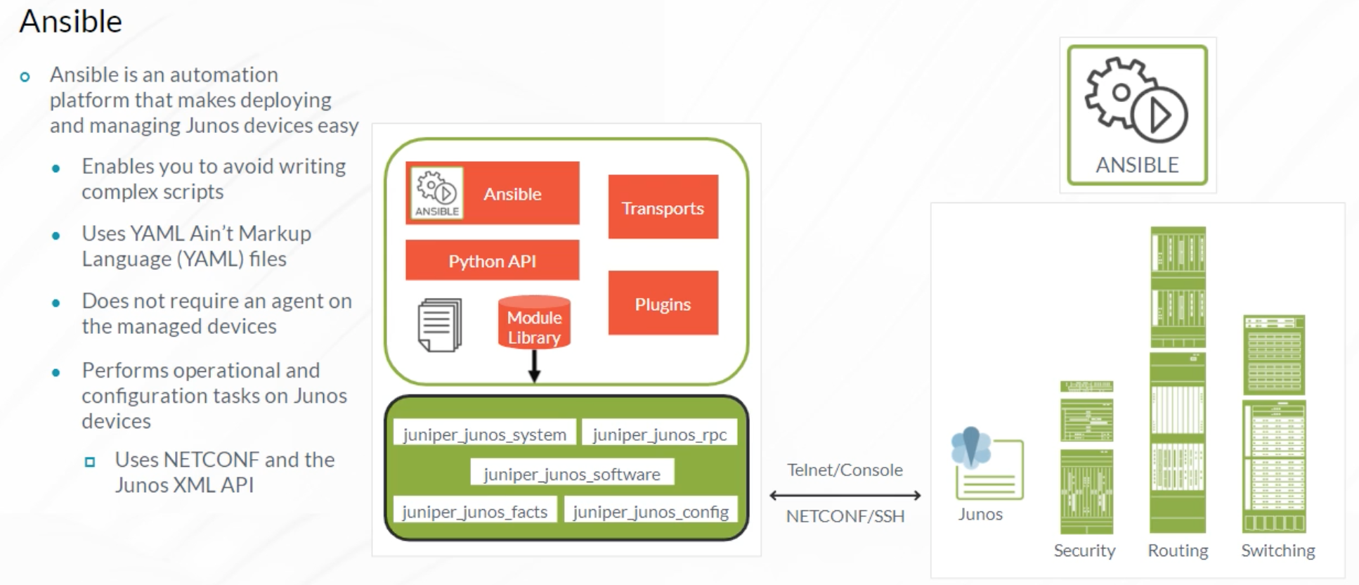

Salt is a powerful configuration management platform that was created and maintained by the SaltStack company. It was purchased by VMware in 2020. Salt enables you to define the desired state of a system and enforce that state on managed devices. You can also use Salt to execute commands on remote devices. It is Python-Based and utilizes a Salt Proxy minion to connect to Junos devices.

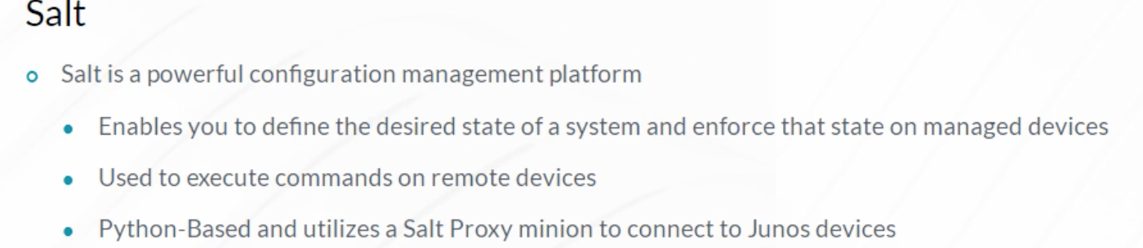

The Salt Proxy minion supports the ability to gather facts from Junos devices, manage and commit configurations, execute RPCs and CLI commands, install software, and copy files. Salt is event-driven and popular for use with Junos platforms because of its ability to perform event-driven closed loop automation.

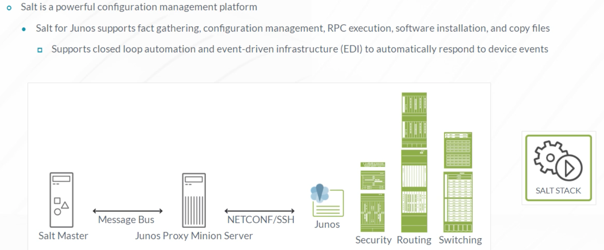

Puppet is designed to perform device configuration management, and it provides an efficient and a scalable solution for managing the configurations on a large number of devices. System administrators frequently use Puppet to manage compute resources, such as physical and virtual servers. Juniper Networks supports using Puppet to manage network devices running Junos. Puppet is deployed using a client server model where the Puppet server manages one or more agent nodes.

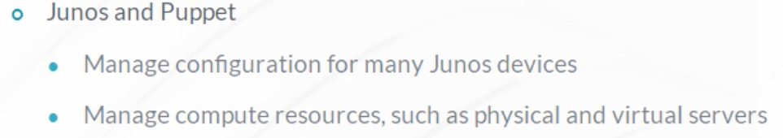

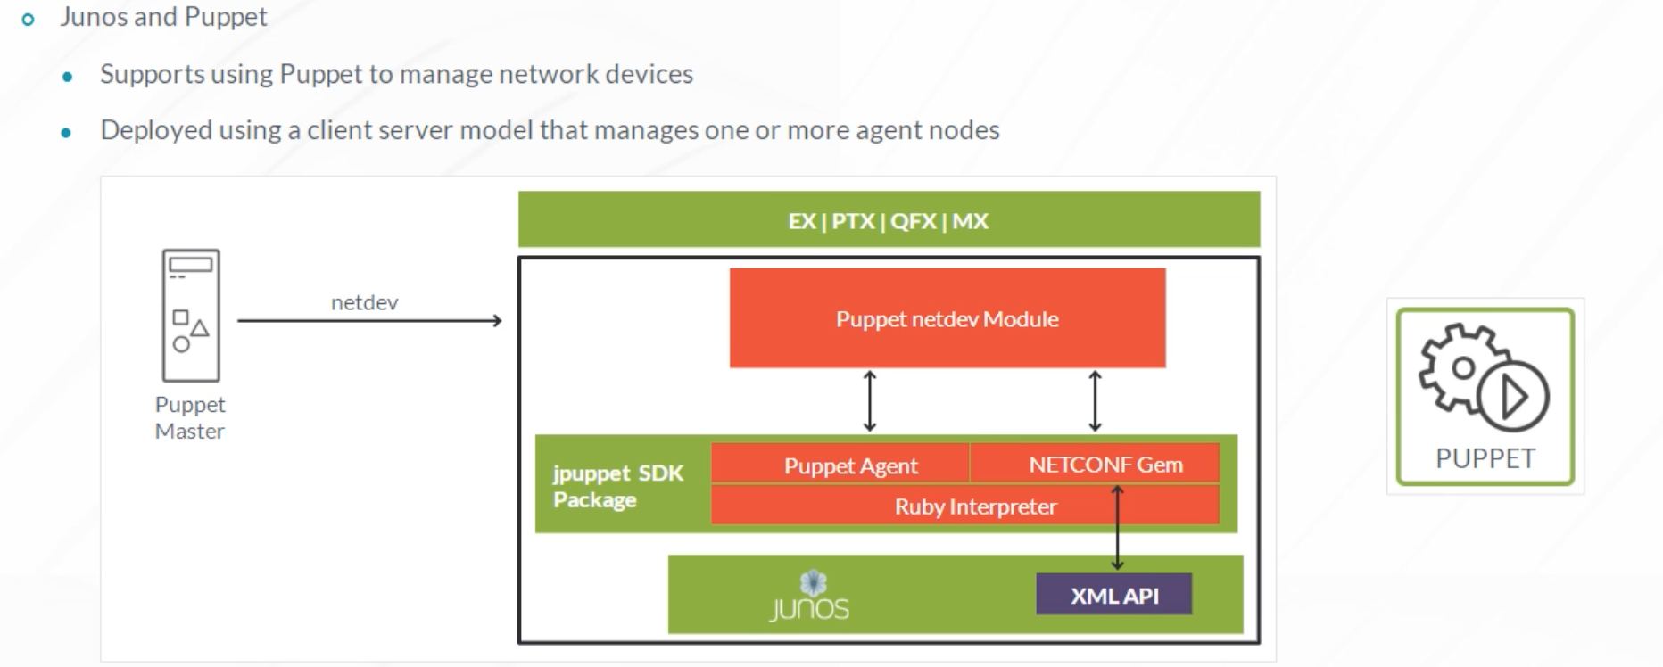

The client process or Puppet agent runs on each of the managed resources. Puppet’s manifest files describe the desired system configuration. The Puppet server compiles the manifests into catalogs. The Puppet agent periodically retrieves the catalog and applies the necessary changes to the configuration. Puppet is based on the Ruby Programming language. To use Puppet with Junos devices, you need to install the jpuppet module on the Junos device. Documentation for Juniper support of Puppet can be found on the Juniper website.

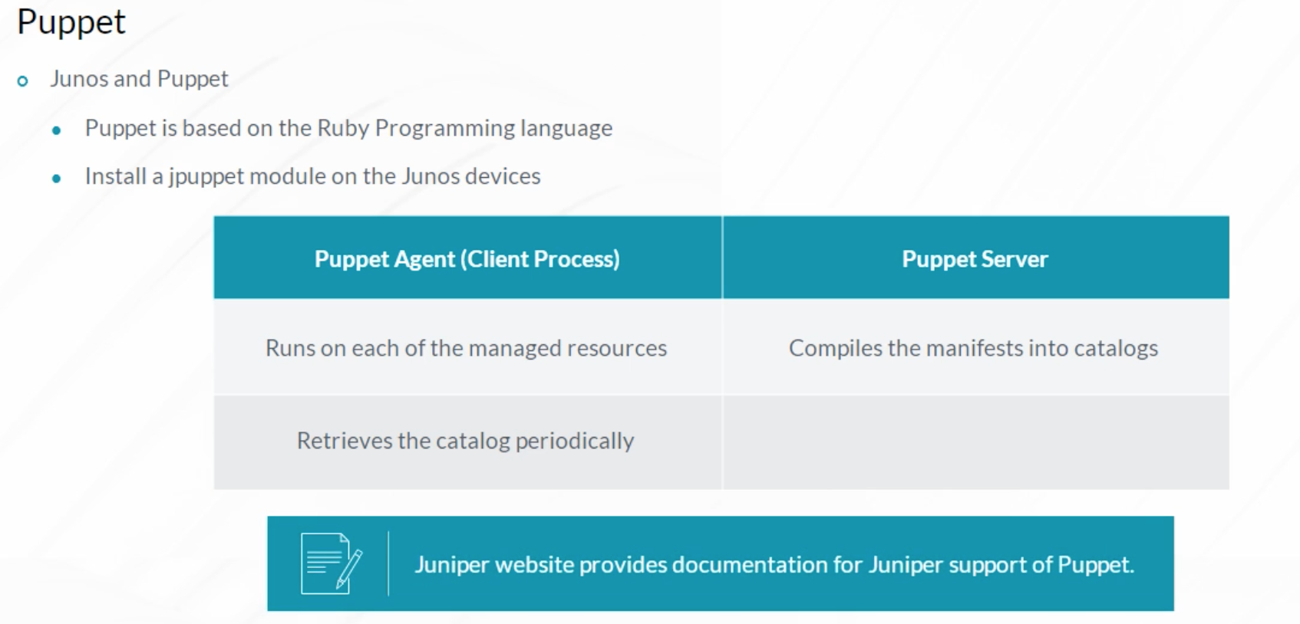

Chef automates the provisioning and management of compute, networking, and storage resources onsite or in the cloud, or both. Chef transforms code into infrastructure, enabling you to configure, deploy, and scale infrastructure in real time, and reduce the risk of human error. Chef enables you to write abstract definitions of your infrastructure in Ruby, and manage the definitions like you manage source code.

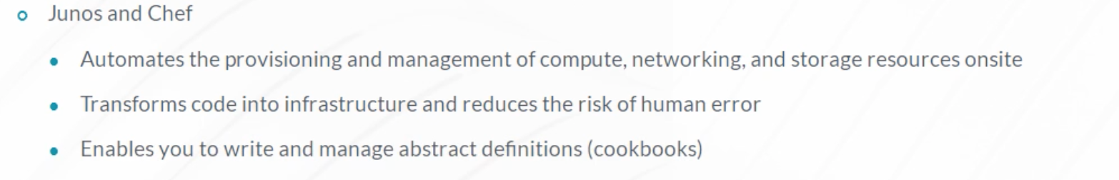

These abstract definitions, which are called cookbooks, are applied to the nodes in your infrastructure by the Chef clients running on those nodes. Chef is supported on selected Junos devices using a Chef client, that is installed on the Junos device. You can find installation and support information by searching the Juniper website.

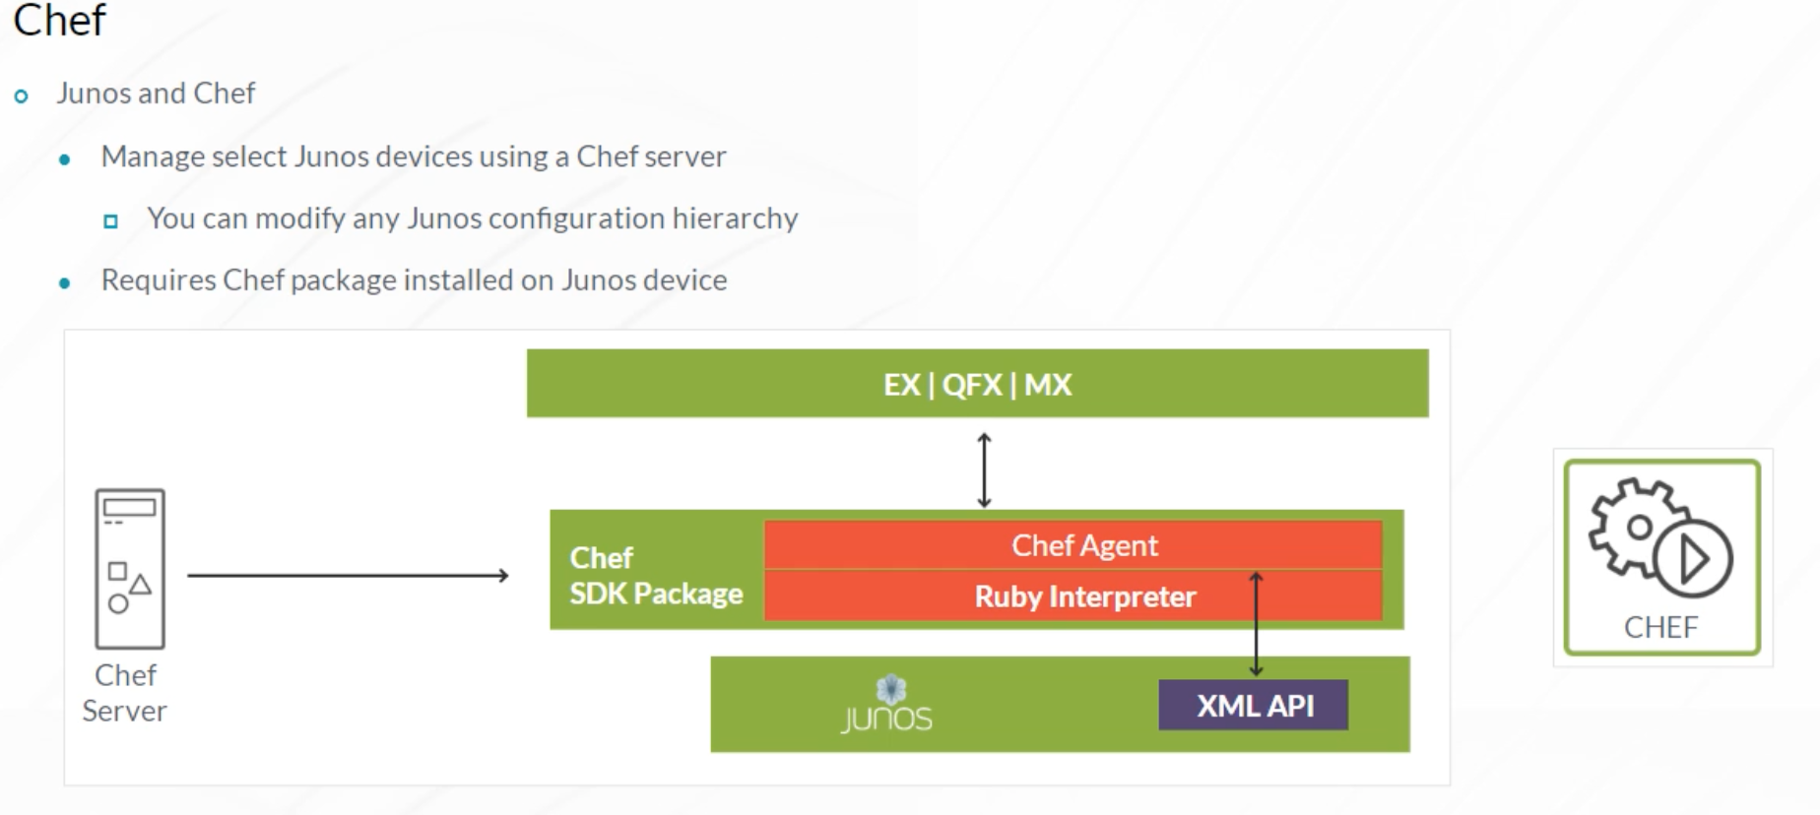

The Junos Extension Toolkit (JET) is an evolution of the Junos software development kit (SDK), that provides a modern and programmatic interface for developers of third-party Junos applications. Using JET, Junos devices can host one or more third-party applications, such as monitoring tools, on-box Puppet and Chef agents, a Git client, or even a Twitter client that generates tweets when triggered by specific device events.

JET contains tools that aid in programming the Junos control plane. The Junos control plane has always been programmable, but JET makes it easier and faster. Customers can use JET to create customized CLI commands and SNMP MIBs, instead of waiting for Juniper to add the functionality to the Junos OS. The flexibility of JET broadens the ability of Junos to meet market demands for Juniper and customers.

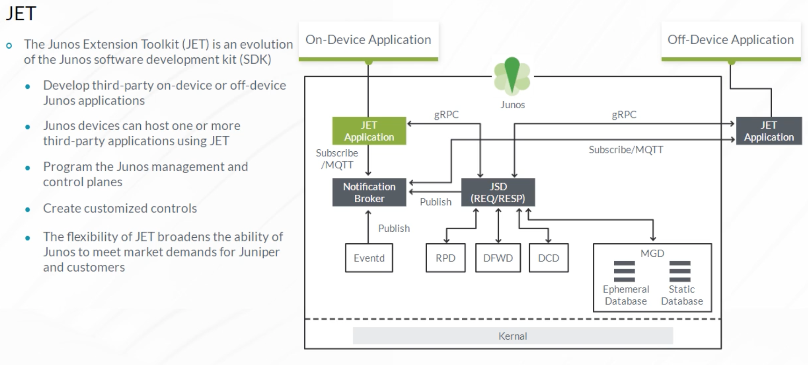

All communication generated using the CLI, NETCONF, and the Representational State Transfer (REST) API pass through the management (mgd) process. An additional automation process is available in Junos called the JET Service process (jsd). The jsd process aggregates the individual APIs belonging to the Routing Protocol Daemon (rpd), the Firewall Filter Daemon (dfwd), and other Junos processes, and exposes those APIs with a consistent look and feel. It exposes the same APIs that Juniper programmers use for internal development and provides another set of APIs to use for automation. Remote procedure calls that utilize jsd are transported using the gRPC protocol instead of NETCONF.

Some of the benefits of the JET APIs include faster commit times, improved device telemetry, and a wider range of possible languages available for automation.

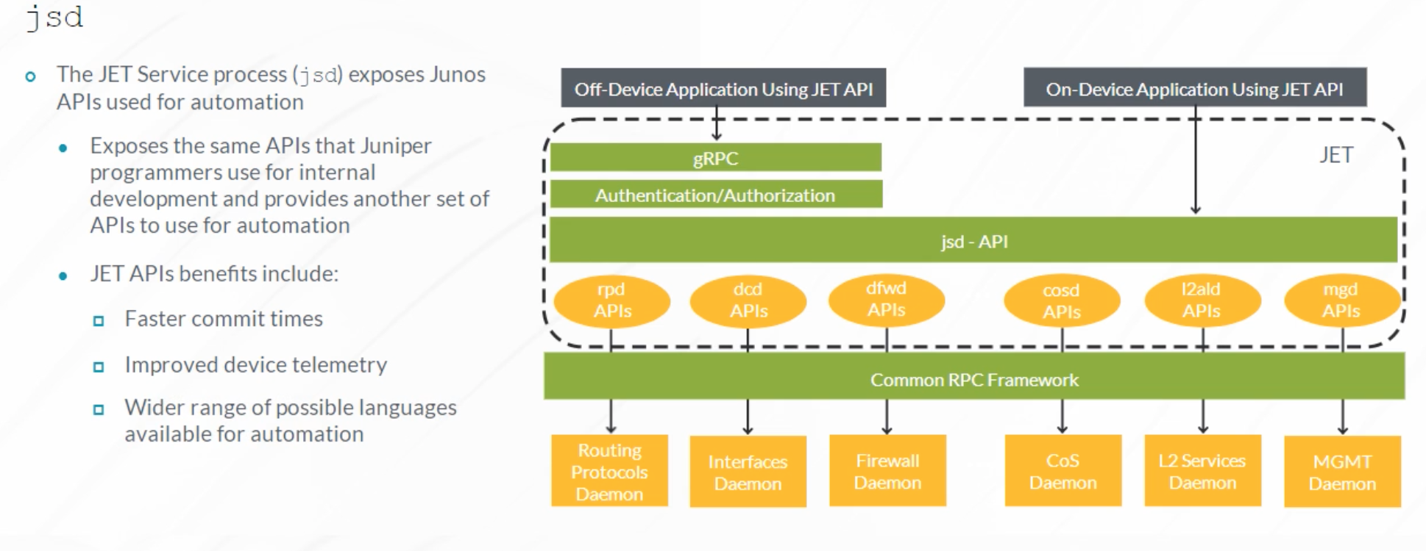

JET supports multiple programming languages for off-box application development. On-Box JET applications can be developed in Python, C, or C++. If an application that you plan to develop has a dependency on C or C++ modules or the application needs to be signed, then you can use the JET virtual machine provided by Juniper to develop the application. As mentioned earlier, JET uses gRPC, an RPC framework, as a mechanism to provide the request and response service. The gRPC server is part of the jsd process.

To keep up with the rapid configuration changes that automation systems can generate, the JET includes the Fast Programmatic Configuration feature, which is often referred to as the Ephemeral database. The Ephemeral database can commit over 1,000 configuration changes per second. To reach this magnitude of commits per second, commits are not validated. This means that you need to ensure that the app is pushing a valid configuration.

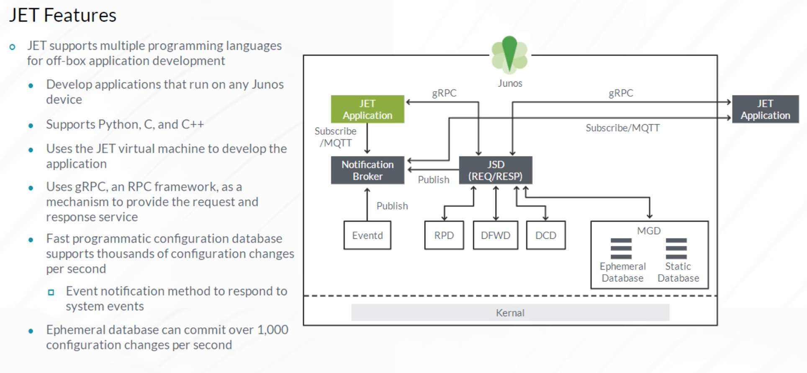

Junos Snapshot Administrator in Python (JSNAPy) captures and audits runtime environments of network devices running Junos OS. It automates network state verification by capturing and validating the status of a device. It takes pre-modification and post modification snapshots and compares them based on provided test cases. JSNAPy can also be used to audit the runtime environment of a device against pre-defined criteria. JSNAPy is an open-source project, and the source code is available on the Github website. You can access the website from the Reference Links document.

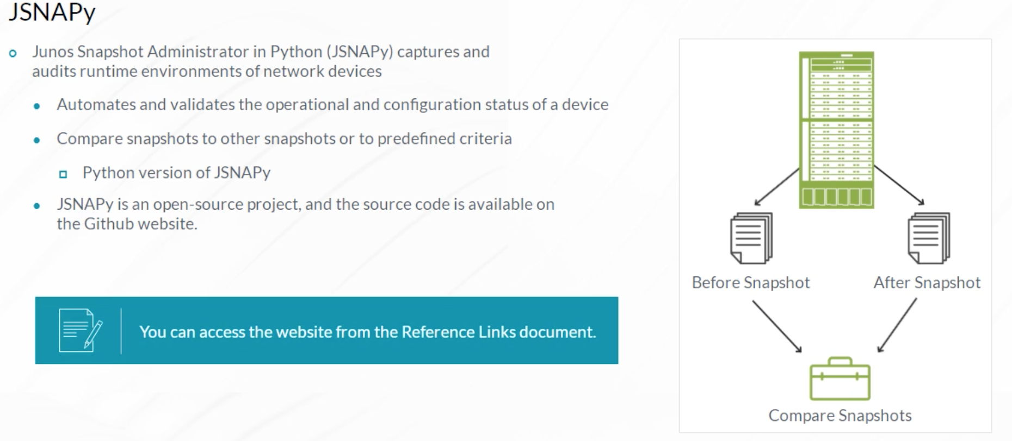

Zero-Touch provisioning (ZTP) enables you to setup new devices in your network without manual intervention. When you connect a device to the network and boot it with a default configuration, it attempts to upgrade the Junos OS software and load a pre-existing configuration file from the network. The device uses information that you configure on a Dynamic Host Configuration Protocol (DHCP) server to determine whether or not to perform these actions and to locate the necessary software image and configuration files on the network. If you do not configure the DHCP server to provide this information, the switch boots with the pre-installed software and default configuration.

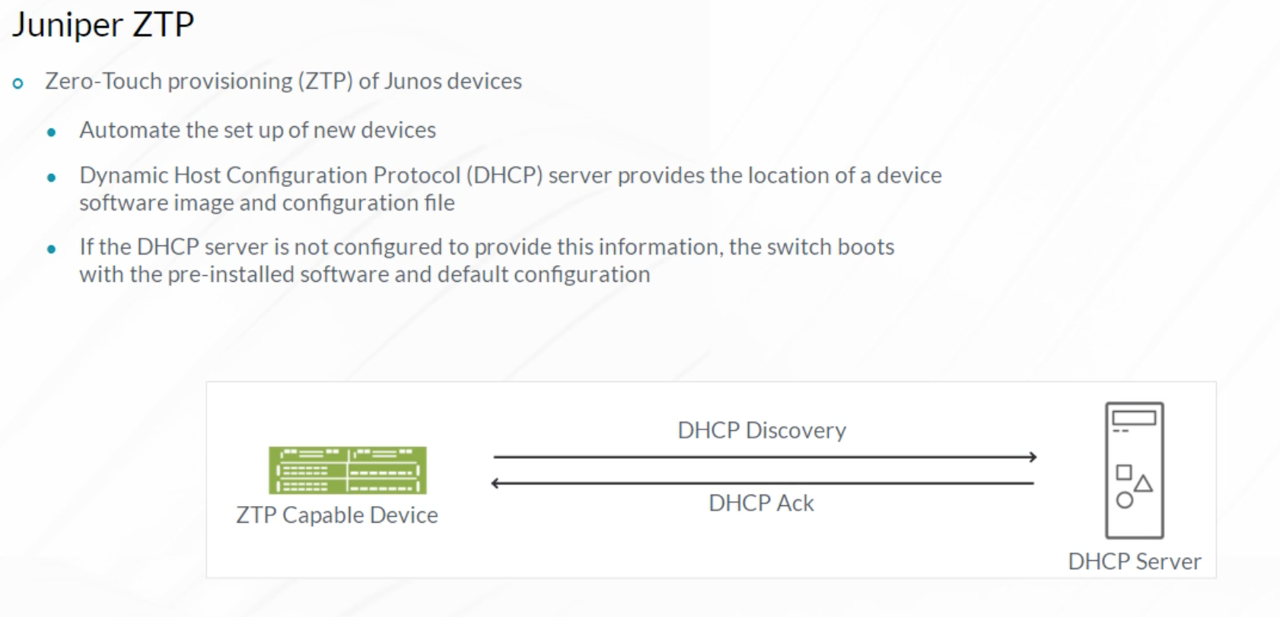

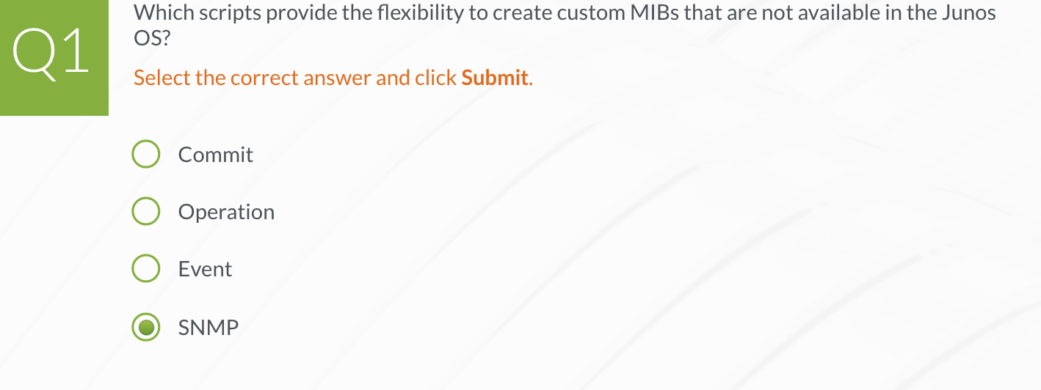

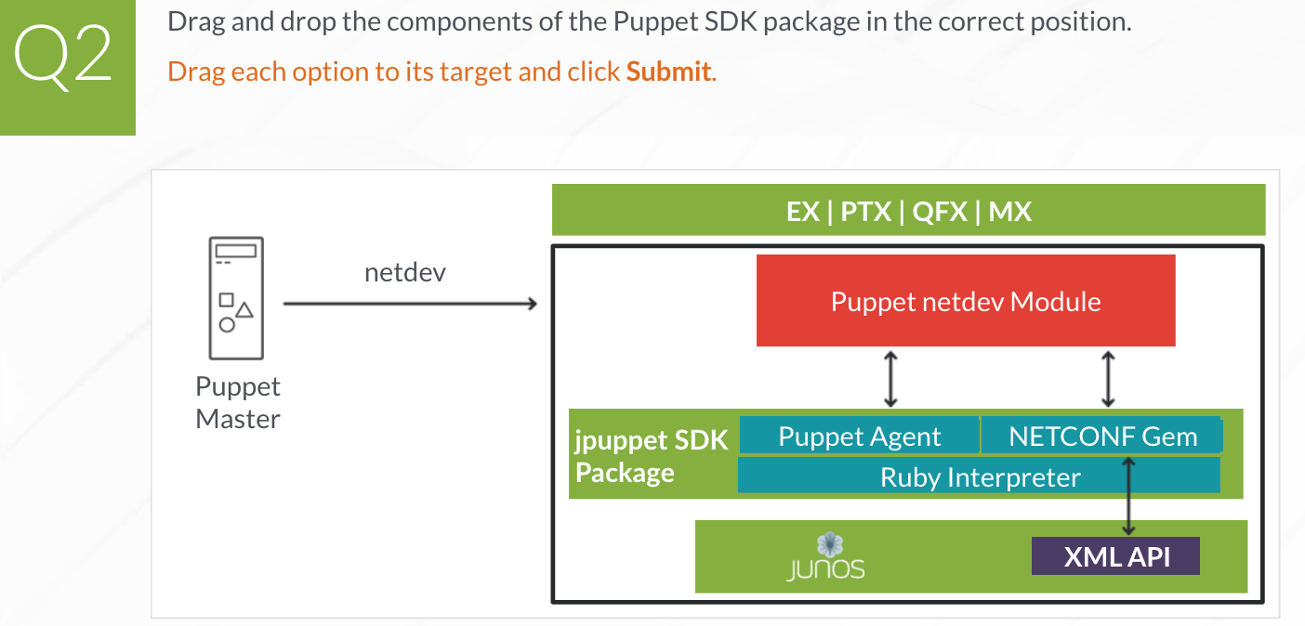

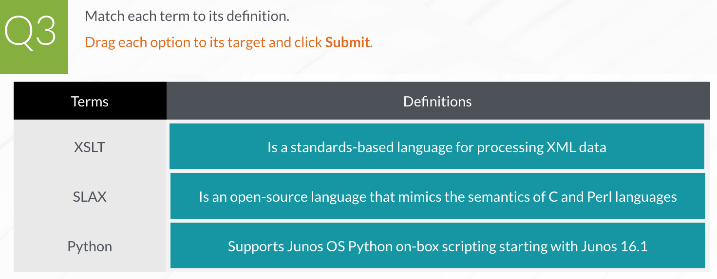

1. **XML and XPath**

**XML Document Format**

XML is a standards-based way of structuring and communicating data. It was developed by the World Wide Web Consortium (W3C). Many Junos OS automation tools make extensive use of XML to exchange data. Both the Junos OS CLI and the Junos OS infrastructure communicate using XML.

When an operational mode command is entered in the Junos OS CLI, the CLI converts the command into XML format for processing. After processing the command, the Junos OS returns the output in an XML document, which the CLI converts back into a readable format for display. Remote Junos OS automation applications can use XML-based data encoding to perform operational and configuration operations. The Junos OS XML API provides an XML equivalent for all statements in the Junos OS configuration hierarchy and most operational mode CLI commands. Each operational mode command with a Junos OS XML counterpart maps to a request tag element and, if necessary, a response tag element.

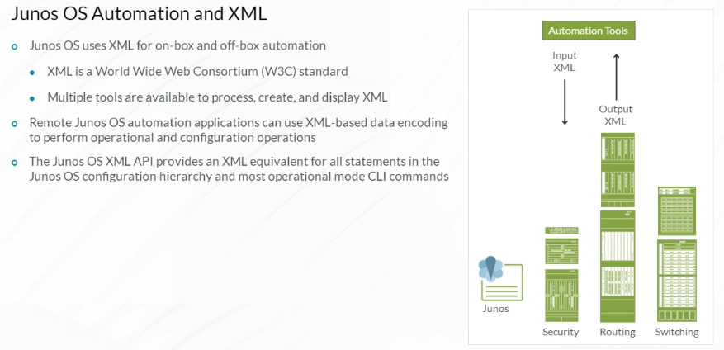

XML is a standards-based way to structure and communicate information. It looks similar to HTML because it uses tags in a similar fashion. XML tags communicate information about the data contained between the tags. XML documents are strictly hierarchical, so opening and closing tags showing the start and end of the data, to which an XML tag applies, must always be present. This is not always true in HTML. XML data representing the course name between opening and closing tags is shown. The XML data is formally identified as a text node, while the full construct including the tags is an element node.

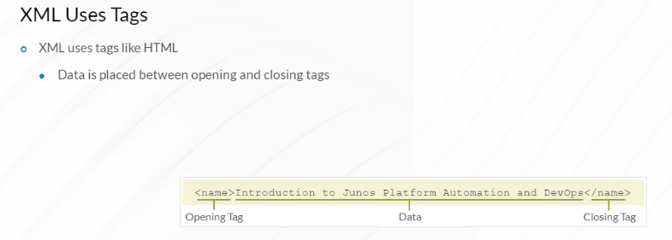

This example shows two methods that are used to represent a level of an XML hierarchy when no data is present. In some cases, there is no data to put between the opening and closing tags for a particular level in an XML hierarchy. In this case, you can combine the opening and closing tags using XML shorthand notation.

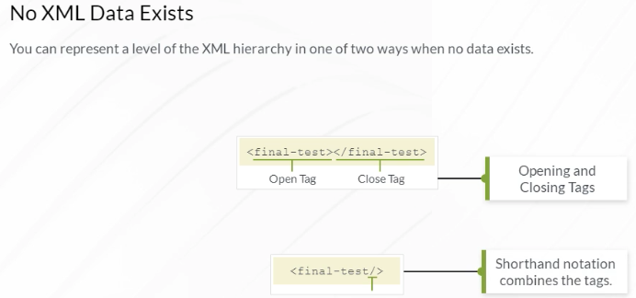

The beginning of an XML document that represents the course name is shown. The root level of the document is an element node named course. All content for the course falls between the opening and closing tags.

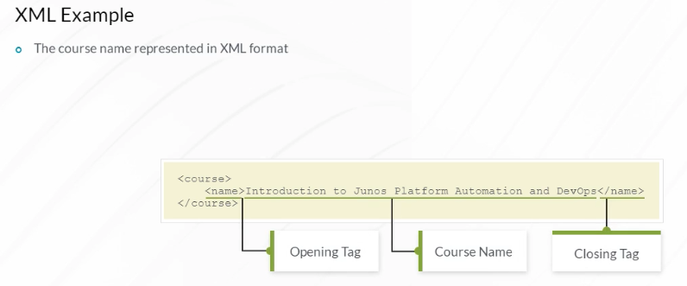

Next, a few new sections are defined in the XML document to organize the course modules.

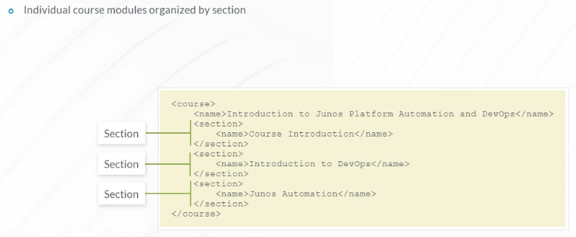

Next, a few subsections are defined. As you can see, using XML, you are able to represent the hierarchical structure of the course. You can add extra information to any of these elements and also, add extra elements.

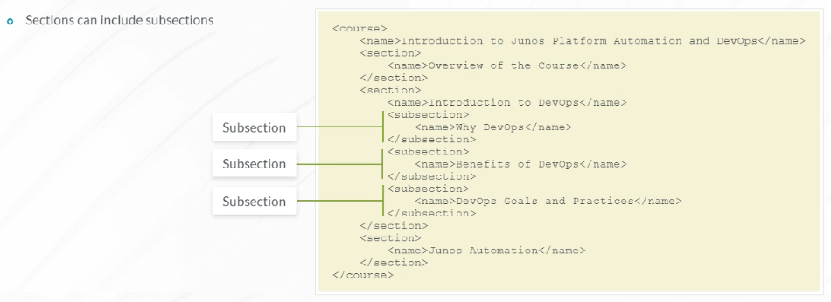

XML namespaces are used to guarantee uniqueness for element names and data values in an XML document. An XML document namespace is defined using the xmlns attribute. Defining a unique document namespace is recommended because XML document data is commonly collected and merged into larger data sets and applications. Each document’s unique namespace greatly reduces the probability of an element name or element value collision when the data is merged. In the example XML document, the <course> element node and all nodes that are within the <course> element node share the same namespace.

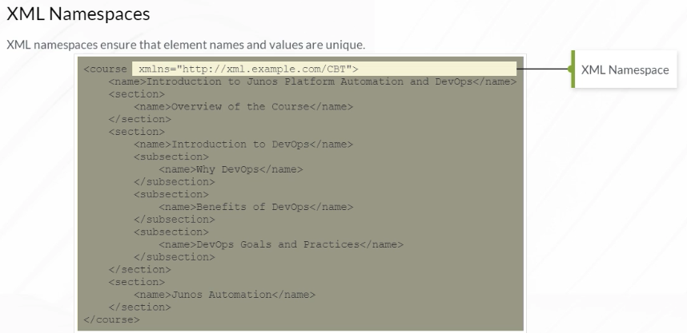

The same XML document can use elements defined using different namespaces. In the example, the main namespace is http://xml.example.com/CBT. But, anything beginning with the graphics: identifier uses a different namespace, defined as http://xml.example.com/GRAPHICS.

Anyone using the XML document can identify which elements use which namespaces.

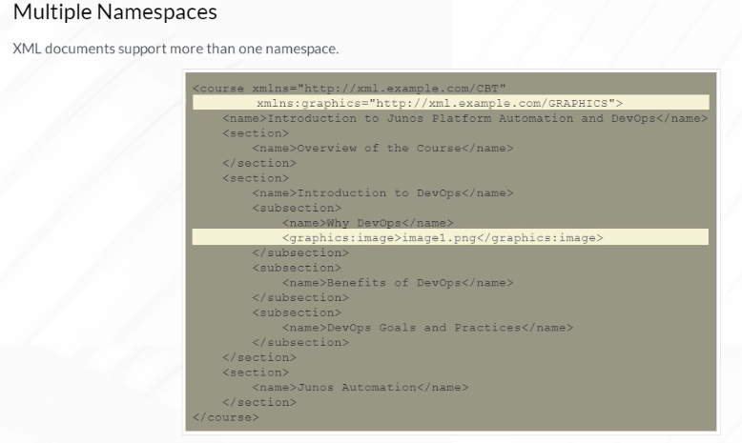

People like the flexibility of XML and use it to represent all types of data using their own unique XML data structures. With this flexibility comes a question–, if any type of data can be organized in an XML hierarchical structure, how do computers or people know how to interpret the XML document? An XML schema definition (XSD) document is a file that ensures that everyone working with an XML document is using a standard set of tags to communicate information. The XSD is what makes the XML document meaningful. XSD, like XML, is a standard developed by W3C. XSD documents are themselves XML documents using a specific structure defined in the W3C standard.

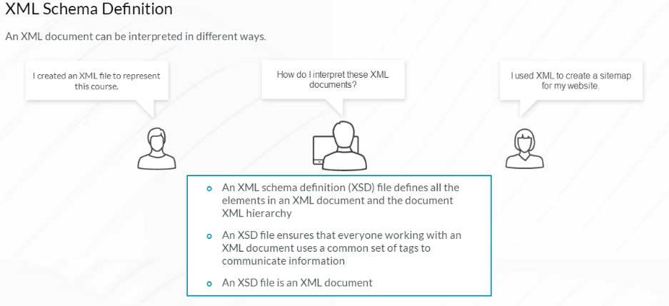

An example of a simple XSD file is shown. You can see how complex XML type rootType is defined, containing a sequence of elements named device-name, interface-count, and date-created. Each element type is defined to be either a string, an integer, or a date. Using the XSD file in the example, a valid XML document matching the XSD file contains a root element named root, with nested elements device-name, interface-count, and date-created. Of course, many other documents that use the same schema definition can also be created.

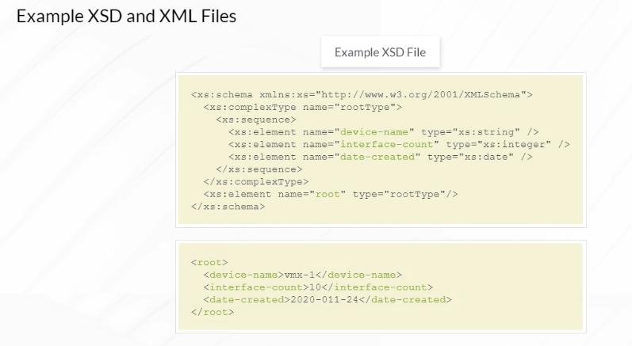

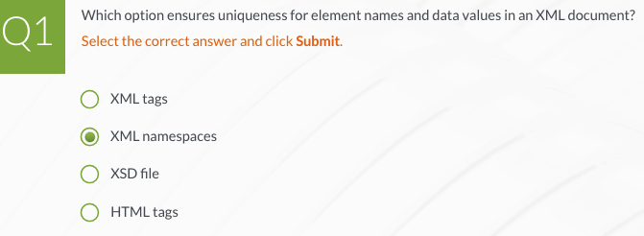

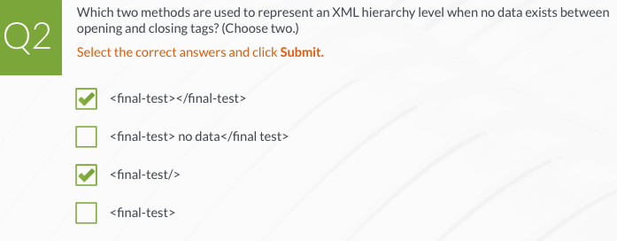

**XML in the Junos OS**

The Junos OS CLI communicates with the underlying Junos OS infrastructure using XML. The Junos OS software natively supports XML for configuration and operation of the device. Junos OS administrators can leverage this fact to interact with Junos OS software using scripts, automation systems, and other tools.

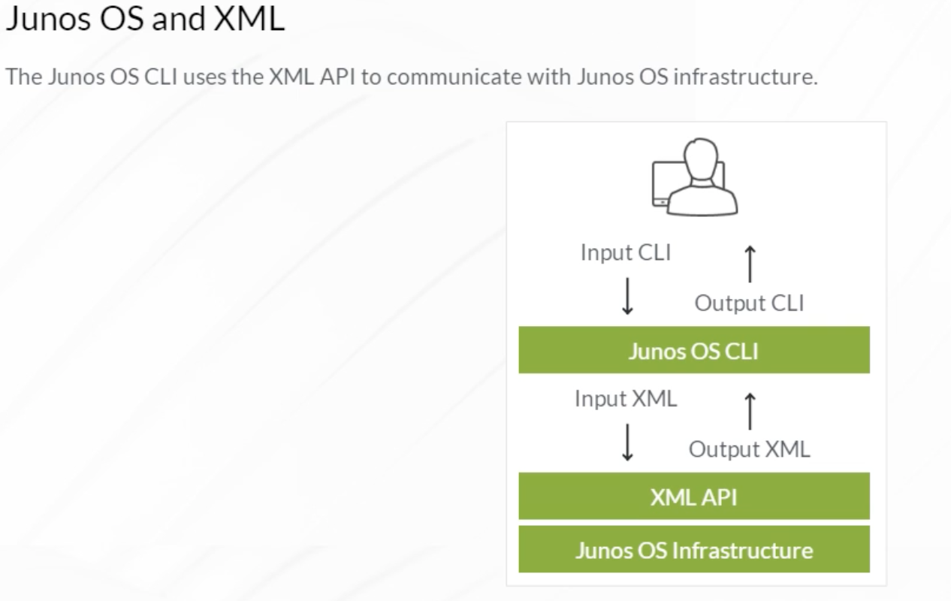

When you are using the Junos OS CLI, you are using a program that makes requests to the Junos OS Infrastructure. The communications between the CLI and the Junos OS Infrastructure are translated to XML. In the example, you can see the **show route active-path** command converted to a request in the form of a short XML document. You can use the **| display xml rpc** modifier in a CLI command to see the equivalent XML Junos OS remote procedure call. The element within the <rpc> and </rpc> tags is the actual Junos OS remote procedure call (RPC).

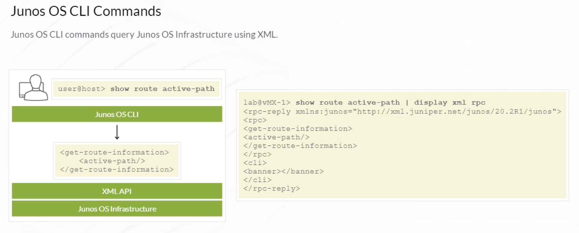

The Junos OS Infrastructure returns the requested information to the Junos OS CLI process in the form of an XML document. The Junos OS CLI process then transforms the XML into plain text and displays this information to the user in standard Junos OS CLI format.

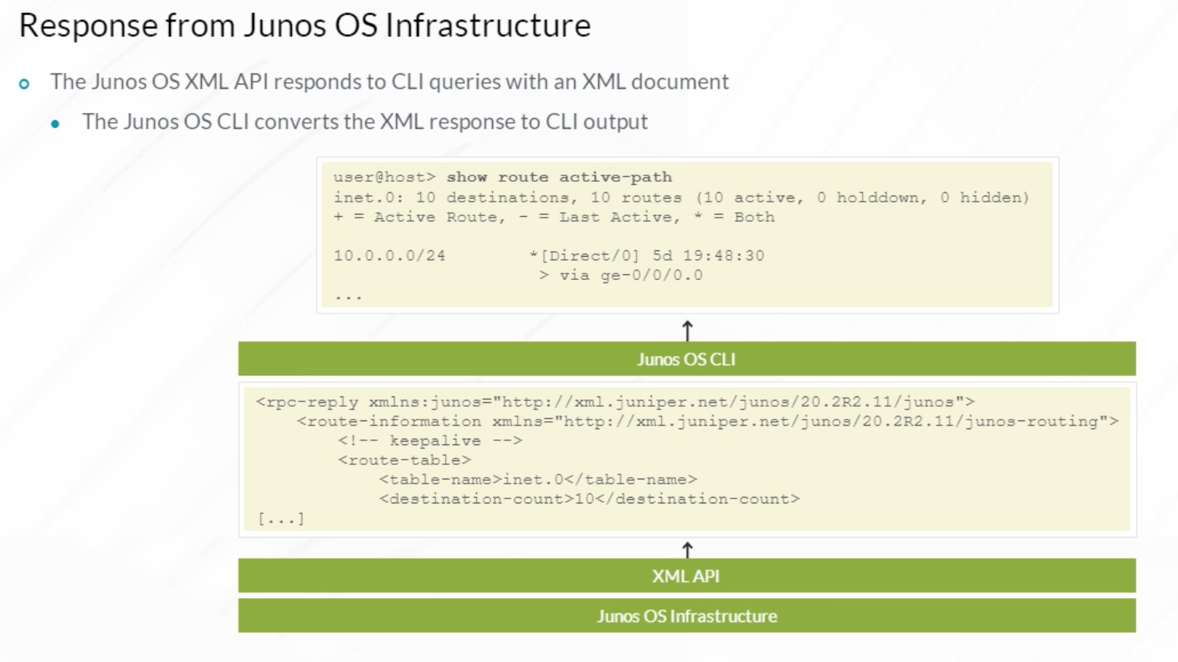

You can see the original Junos OS Infrastructure XML response to a Junos OS CLI command by using the **| display xml** modifier at the end of a Junos OS CLI command.

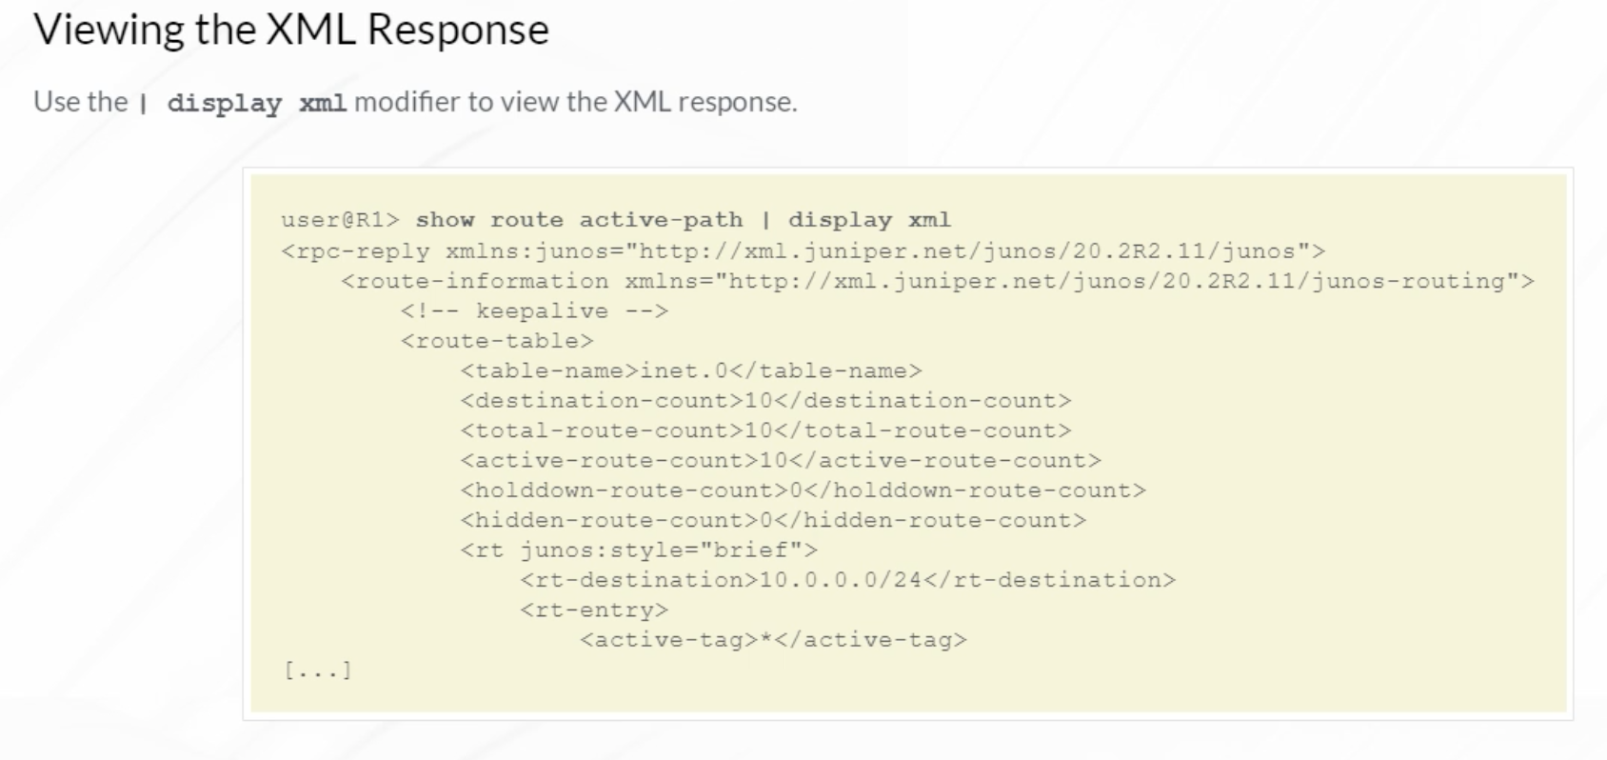

The Junos OS configuration can also be represented in XML. To view a device configuration in XML format, use the **show configuration | display xml** command. The example shows a portion of the Junos OS configuration displayed in XML hierarchical format.

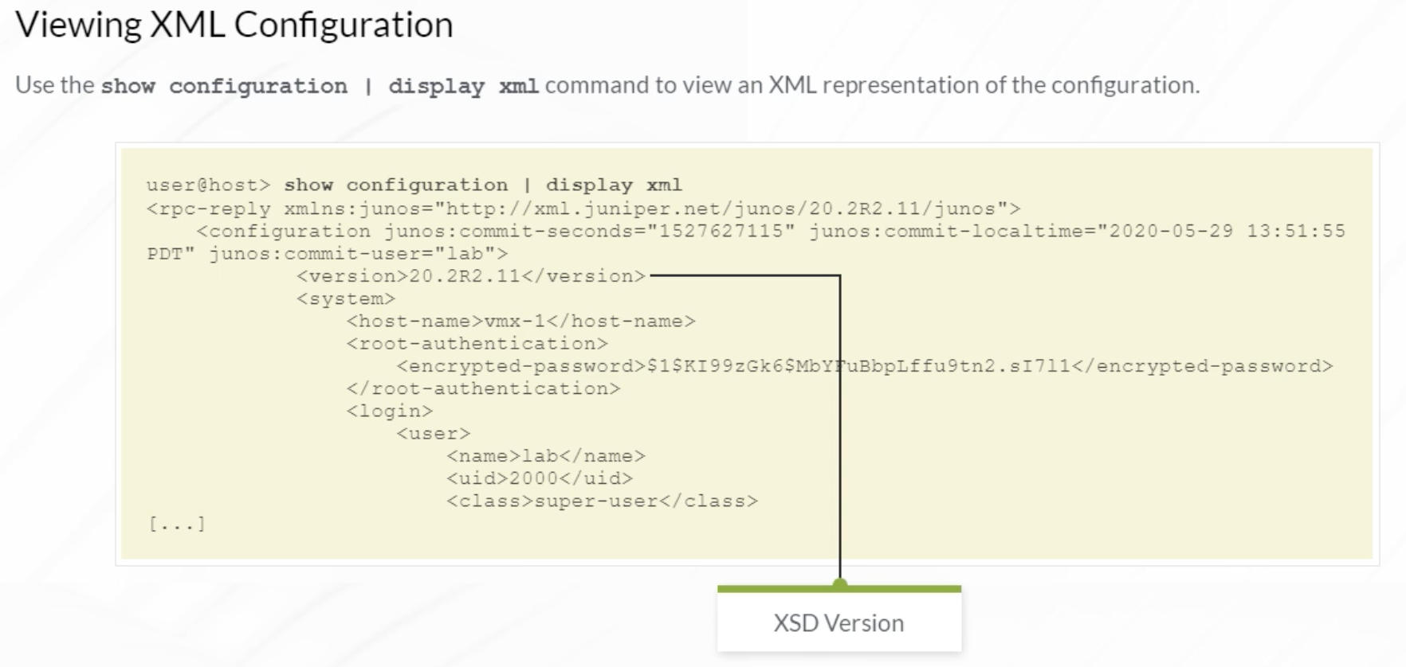

Junos OS XML schema definition (XSD) files, that define all possible device configuration options and all operational commands and their output, are published for every Junos OS release. Archived XSD files can be downloaded from the Junos OS XML API download site. Juniper releases two files for each Junos OS release, for example, for Junos OS version 20.2, the config-20.2.xsd file, which contains the configuration XSD and the operational-command-20.2.xsd file, which contains the operational data XSD. Use the schema for the version of Junos OS that you are running. The configuration XSD can be generated from a Junos OS device.

Using a Network Configuration Protocol (NETCONF) session with a Junos OS device, and an XML document similar to the example, an XML schema language representation of the entire configuration hierarchy can be generated. The XML document contains a <get-xnm-information> tag element and the <type> and <namespace> tags with the indicated values within a tag element.

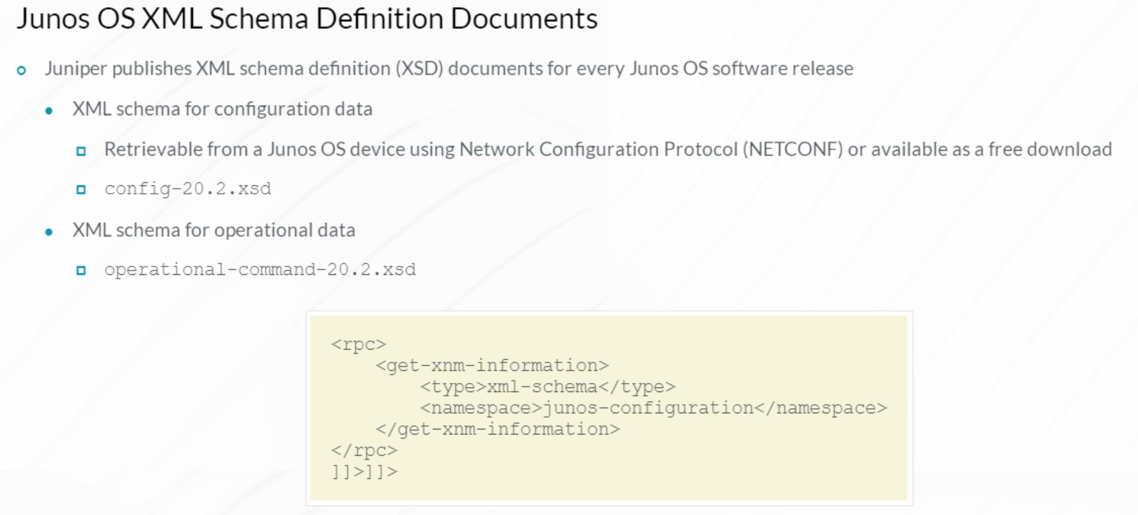

A Junos OS XML document namespace can be used to identify the version of the XSD to use to interpret an XML document. In this example, schema for Junos OS 20.2 should be used. Using a schema definition for a different Junos OS version may work when interpreting a document, but it is not the best practice.

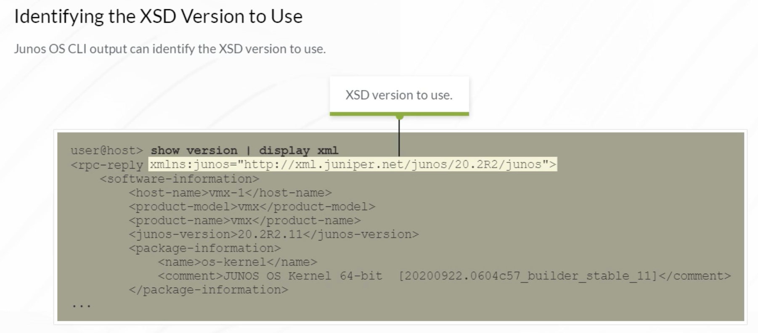

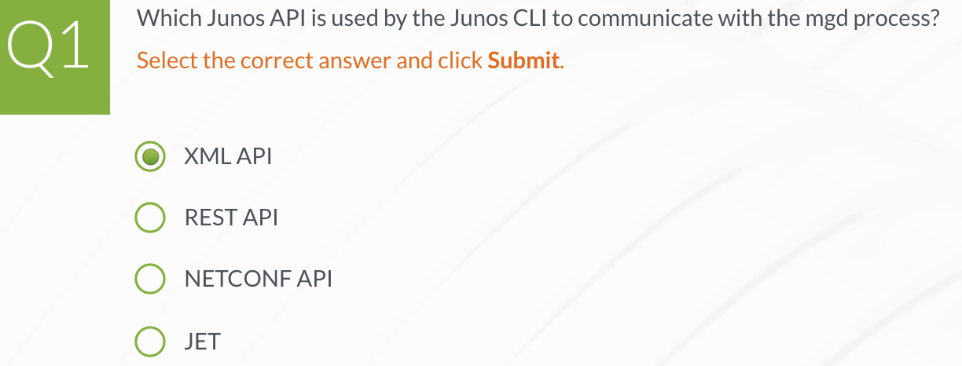

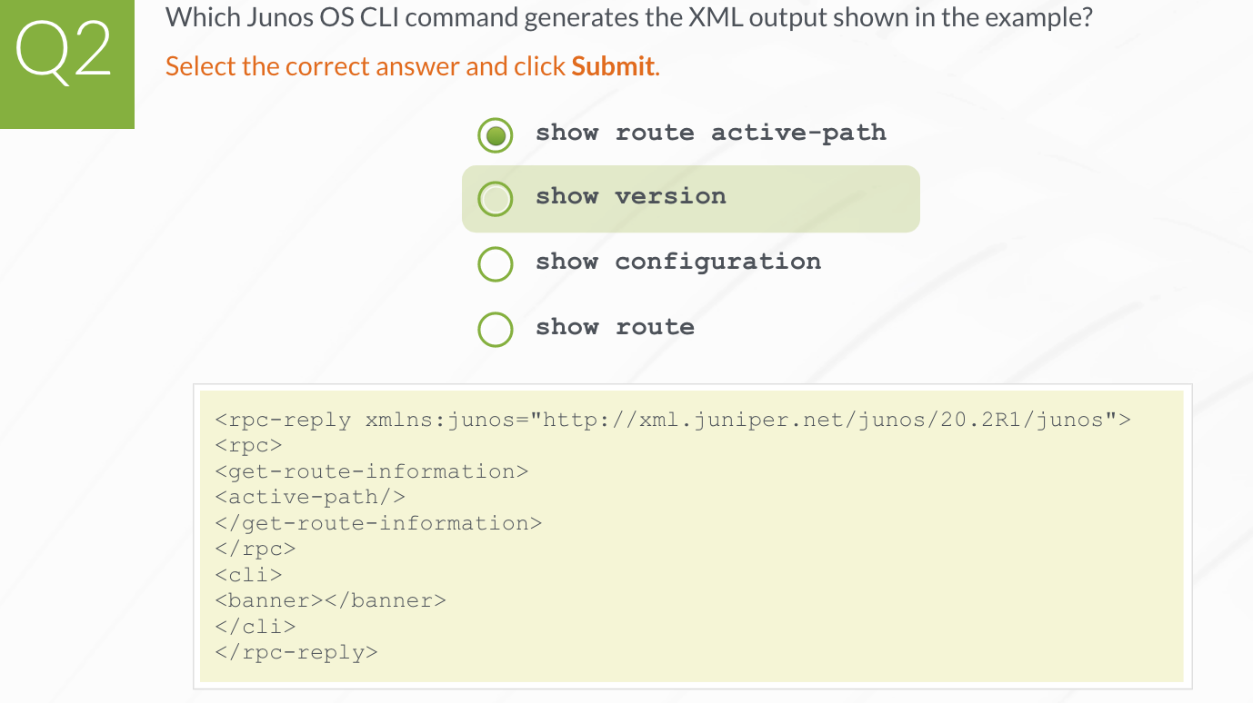

**Navigating XML Using XPath**

Because XML is applied in a wide range of use cases, XML defines a document object model (DOM) to ensure XML documents are parsed consistently. Different parts of an XML document are represented as nodes. Some common XML node types are shown here. These XML node types are explained in detail next.

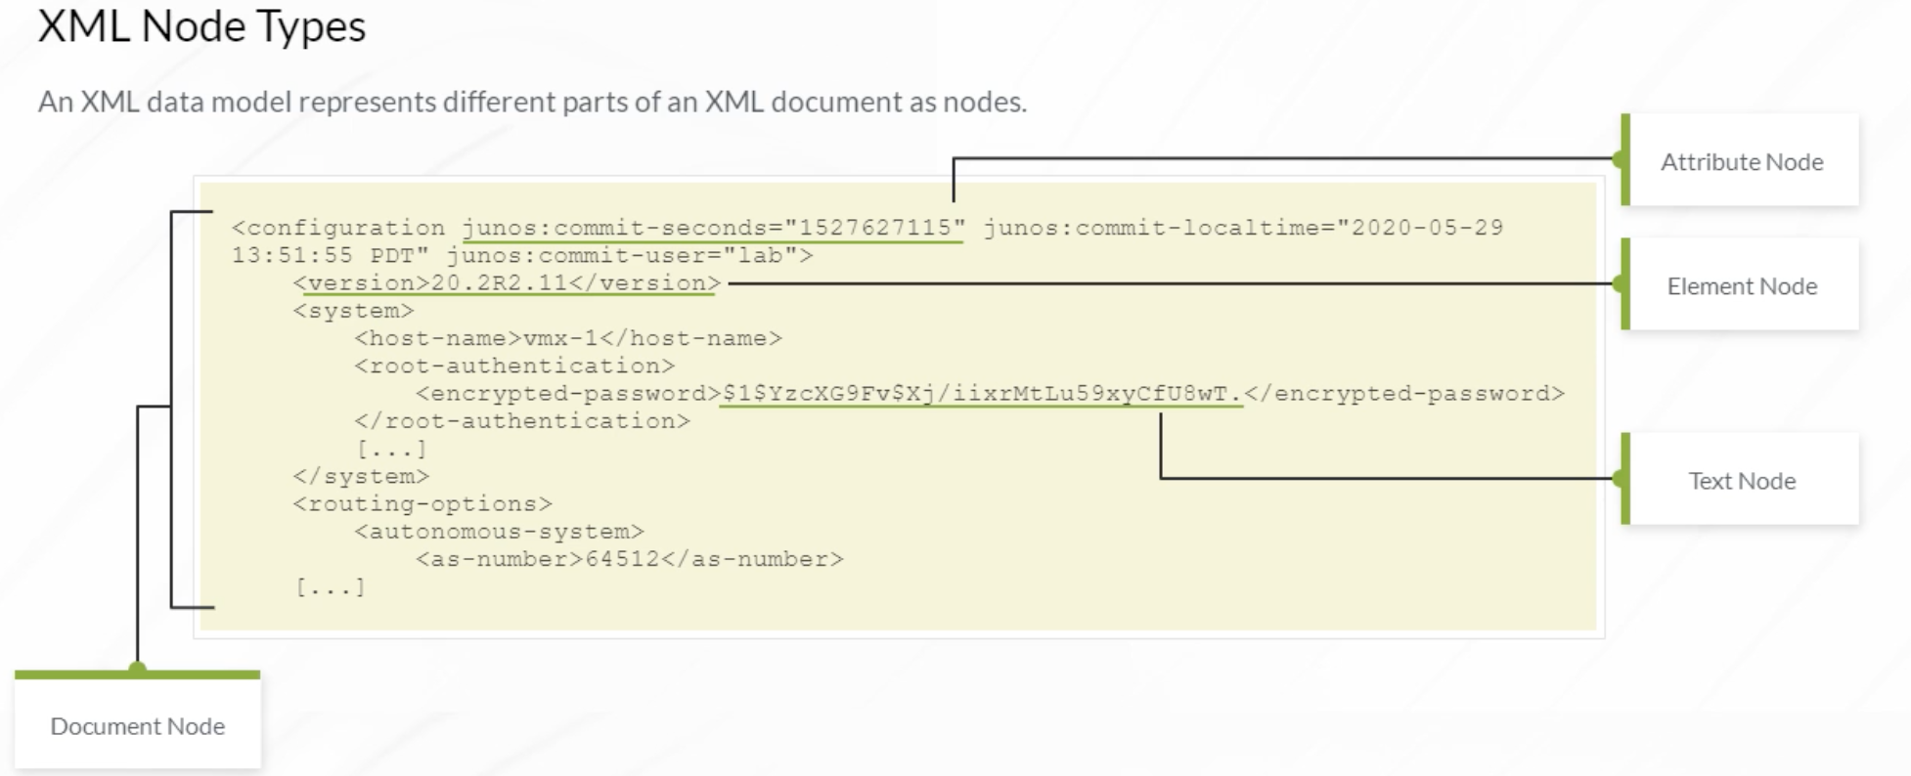

An XML element node consists of matching opening and closing tags and any data appearing between those tags. An element node may contain additional nested data including additional elements. Element nodes can be nested multiple levels deep. An XML document can only contain one root element. In this example, <configuration> is the XML document root element. A root element node is only a child element of a document node.

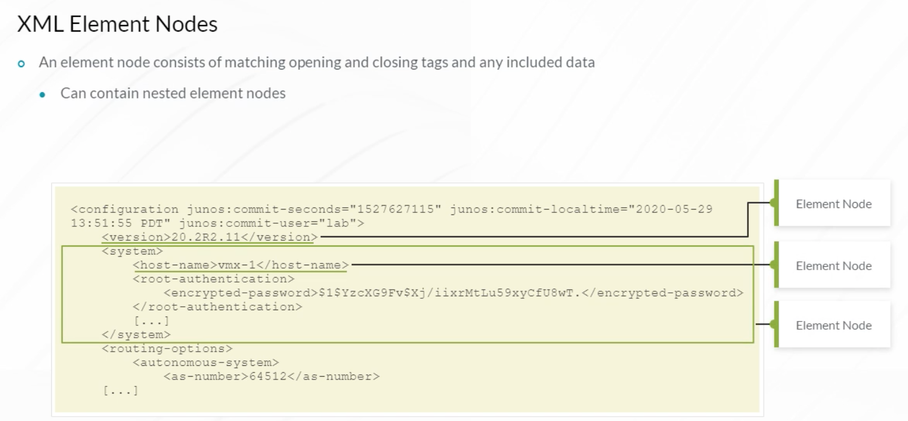

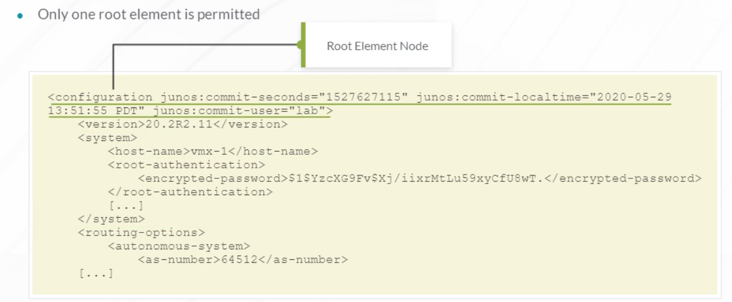

Extensible Stylesheet Language Transformations (XSLT), Stylesheet Language Alternative Syntax (SLAX), Python, and other automation programming languages that interact with the Junos OS using XML use Extensible Markup Path Language (XPath). XPath is a standard way to identify and locate elements in an XML document. XPath’s expression syntax enables you to define complex matching criteria for elements in an XML document.

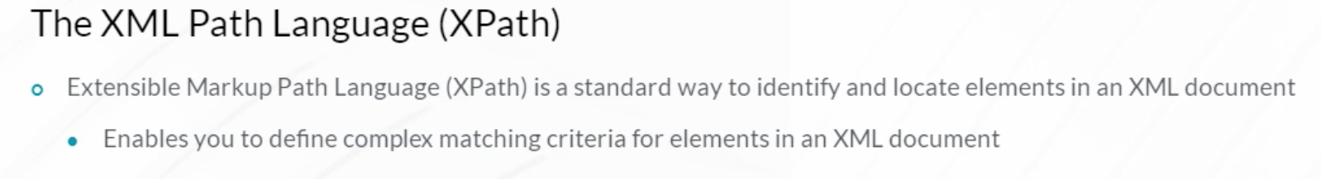

XML element nodes in XPath are viewed as being arranged along certain axes. An ancestor axis points from a node up through its series of parent nodes. A child axis points down the list of an element node’s direct child nodes. The attribute axis points through the list of an element node’s set of attributes. The descendant axis contains all the descendants of a node. A sibling relationship means that two elements have the same parent.

There are numerous other axes that are not listed here. Each XPath expression is evaluated from a particular node, which is referred to as the context node (or simply context). A context node is the node at which the language processor is currently focused. Languages like XSLT change context as a document hierarchy is traversed, and XPath expressions are evaluated from that particular context node.

XPath supports standard logical operators, such as AND and OR, comparison operators, such as =, !=, <, and >, and numerical operators, such as +, -, and *.

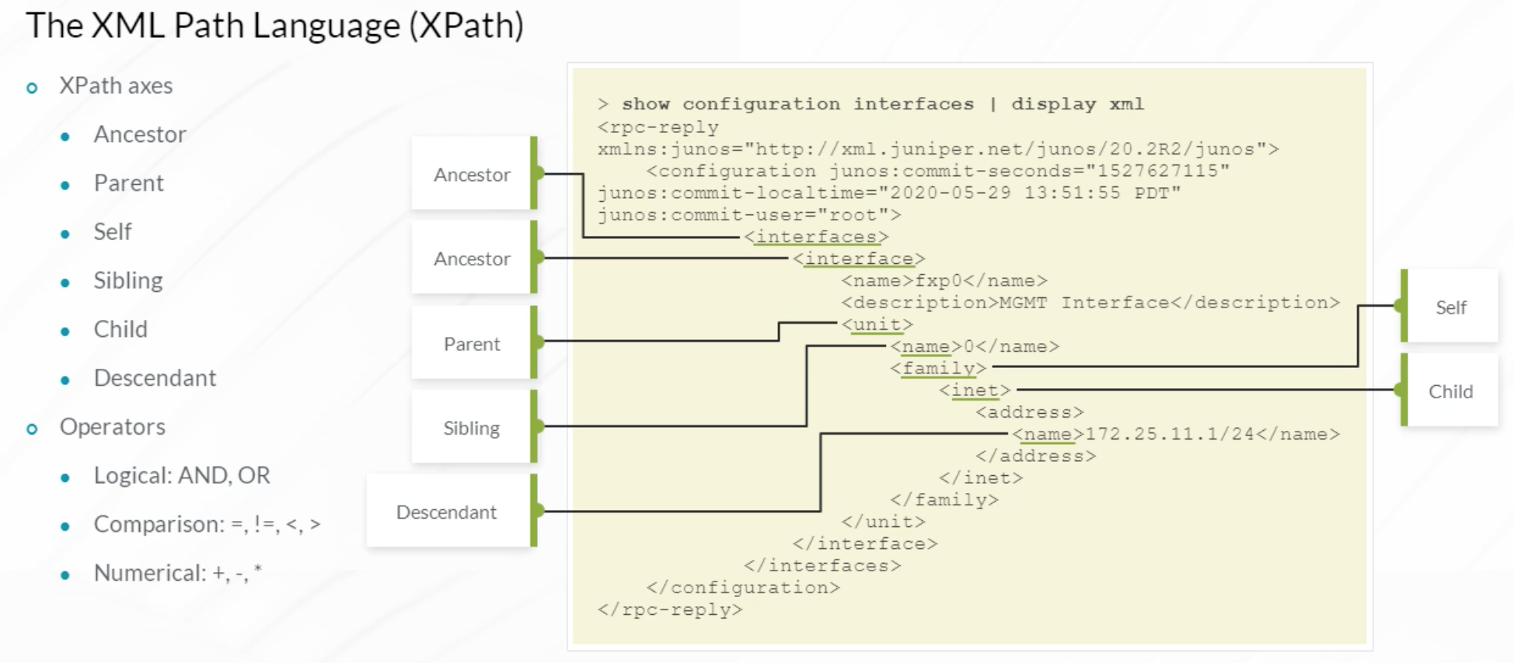

Many automation tools and programming languages enable you to select XML nodes using XPath syntax. An XPath expression contains two types of syntax—a path syntax and a predicate syntax. XPath path syntax specifies which nodes to inspect in terms of their path locations on one of the axes in the document’s hierarchy. You identify the XML node to access by specifying each level of the node’s location in the XML hierarchy separating each hierarchy level using a forward slash. The method is similar to the way you specify the path to a specific file system directory on a UNIX host.

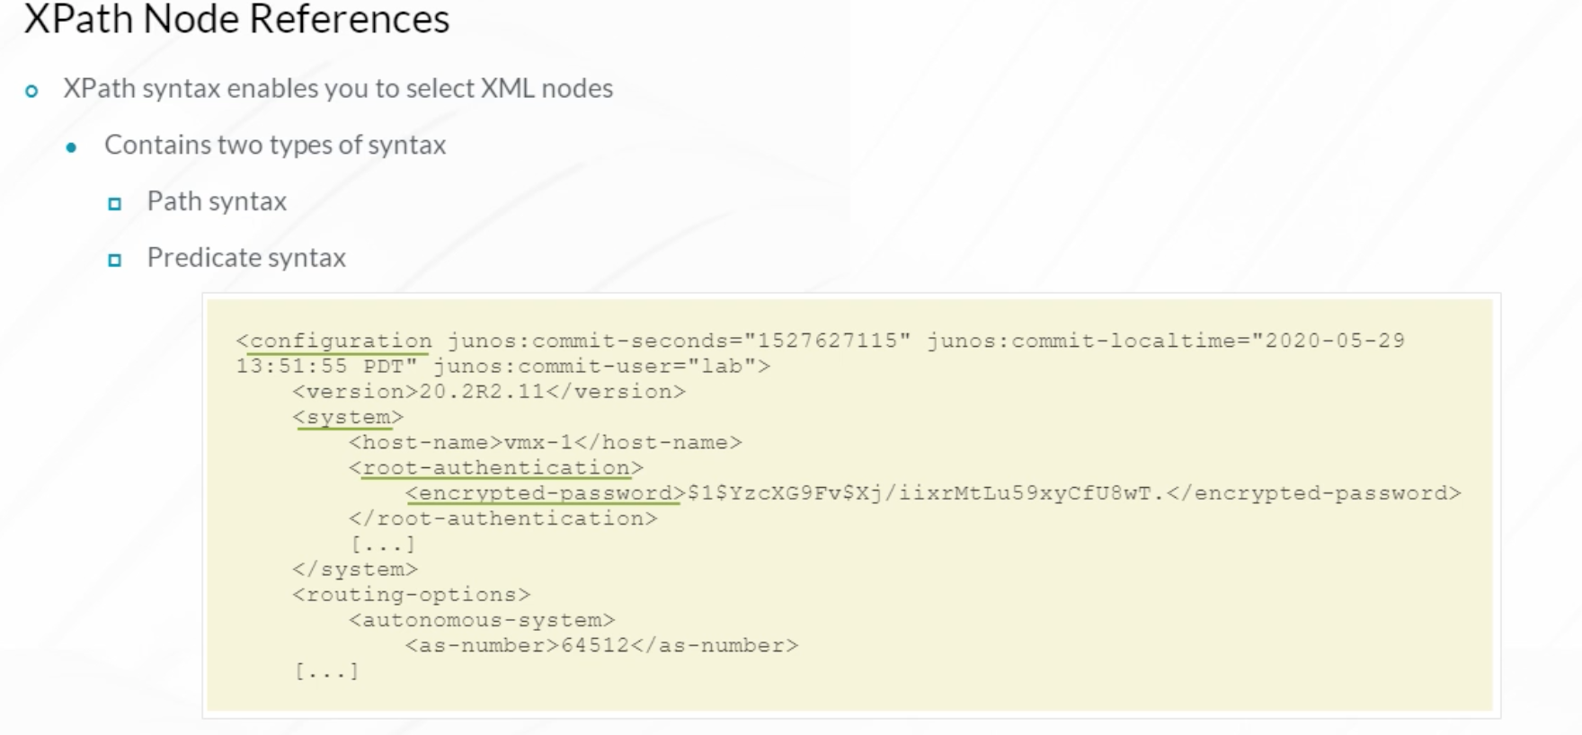

The XPath example references the encrypted-password element. Because the XPath starts from the root of the hierarchy (/), which is a document node, it is called an absolute path. XML also supports using relative paths (paths originating from the node you are currently examining). For example, if you are currently at the configuration node and want to access the root password data within the encrypted-password element, you could specify an XPath of system/root-authentication/encrypted-password.

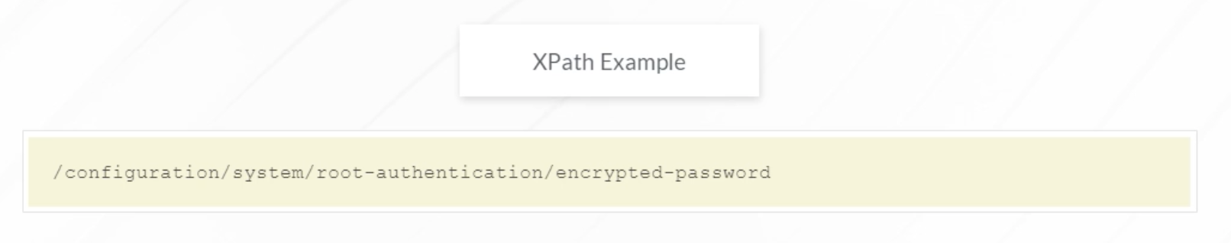

If a Junos OS automation script is already examining the configuration/system node, you can identify data directly below that XML hierarchy level using a relative path like root-authentication/encrypted-password. You can also refer to a parent node by using ../ notation.

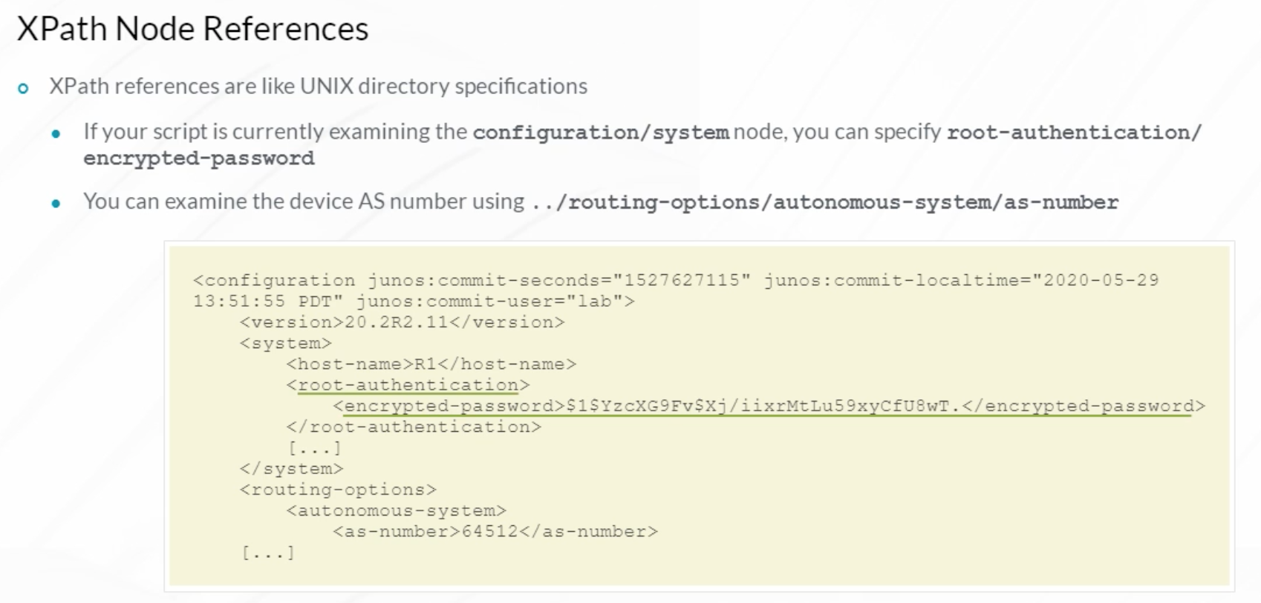

Sometimes there is more than one element at the same hierarchy level with the same name. For example, in the XML output displayed, there are two user accounts. If you want to retrieve the lab user ID (UID) value, and you specify an XPath of system/login/user/UID, you cannot be assured of getting the correct user information because there is more than one user ID in the XML document.

XPath predicate syntax enables you to perform tests for each node selected by the XPath path syntax. Only nodes that pass the test are included in a result set. A predicate appears inside square brackets following a path node. Using the given example, to specify that you want the user whose name is lab, specify the name in square brackets following the user element. The syntax tells XPath to look for a user element called name with a value of lab.

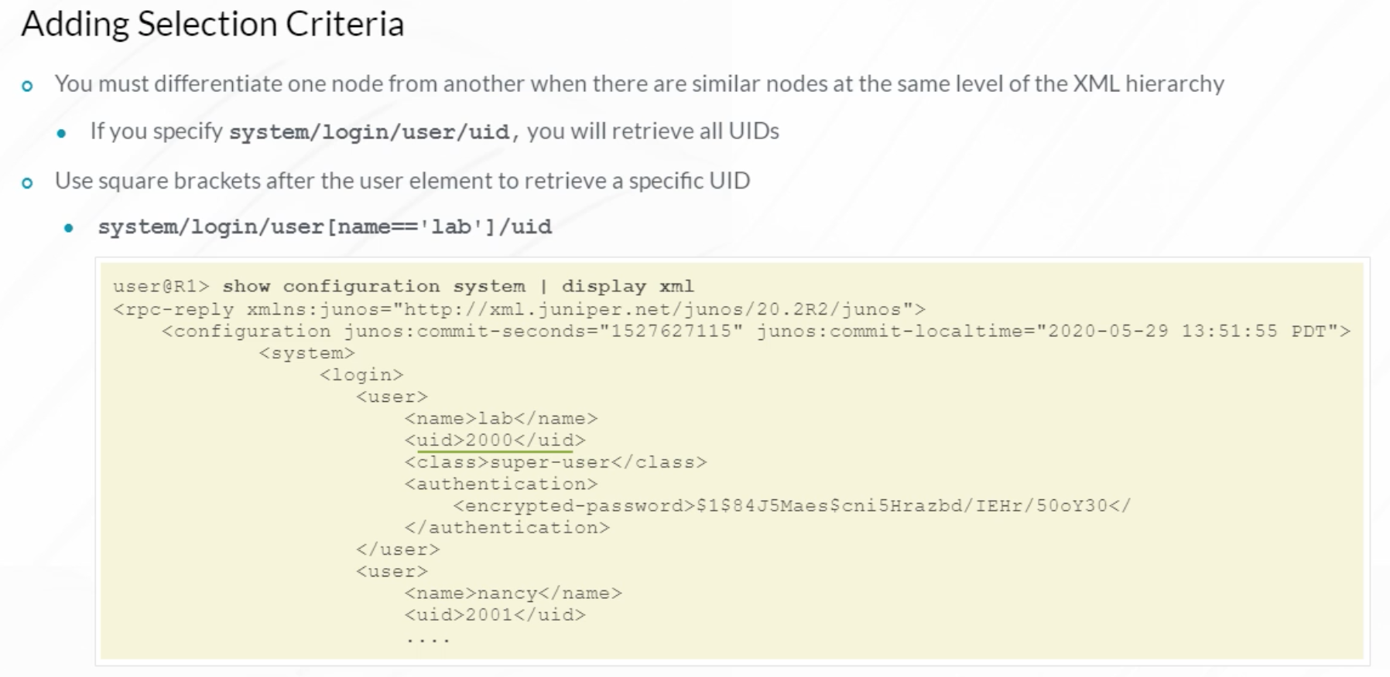

Use an @ symbol to retrieve the contents of an attribute. Attributes are the variables or name/value pairs that appear within an opening XML tag. The first example shows a name as a hierarchical element. The second example shows a name as an element attribute, and how to use an XPath expression to access the attribute.

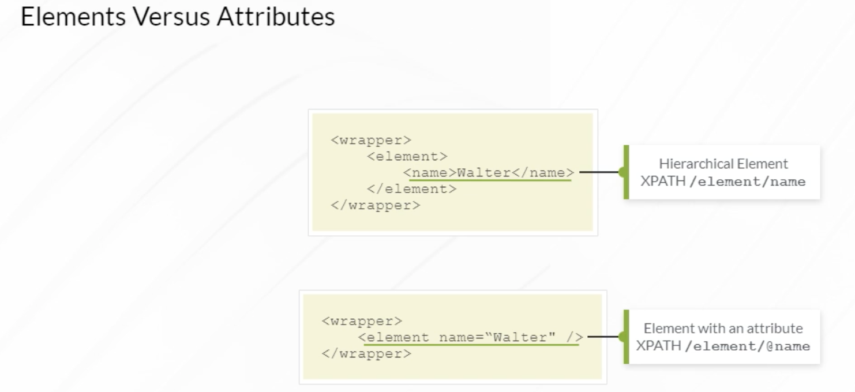

There are two important XML attributes that are commonly used in commit scripts to validate configuration changes before they are applied. Commit scripts are processed during a device commit operation. The candidate configuration in XML format is used by a commit script as input. In the XML candidate configuration, the junos:changed attribute is attached to element nodes that have changed compared to current active configuration. The example describes using XPath syntax to match on those attributes.

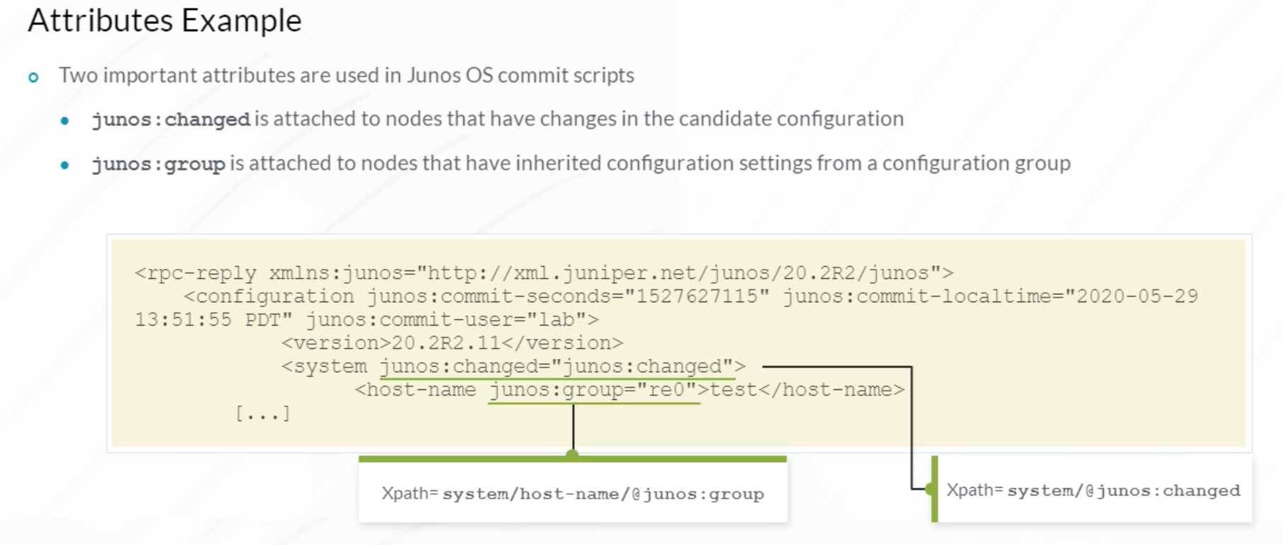

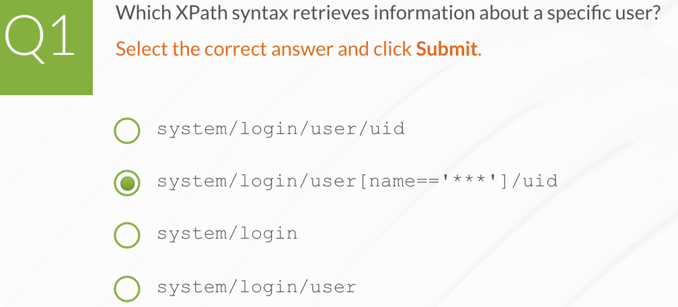

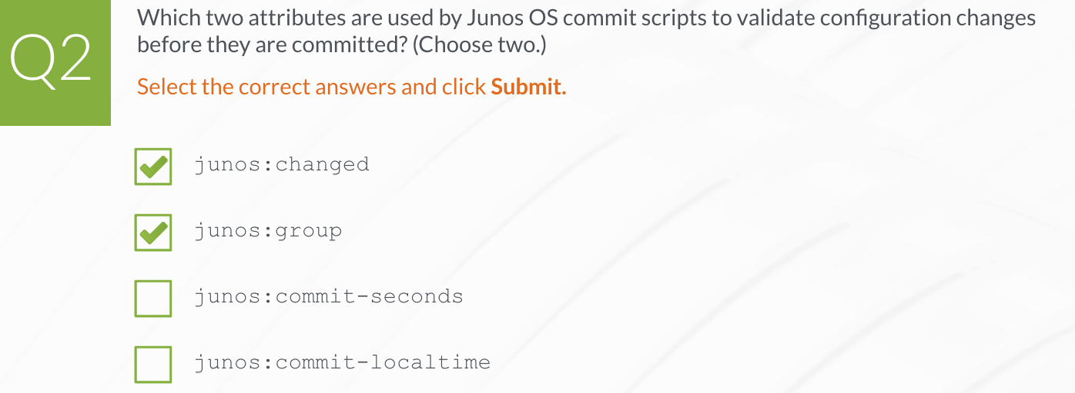

1. **XML and NETCONF**

**NETCONF**

Juniper developed the Junos XML Management Protocol, formerly known as JUNOScript, as an easy, reliable method of automating Junos devices.

After using and improving JUNOScript for several years, Juniper worked with the IETF and shared it with the broader networking community. The solution was renamed as Network Configuration Protocol (NETCONF) and first appeared as RFC 4741. Support for SSH was added in RFC 4742. These RFCs were then updated in 2011 by RFC 6241 and RFC 6242.

The real strength of NETCONF is that it is a management protocol developed specifically for networking devices. NETCONF can lock, read, modify, delete, and unlock a device configuration. It also has the ability to issue operational mode commands. Since NETCONF is an IETF standard, it is used by multiple vendors, enabling organizations to use the same protocol to manage different vendor devices.

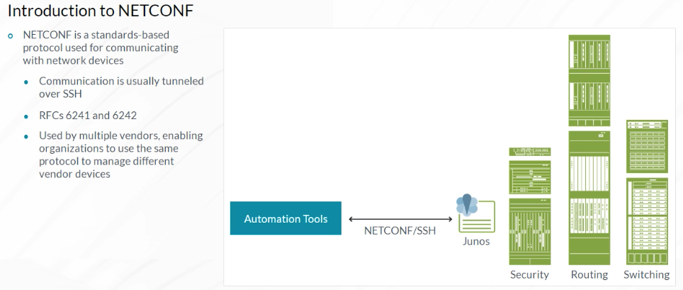

The NETCONF protocol is built specifically for networking and consists of four layers. The Transport layer is responsible for creating sessions with network devices. The sessions can be established using the protocols shown. Junos primarily uses SSH.

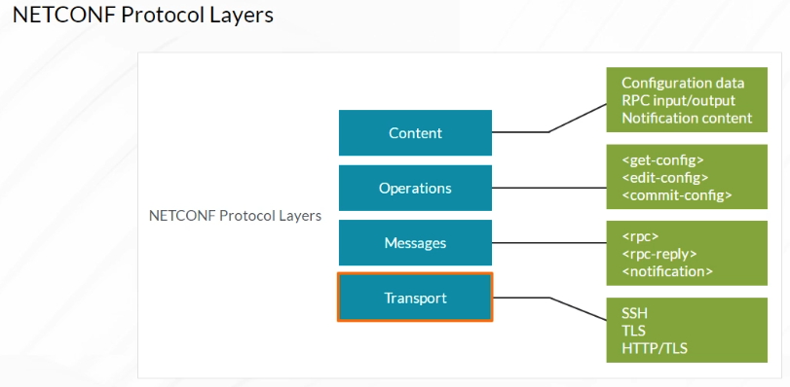

The Messages layer provides a simple, transport-independent framing mechanism for encoding remote procedure calls (RPCs) and notifications.

The Messages layer consists of three XML elements.

The <rpc> element encapsulates all RPCs sent to a NETCONF server. The <rpc-reply> element encapsulates all RPC replies from a NETCONF server including returned data and any OK, error, or warning messages. The <notification> element is a one-way message sent asynchronously to NETCONF clients that initiates a <create-subscription> RPC to the NETCONF server. When an event of interest occurs that meets the specified filtering criteria, an event notification message is generated. Refer to RFC 5277 for more details on notifications.

NETCONF messages are used in all NETCONF sessions to encapsulate NETCONF operational commands and data elements.

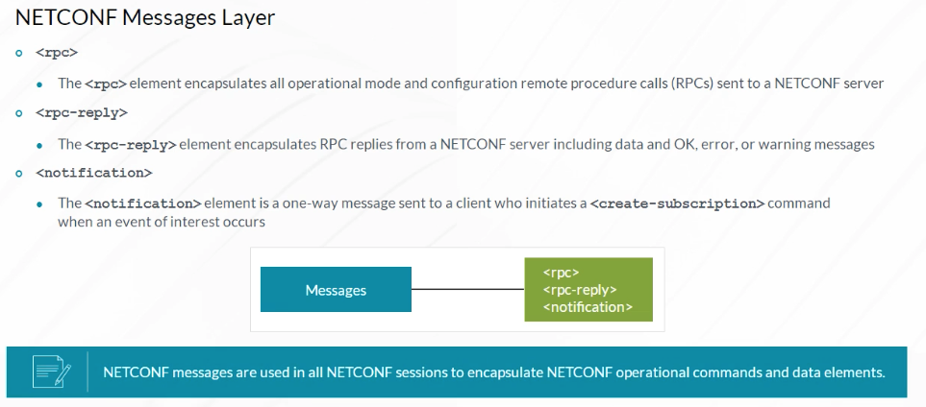

The Operations layer defines commands that are used to perform operations on a network device. These Operations layer commands are placed within one of the Messages layer tags explained earlier.

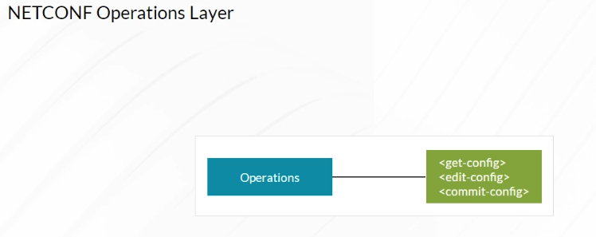

The different Operations layer commands are as follows:

•<lock>, which is used to obtain a lock on a device configuration file before modifying it,

•<unlock>, which is used to unlock a configuration after modifying it,

•<get>, which retrieves data from the running configuration database or device statistics,

•<get-config>, which retrieves the configuration from a device,

•<edit-config>, which is used to modify device configuration,

•<copy-config>, which creates or replaces an entire configuration,

•<commit>, which commits a candidate configuration,

•<discard-changes>, which rolls back a candidate configuration to the current running configuration,

•<delete-config>, which deletes a device configuration file,

•<validate>, which validates that the specified configuration can be loaded on the device,

•<create-subscription>, which creates a NETCONF subscription for notifications,

•<close-session>, which gracefully closes a NETCONF session, and

•<kill-session>, which closes a NETCONF session other than the one you are currently using.

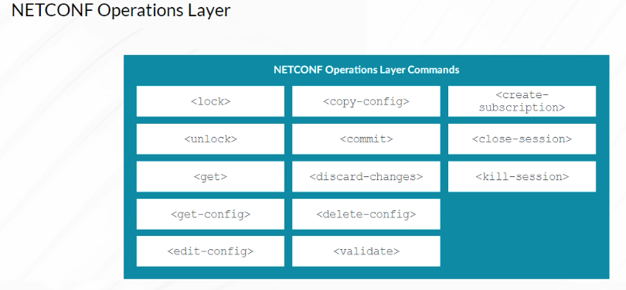

The NETCONF Content layer is where specific RPC parameters are encapsulated and sent to a NETCONF server. The XML API provided by the Junos mgd process on the server accepts and processes the incoming RPCs and generates an RPC response that is returned to the client.

The configuration data that you request from or upload to a Junos device is included in the Content layer. One good feature of NETCONF is that, other than the Transport layer that is normally encrypted using SSH, all other layers are clear text, making the protocol easy to monitor and troubleshoot.

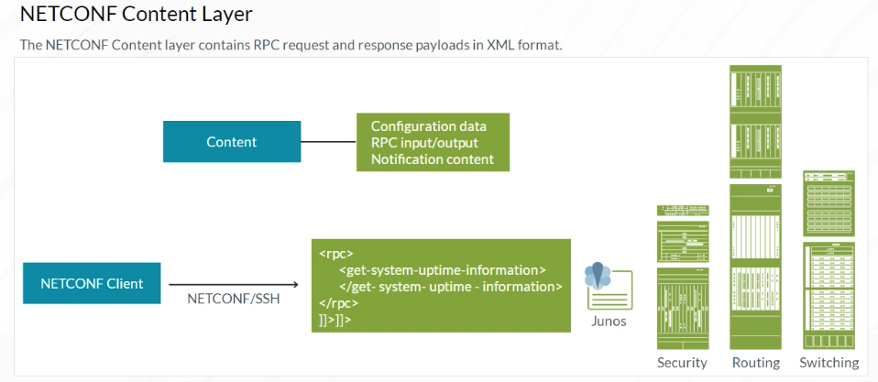

To enable NETCONF with SSH as the Transport layer protocol on a Junos device, issue the **set system services netconf ssh** configuration mode command. Junos defaults to using TCP port 830 for NETCONF over SSH connections. Some NETCONF client applications use the standard NETCONF TCP port 830 as specified in RFC 4742. To enable Junos OS to listen for NETCONF connections on port 830, issue the **set system services netconf ssh port 830** command.

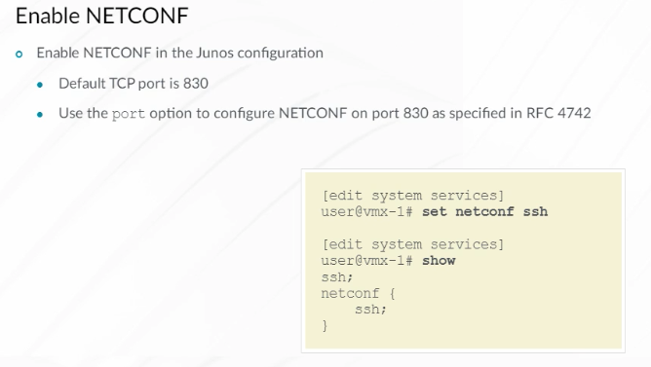

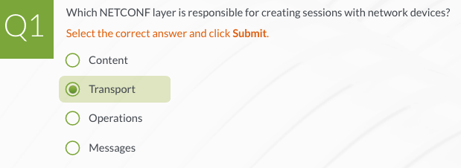

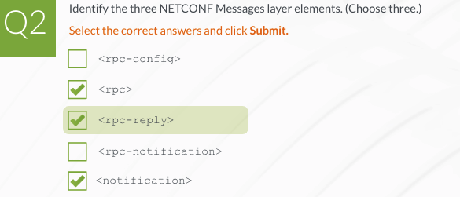

**Junos RPCs**

One way to learn Network Configuration Protocol (NETCONF) is to open a NETCONF session on a Junos device. All NETCONF messages, operations, and content are text-based so you can input them using the keyboard. Start a NETCONF session using the Junos CLI by typing netconf while in the operational mode. Note that when starting a NETCONF session, the username and corresponding Junos login class are displayed. Verify that the displayed user account has sufficient permissions to perform the required configuration and operational tasks. The same permissions are required for performing tasks using the Junos CLI and issuing remote procedure calls (RPCs) using NETCONF.

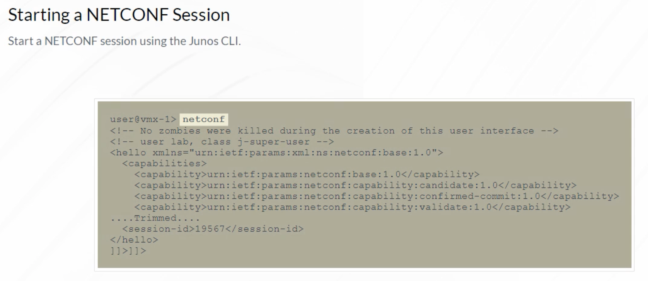

Note that the Junos NETCONF server displays its capabilities and the session ID—this information can be useful if there are multiple, concurrent sessions. Note the string at the end of the output. NETCONF messages typically end with this string. Refer to RFC 6242 for more details on when this termination signal must be used. Juniper provides a NETCONF XML Management Protocol Developer Guide.

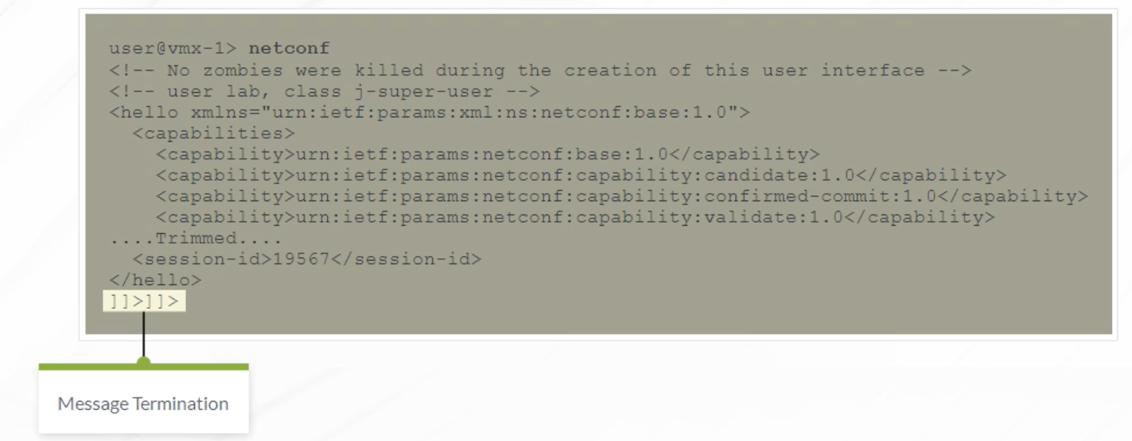

Here is an example to illustrate the execution of a Junos RPC using a NETCONF session. The <get-system-uptime-information> RPC is equivalent to a Junos CLI **show system uptime** operational mode command. The results sent back from the Junos NETCONF server are encapsulated in <rpc-reply> tags. This is a well-formed XML document, although it is not formatted using XML indentation. This output is generally processed by computers instead of humans.

Note that according to RFC 6241, the <rpc> element should have an attribute named message-id, which is an arbitrary string chosen by the sender, typically, a monotonically increasing number. This attribute must be returned in the  
<rpc-reply> element unmodified. The Junos implementation of NETCONF does not enforce the presence of message-id. So it is not present in the displayed output.

This is used to ensure that responses are interpreted properly when multiple RPC requests are being initiated in a short period of time.

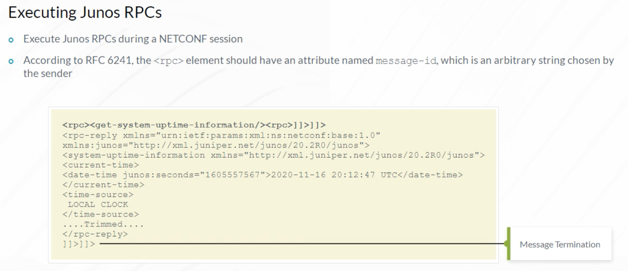

Once a NETCONF session is established, you issue NETCONF RPCs that execute operational mode commands and modify the device configuration. All NETCONF RPC requests are enclosed in XML element tags and end with the ]]>]]> signal.

The Junos XML API receives the XML-formatted RPCs and forwards them to the Junos mgd process for execution. Junos CLI commands are processed using the Junos XML API in the same way. The Junos XML API returns XML-formatted RPC responses from the mgd process back to the NETCONF client.

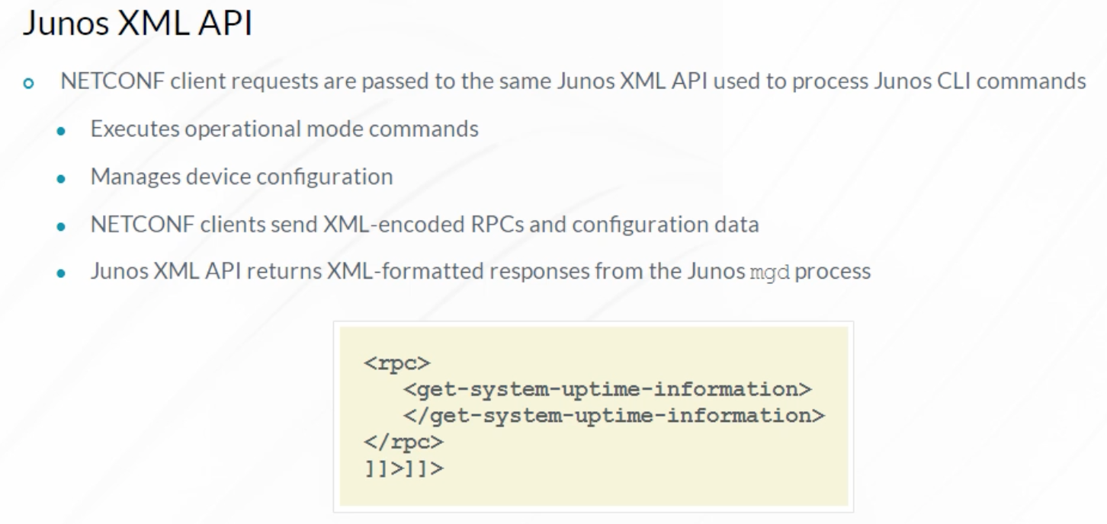

To find the equivalent Junos RPC for the **show interfaces ge-0/0/0** command, issue the **show interfaces ge-0/0/0** command with the **| display xml rpc** option. You should retrieve a reply similar to the one shown in the example.

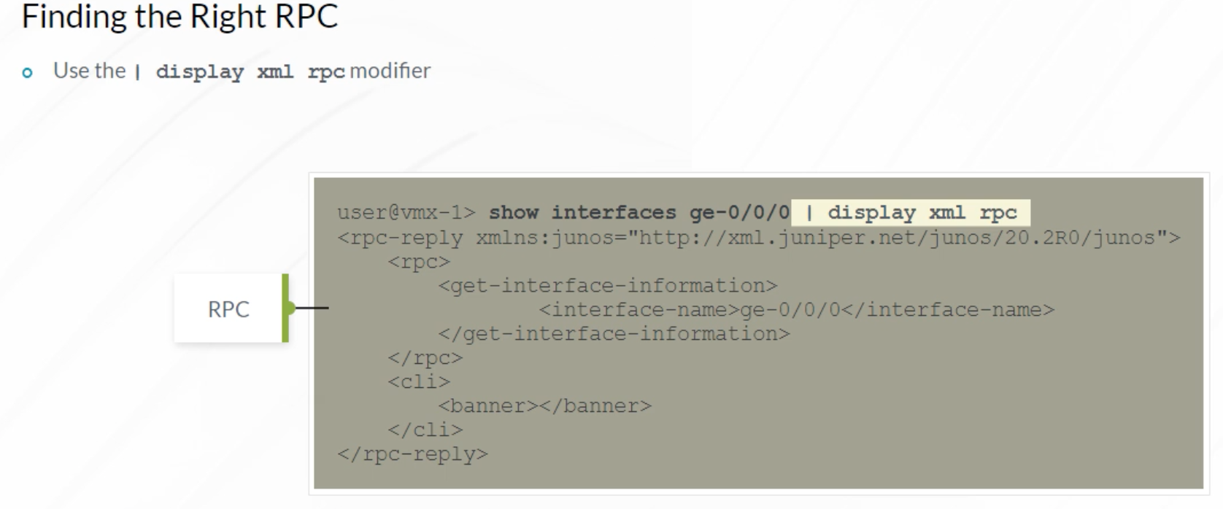

The **| display xml rpc** Junos CLI command option helps determine the correct RPC, but it is not the authoritative source. The authoritative sources are the Junos XML schema definition (XSD) files released with each new version of the Junos OS. The example shows an operational data schema file. It shows that the interface-name option is valid for the RPC in question. The schema definition files are useful if you have difficulties in determining the correct RPC using the Junos CLI or if you want to see additional options.

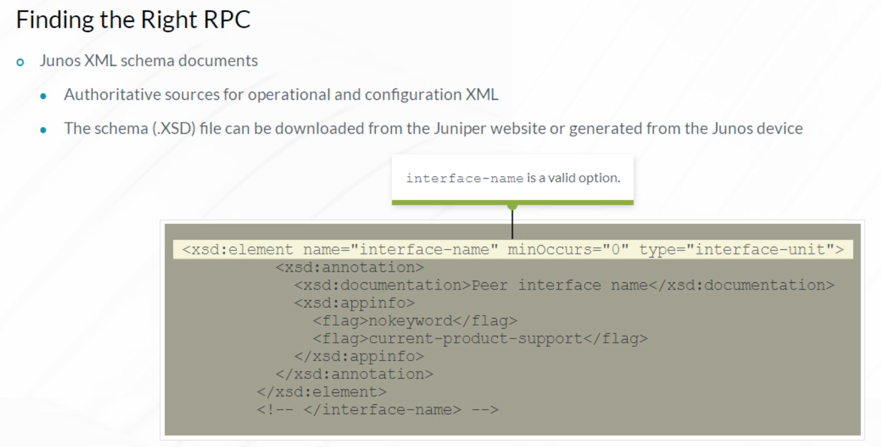

The Junos XML API Explorer is another resource to use in order to find the right Junos RPC. It is easier to read than the Junos schema files. It is also useful because it contains a description of each of the RPC elements. There is an XML API Explorer for operational and configuration tags.

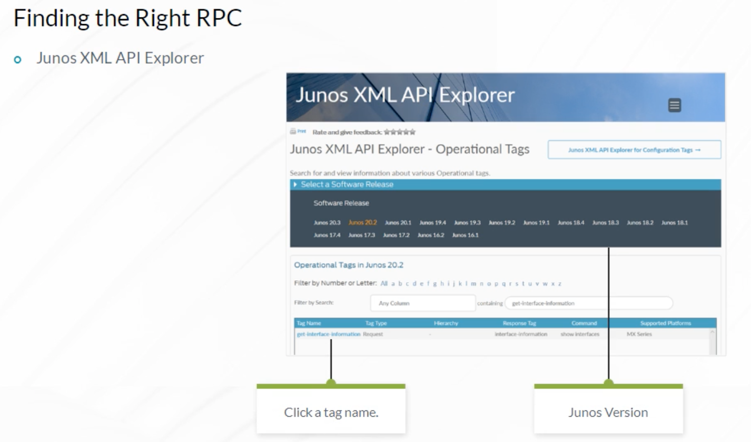

If you prefer to work with printed or PDF documents, you can download the Junos XML API Operational Developer Reference and the Junos XML Management Protocol Developer Reference Guide.

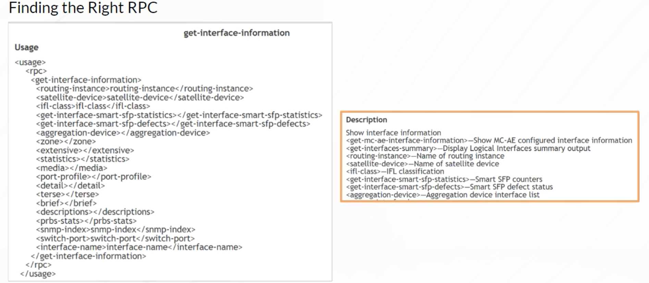

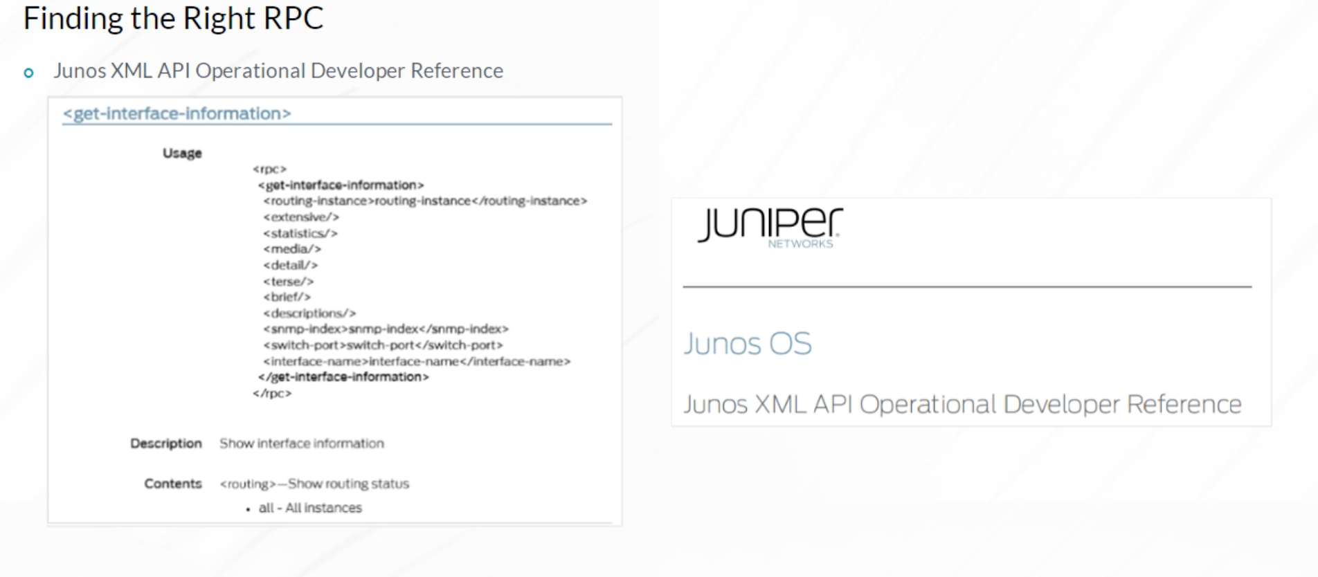

You can use Junos XML RPCs to retrieve and modify device configuration. The example demonstrates the use of the Junos get-config RPC to retrieve the contents of the [edit system login] branch of a Junos device configuration hierarchy.

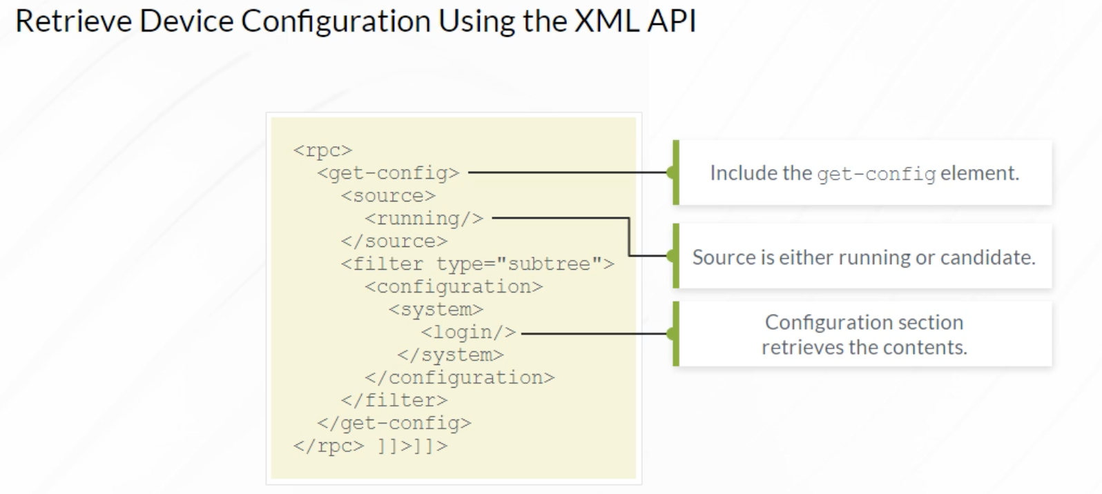

This example shows the data returned using the configuration request. Note that the response places the configuration data within <data> and <configuration> elements. The response also includes the Junos OS version, the date and time when the configuration was last committed, and the name of the user who committed the configuration. A similar process can be used to edit device configuration and to commit it. For more information about modifying configurations using NETCONF, refer to the Junos XML Management Protocol Developer Reference Guide.

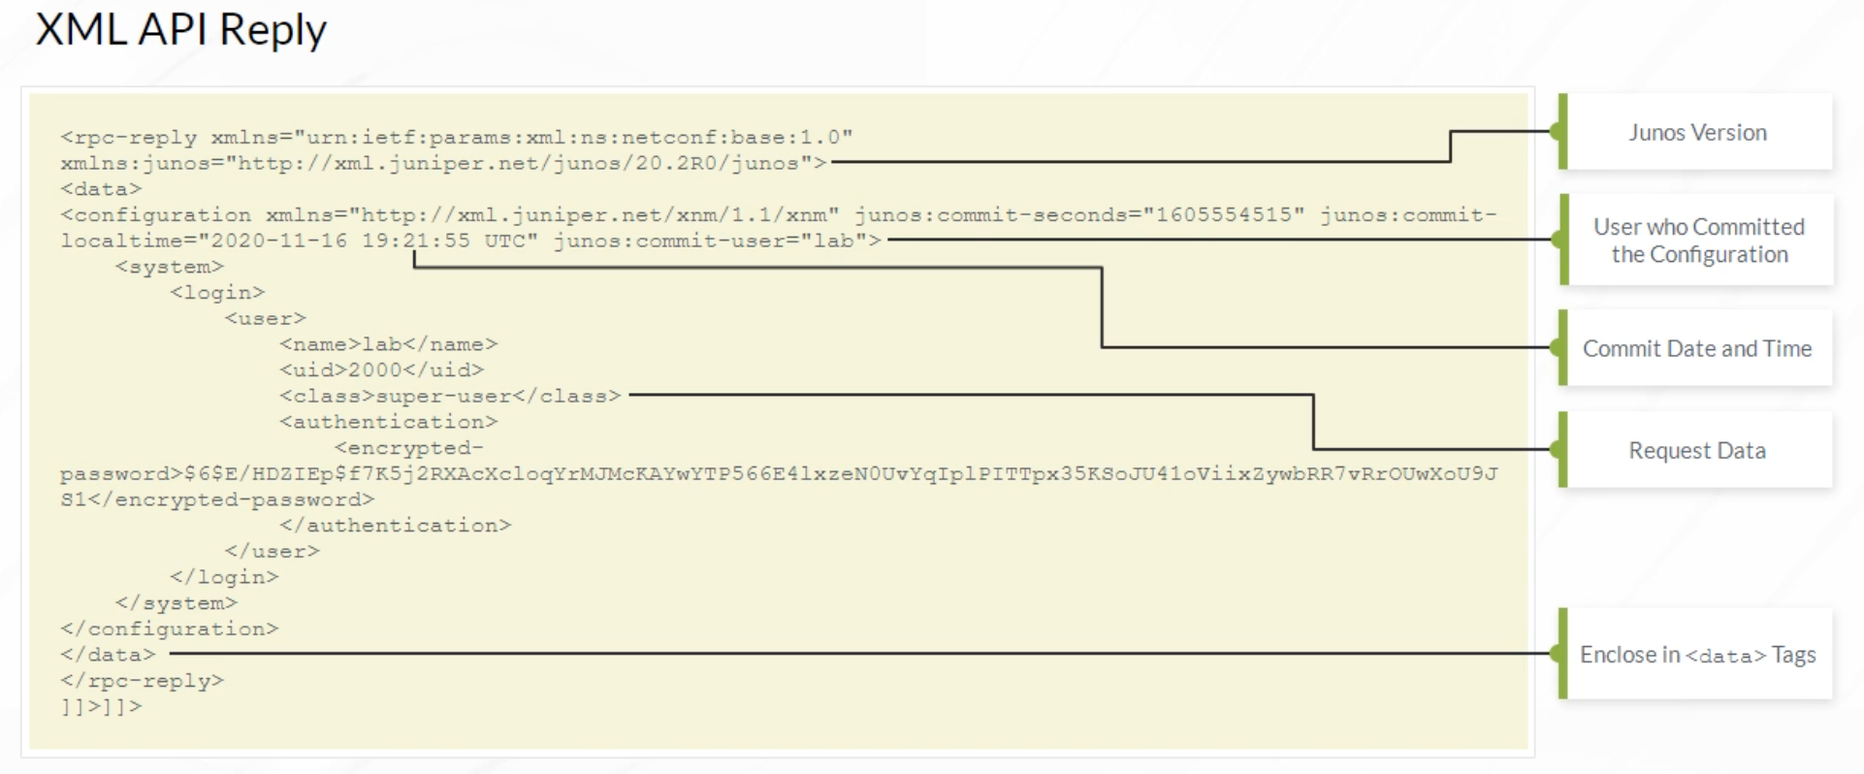

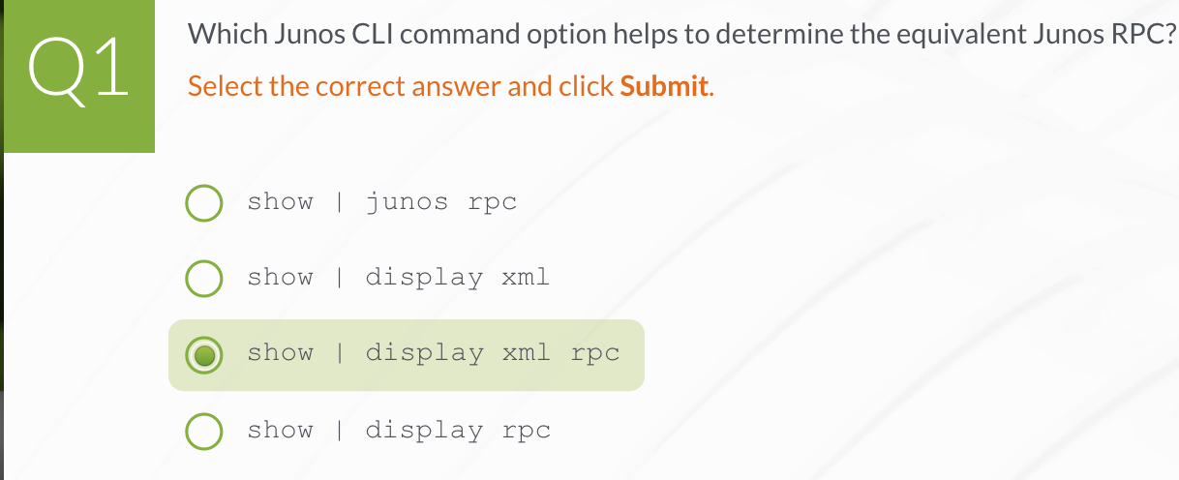

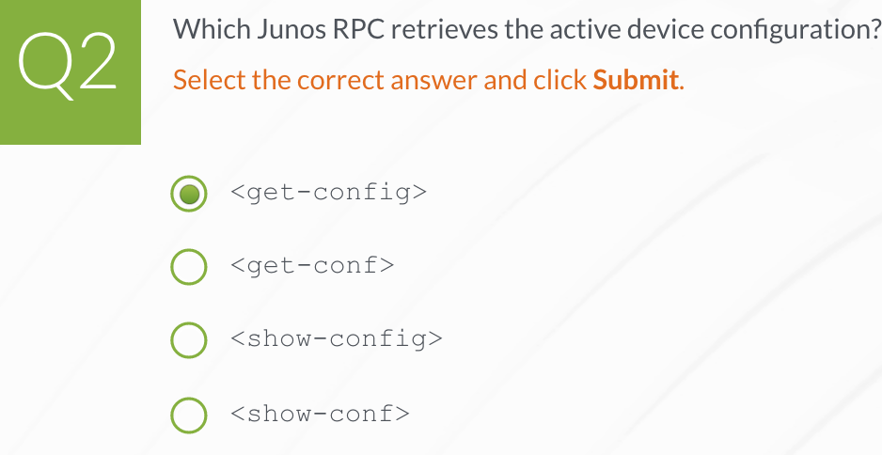

**Junos XML API Programming Languages**

Extensible Stylesheet Language Transformations (XSLT) and Stylesheet Language Alternative Syntax (SLAX) were the first programming languages specifically designed to work with the Junos XML API. Starting with Junos 16.1, Python can also be used to perform the same tasks.

Any programming language that can establish a Network Configuration Protocol (NETCONF) connection, use the NETCONF protocol, and send well-formed XML over that connection can be used to automate devices running the Junos OS. Juniper provides code libraries for multiple programming languages, including Python, Ruby, Perl, and Java. These free libraries make your interaction with NETCONF and the Junos XML API easy.

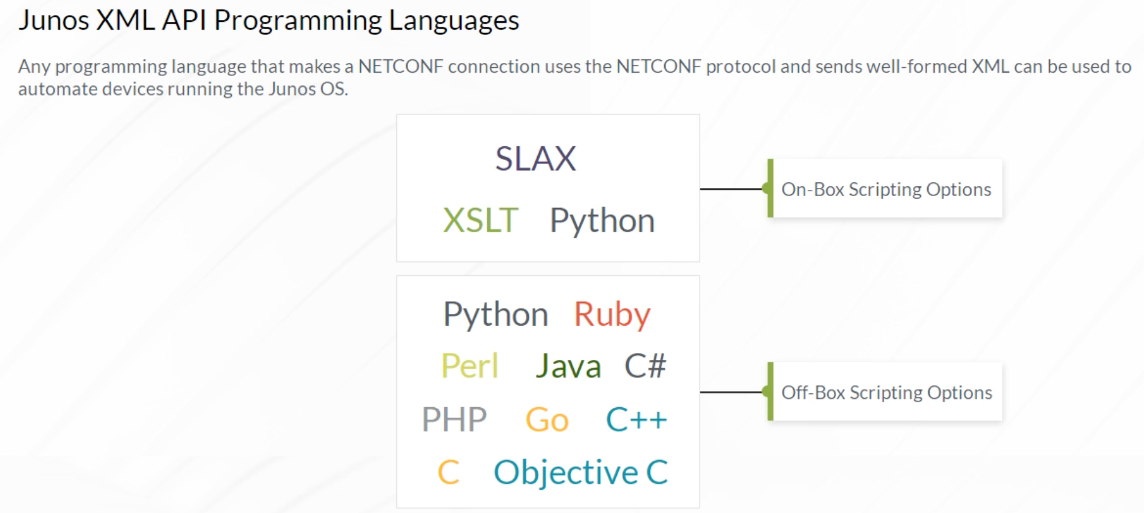

XSLT is a World Wide Web Consortium (W3C) standard language for transforming one XML document into another XML document.

The basic model consists of an XSLT engine or processor that accepts as input a script or stylesheet and an XML document. The XSLT engine uses the instructions in the script to process the XML document’s hierarchy. The script identifies interesting portions of the XML document, how it should be inspected, and what XML output should be generated. Because XSLT was created to permit generic XML-to-XML transformations, it is a natural choice for both inspecting Junos configuration syntax and for generating errors and warnings. XSLT includes powerful mechanisms for finding configuration statements that match specific criteria. For more information about XSLT support in Junos, refer to the Juniper Automation Scripting User Guide.

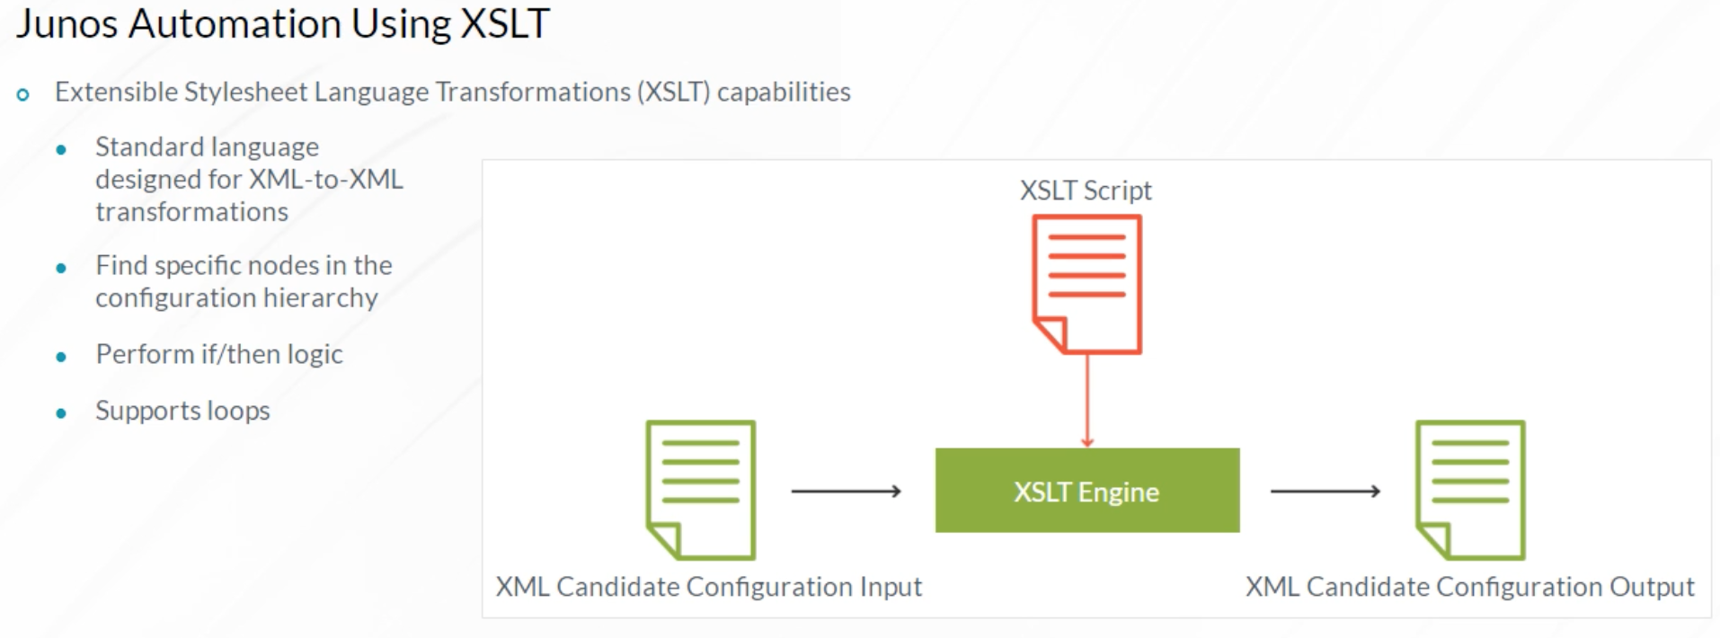

An example of an XSLT conditional logic statement is shown. In this example, when the host-name statement is included at the [edit system] hierarchy level, change the host name to vmx-1. Otherwise, issue the warning message: Missing [edit system host-name]. XSLT is a standard programming language for manipulating XML, but it is not a preferred language for most programmers.

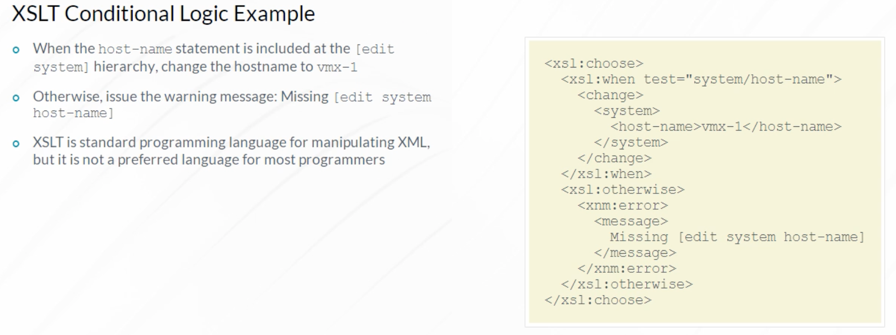

SLAX is a programming language developed by Juniper Engineers to make automating Junos easier. SLAX is now open source. One benefit of SLAX is that it is easier to use than XSLT. SLAX has the same capabilities as XSLT, and you can translate back and forth between the two languages. Actually, SLAX code is rendered into XSLT before being processed by the XSLT engine. SLAX is preferred by programmers who are not already accustomed to XSLT because SLAX enables the programmers to concentrate on the programming task rather than on learning a new programming syntax.

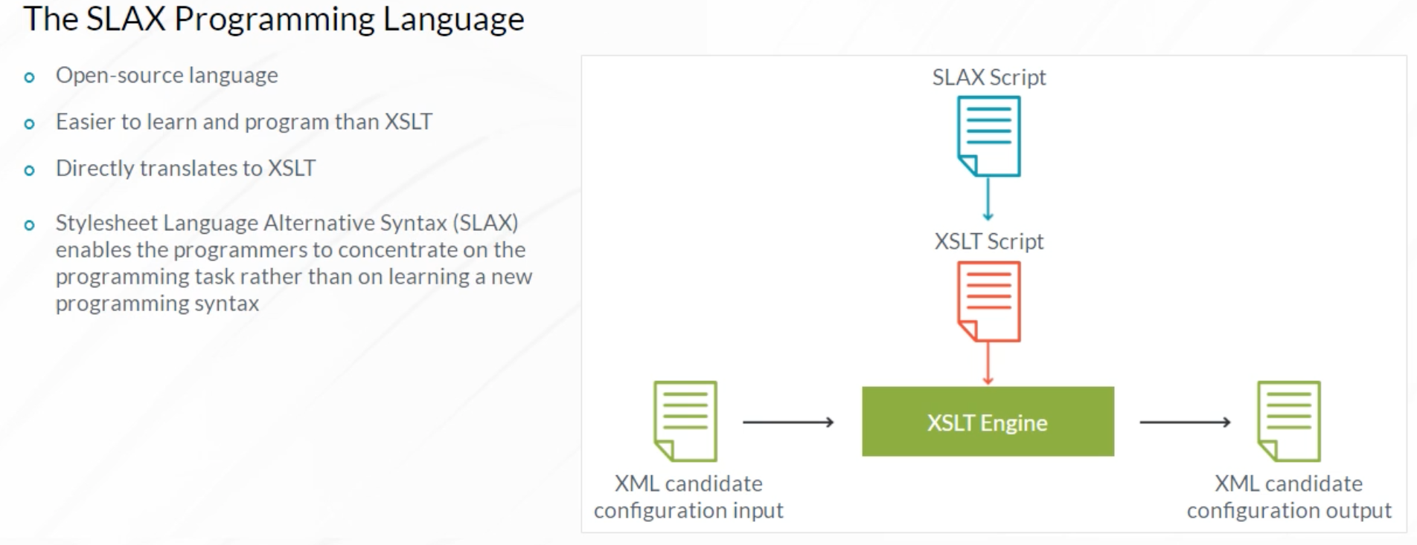

Here is the portion of a SLAX script that invokes the Junos get-configuration remote procedure call (RPC) on a local device, stores the output in the $results variable, and checks for the presence and value of a host-name in a Junos device configuration using Extensible Markup Path Language (XPath). Using XSLT, instead of familiar if, else if, and else programming statements, you would use when statements and create a program as an XML file. SLAX’s C- or Java-like syntax is more familiar to most programmers. SLAX is widely used by the Junos automation community. For more information about SLAX syntax and capabilities, refer to the Junos Automation Scripting User Guide.

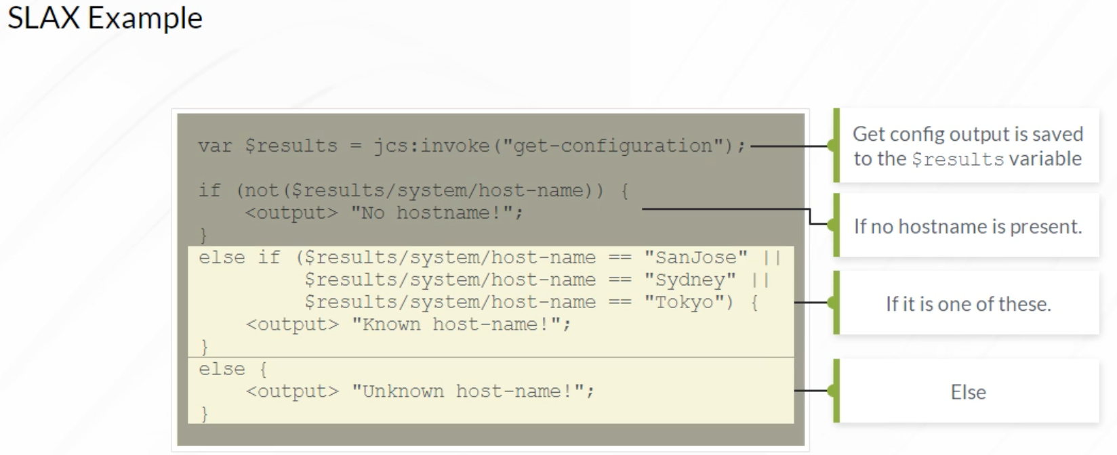

The SLAX programming language, although similar to C and Java, has some limitations because of its close ties to XSLT. Junos OS Release 16.1 introduced native Python support, bringing the power of Python to Junos. The Python NETCONF protocol library, as well as the Junos PyEZ library are open-source. Both are freely available at the **GitHub** website. You can access the website from the Reference Links document. Junos PyEZ builds on top of the NETCONF library to simplify Junos automation as much as possible.

The example Python script uses the Junos PyEZ library to connect to a Junos device and retrieve information from the device, known as facts, and prints the facts to the screen. The result of running the script is shown. Other tasks such as viewing or loading device configuration are made easy using Junos PyEZ. A big advantage of using Python for Junos automation is that the same language, libraries, and programs can be used for both on-box and off-box automation.

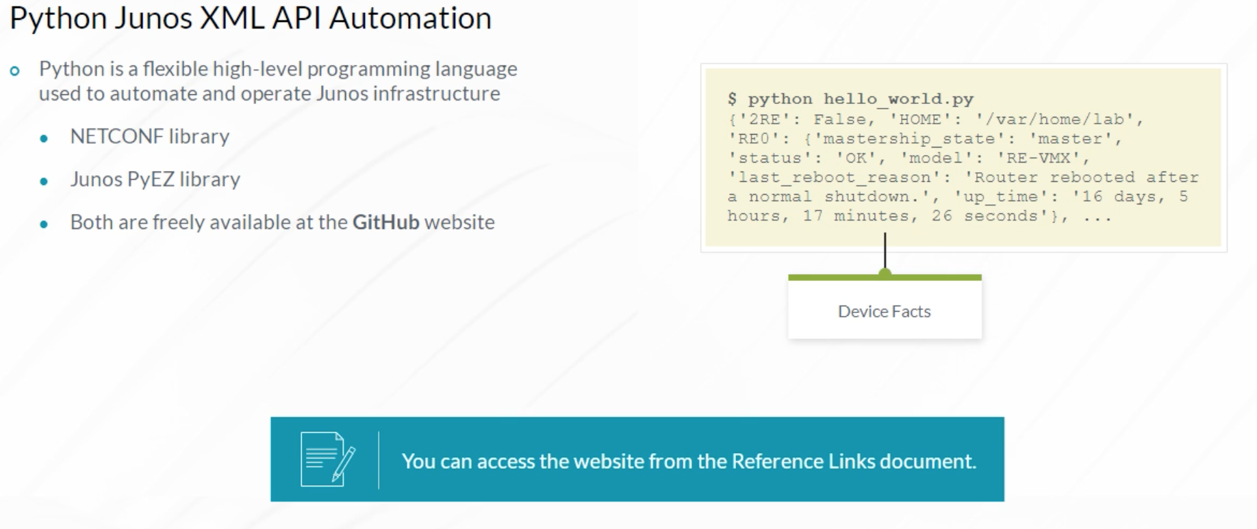

Juniper Networks provides a Perl module JUNOS::Device to help you quickly and easily develop custom Perl scripts for configuring and monitoring the Junos OS. The module implements a JUNOS::Device object that client applications can use to communicate with the Junos XML protocol server. The Perl distribution includes several sample Perl scripts that illustrate how to use the module to perform various functions. The Junos XML protocol Perl distribution uses the same directory structure for Perl modules as the Comprehensive Perl Archive Network (CPAN). It includes a lib directory for the JUNOS module and its supporting files, and an examples directory containing sample scripts. The library contains several modules, but client applications directly invoke only the JUNOS::Device object. For detailed instructions on installing the Junos XML protocol Perl client and associated sample scripts, refer to the Junos XML Management Protocol Developer Guide.

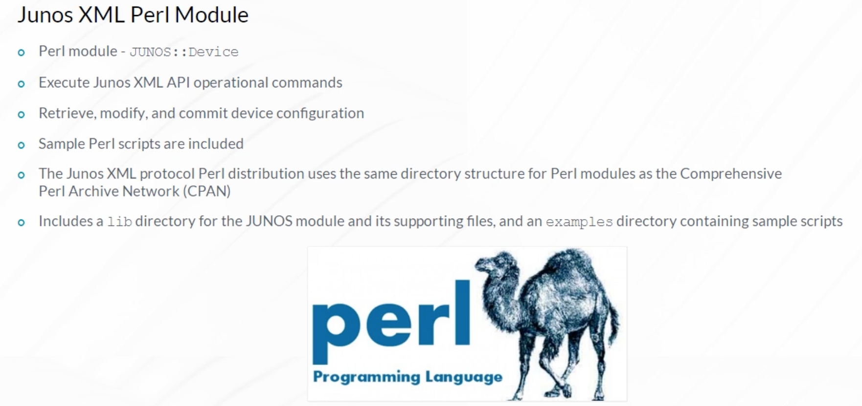

The NETCONF Java toolkit, which is available at the **GitHub** website, provides an object-oriented interface for communicating with a Junos NETCONF server. You can access the website from the Reference Links document. It enables programmers familiar with the Java programming language to create applications that can connect to a Junos device, establish a NETCONF session, execute operational commands, and create XML configuration hierarchies.

There are four main classes in the NETCONF Java toolkit:

* Device, which represents a NETCONF over SSH session to a Junos device NETCONF server.
* NetconfSession, which creates RPC requests and processes the RPC replies from the NETCONF server.
* XMLBuilder, which creates XML-encoded data.
* XML, which contains XML-encoded data that represents an operational or configuration request or configuration data.

For more information about how to use the NETCONF Java Toolkit, refer to the NETCONF Java Toolkit Developer Guide.

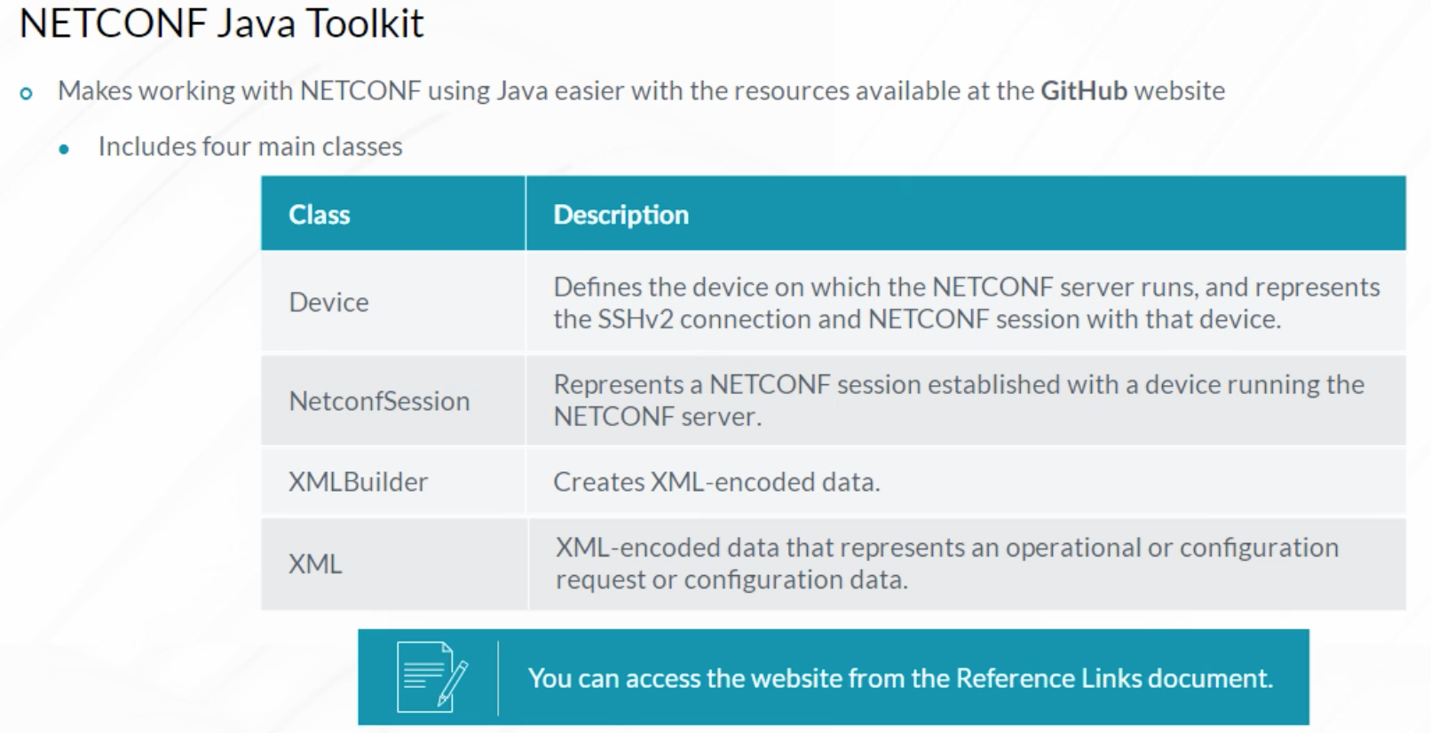

The Juniper NETCONF Ruby Gem is a NETCONF library for the popular Ruby programming language. The NETCONF Ruby gem, available at the **GitHub** website, provides classes and methods that enable Ruby programs to manage Junos devices using NETCONF. It is installed using the gem install net-netconf command. You can access the website from the Reference Links document.

The source code is also freely available. The example Ruby script displayed connects to the target device and authenticates with the provided username and password. It does not perform any additional actions. In addition to the NETCONF Ruby gem, Juniper also provides the RubyEZ framework, which is built on top of the NETCONF gem, enabling automation development without requiring specific Junos XML knowledge.

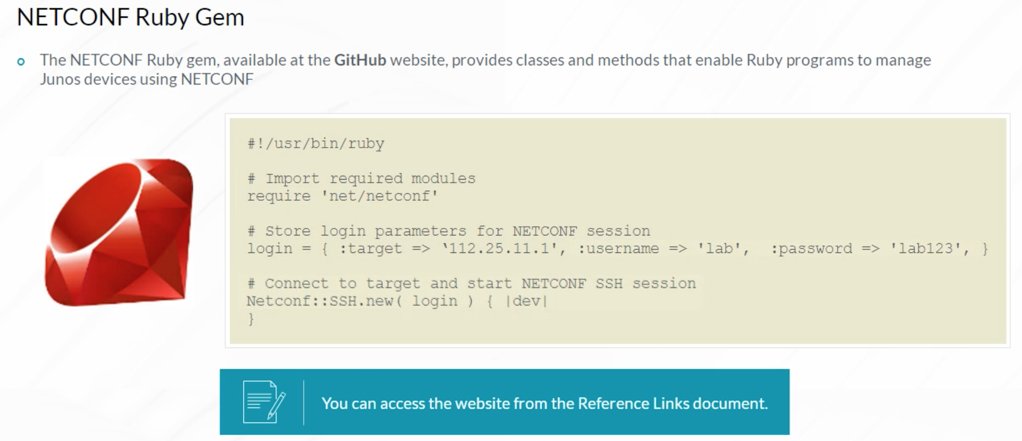

Network administrators of ACME Corp. want to automate Domain Name System (DNS) configuration on Junos devices, including routers, switches, and firewalls. Administrators need to view the existing DNS configuration and change the configuration to include a set of name servers. ACME Corp’s administrators are most familiar with the Ruby programming language because it is currently being used for server infrastructure automation. This case study uses the NETCONF Ruby Gem but other tools could be used in a similar fashion.

Before using the example scripts in a production network environment:

* Avoid the hard-coding of usernames and passwords for security purposes. Consider using SSH keys instead.
* Avoid hard-coding device management IP addresses. Consider passing device host-names or IP addresses as parameters when a script is executed.
* Add error handling to manage authentication errors, timeouts, and so on.

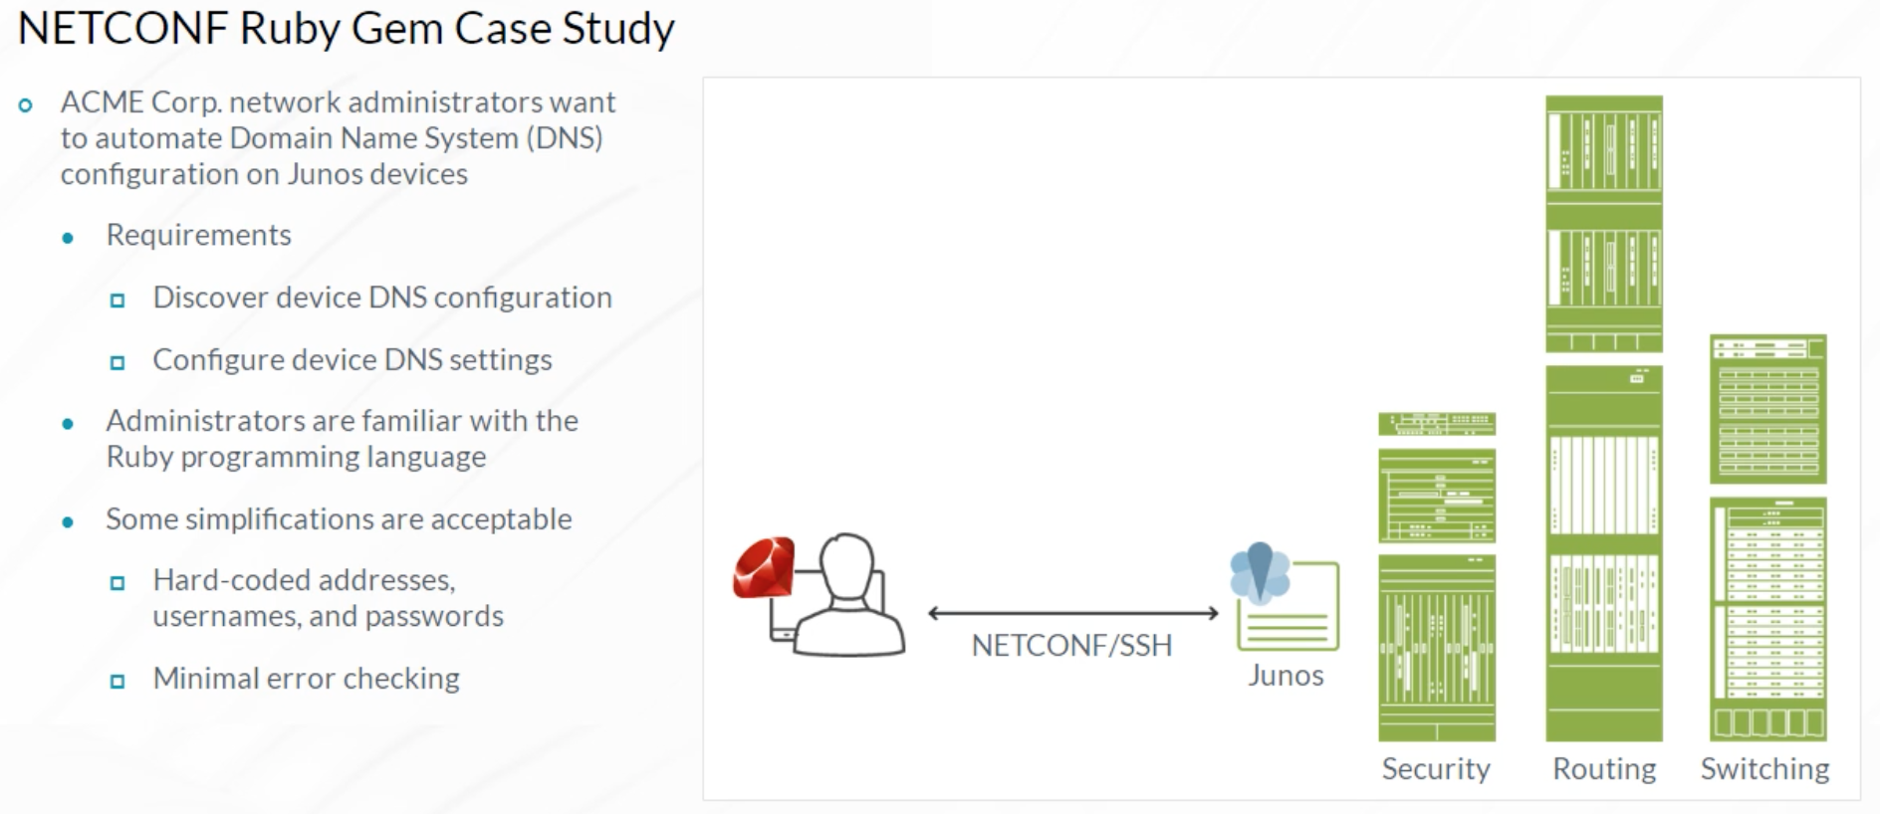

Verify that the Ruby interpreter is installed on the control server. If not, install it using your favorite package manager. Install the Ruby net-netconf gem by issuing the gem install net-netconf command. In this example, an interactive Ruby interpreter (irb) is launched. The require ‘net/netconf’ command returns true, meaning both Ruby and the net-netconf gem are available. Since the solution uses off-box scripts, enabling NETCONF in the Junos configuration is necessary.

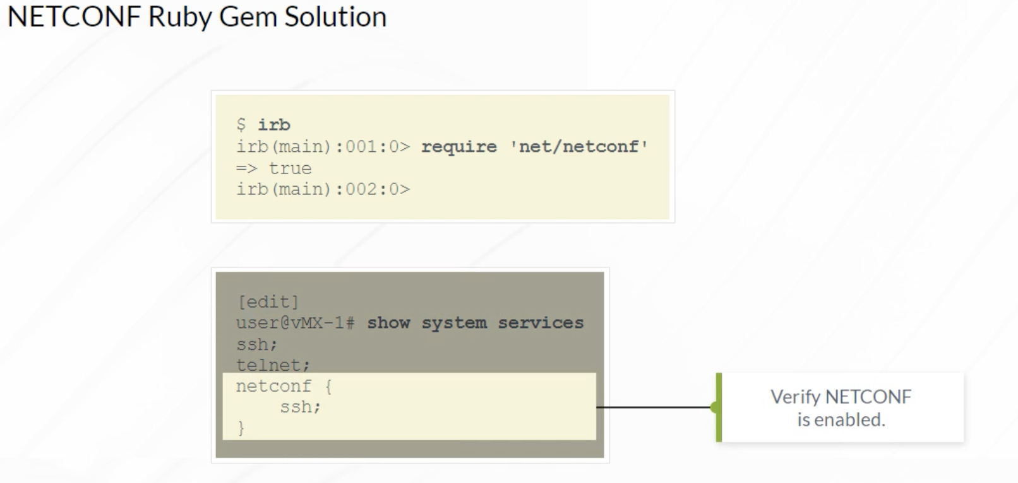

The example script reads the DNS server configuration on a target device. The target device address and login parameters are defined in the login variable. Then, a Netconf::SSH connection is established with a device object. Although detailed coverage of Ruby is beyond the scope of this class, the syntax of the example script is fairly intuitive. A Junos <get-configuration> RPC is executed by calling the rpc method of the dev object and the result is saved to the full_config variable. Finally, the full_config output is filtered using XPath looking for all entries of system/name-server/name and printing the name-server list using the puts function.

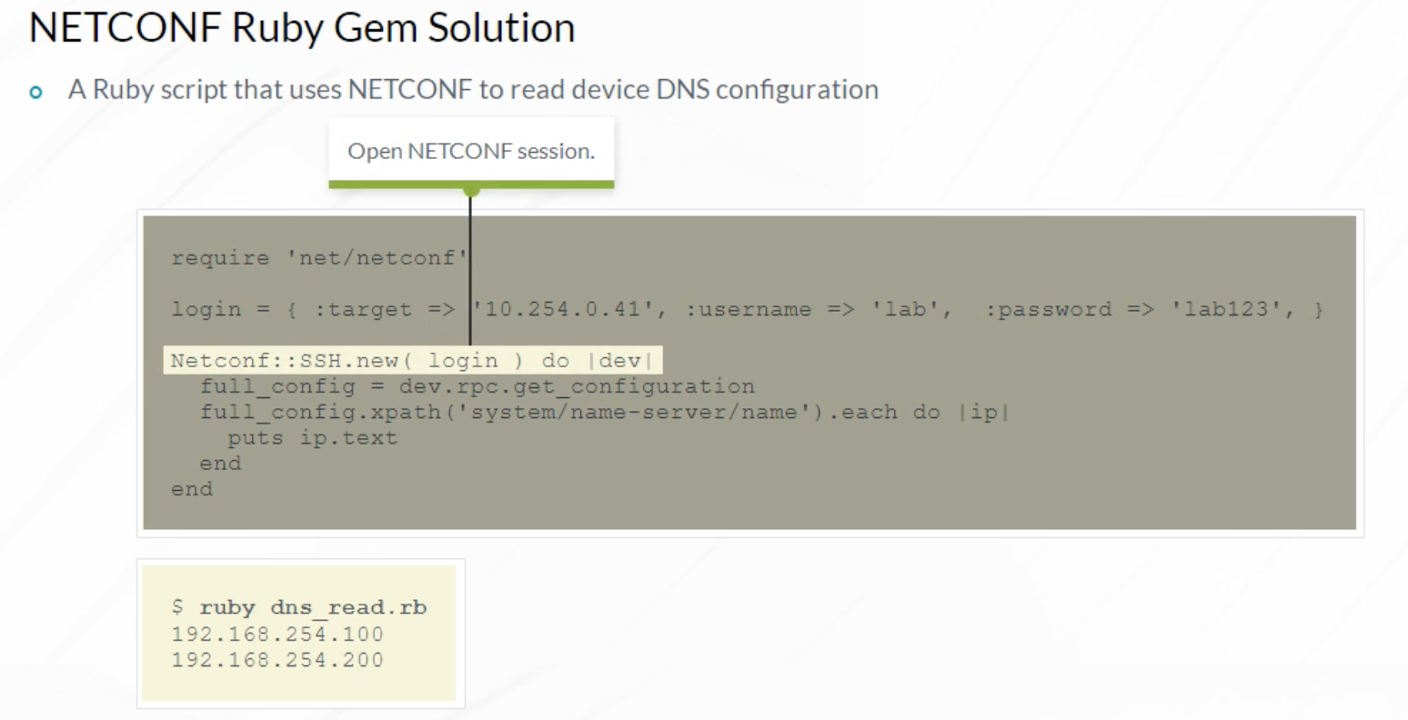

The final part of the task, provisioning DNS server configuration, is performed using the example script shown. It is similar to the previous script. The two examples could actually be combined into one script, but the example uses two scripts for simplicity. One difference between the two scripts is the RPCs that are executed. This example script uses additional RPCs to lock the device configuration, load the new configuration using an XML-formatted data variable called dns_config , commit, and unlock the device configuration. Existing DNS settings are removed using the <name-server delete='delete'/> XML element.

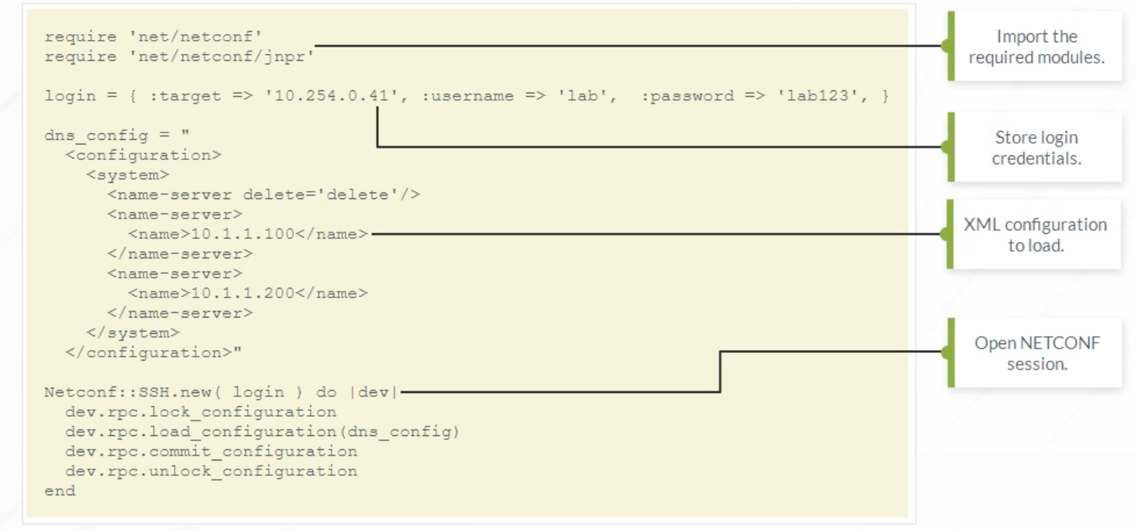

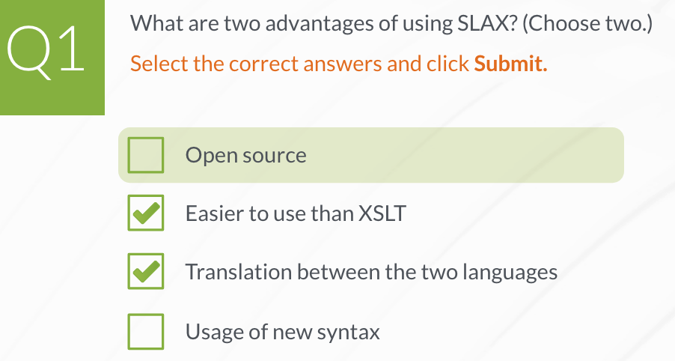

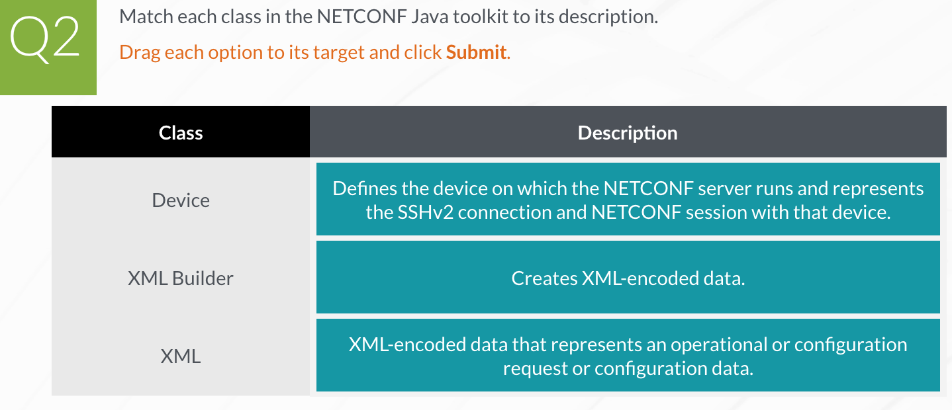

1. **Python Fundamentals**

**Python Basics**

Python is a very popular general-purpose programming language used in multiple fields. It is an open-source interpreted programming language. The Python interpreter is written in C. The syntax of Python is intuitive and concise, helping you quickly create simple programs. Python has a rich ecosystem, with many libraries and modules available to help you develop applications. In many cases, you can solve the task you are working on by simply combining pieces of already existing Python code.

Python uses an automatic memory management model. When an object becomes unused (no active references to it exists), the object is automatically deleted from memory by a Python component called the garbage collector. Python supports concepts from structured programming, object-oriented programming, and certain elements of functional programming. Python is cross-platform. Typically, the same Python script functions identically on Windows, Mac, Linux, and other operating systems. Python is pre-installed on most modern Linux distributions. For other operating systems, download and install Python from the python.org website.

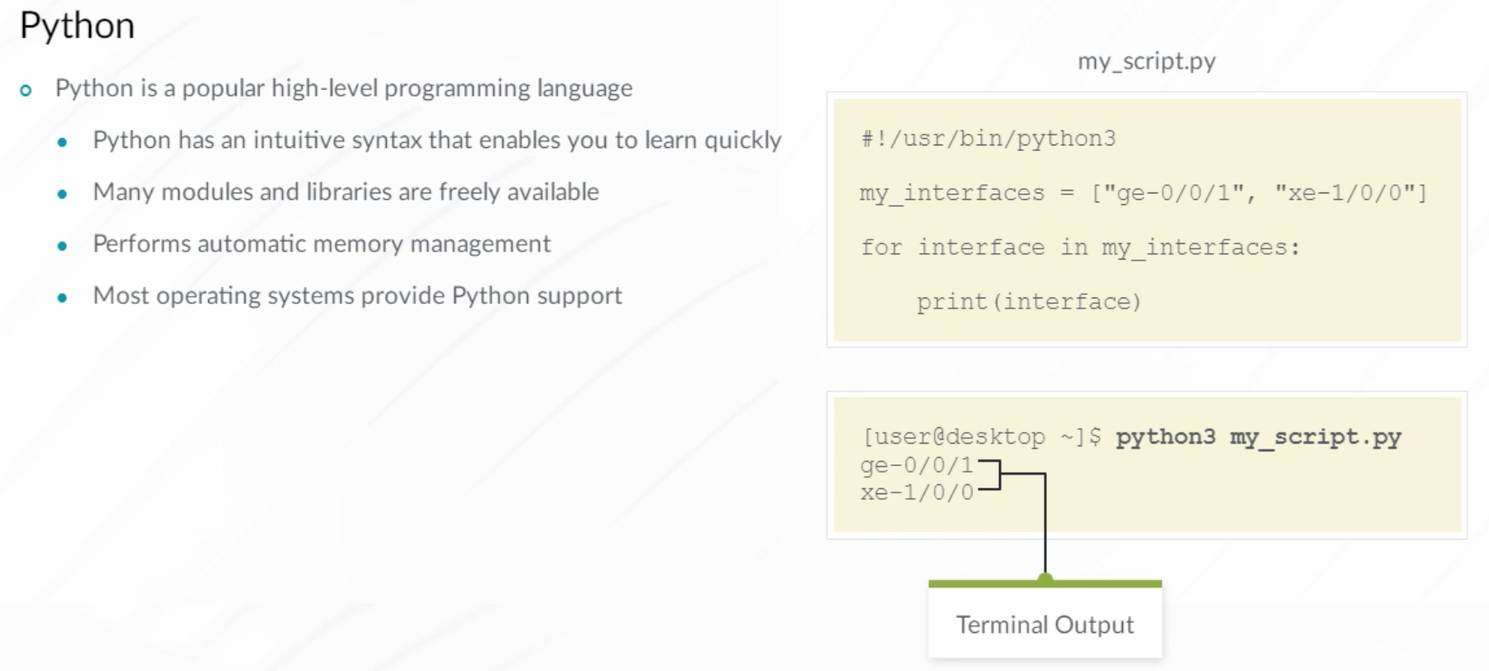

Why learn a programming language when automation tools like Ansible, enable you to perform network automation without having to write code? There are multiple reasons why learning Python is beneficial:

* A number of Python libraries are available that make network device automation easy. Junos PyEZ is one example. These libraries transform Python into a powerful tool for automating all types of network tasks.
* Although tools like Ansible and Salt enable automation without coding, they rely on software modules (typically, written in Python or a similar language) to perform tasks, like configuration uploads and RPC execution. If no module exists for the task that you want to perform, knowledge of a programming language can help you build the module yourself.
* Even if you don’t plan to write Python code, being able to read it is beneficial. It helps you better understand how existing tools work.
* Python enables you to manage your network infrastructure using code.
* Python skills are highly transferable. Python skills are useful if you want to perform advanced data analysis, Web development, or experiment with artificial intelligence (AI) and machine learning (ML).

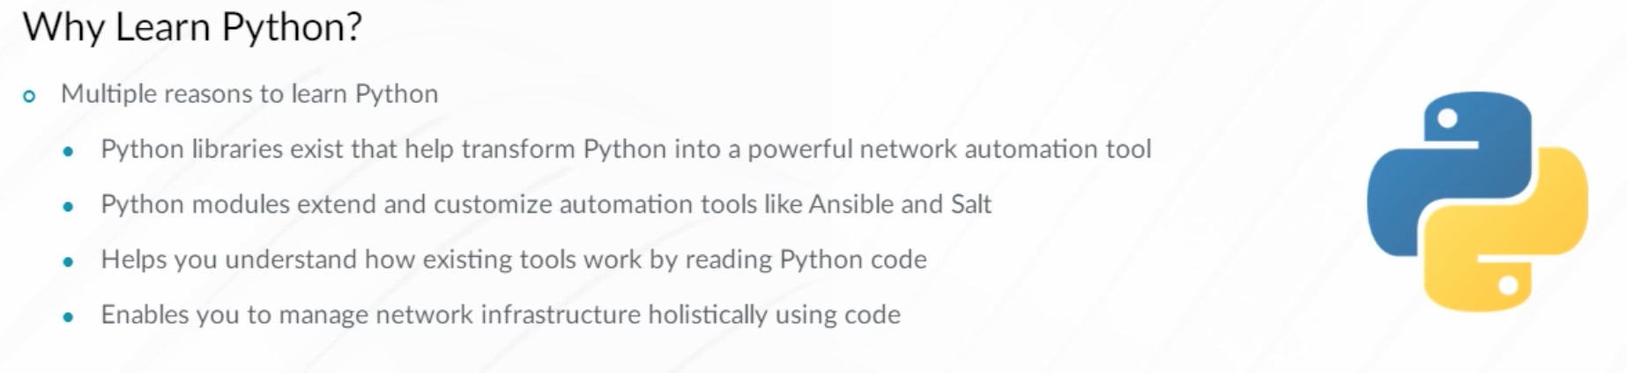

This is an example Python script. It defines a list of interfaces called my_interfaces and demonstrates using Python if/elif/else operators in the body of a for loop. Similar to other languages, if/elif/else flow control operators are used to test conditions and perform a set of operations, if the conditions are met, or another set of operations if the conditions are not met. The startswith() method of the string object is used to check if a given string starts with a particular value. Note that strings use single or double quotes. The first clause checks if the string interface starts with ge- to check if the speed of the interface is 1G. The subsequent check evaluates if the speed is 10G. Should the interface not match any of those values, the operators in the else statement are executed causing the code to print the corresponding message.

Python uses the # symbol to indicate comments (alternatively, three quotes before and after the block of code can be used to indicate a multiline comment). There are some differences in Python syntax compared to more traditional languages like C or Java. Notice that Python strictly enforces the use of white-space (indentation). Because Python uses indentation, you do not have to use curly braces to show structure (nesting of code blocks). Instead, a few spaces or a single tab indicates that the spaced or tabbed block of code belongs to a function or control loop. Note that you are not allowed to mix tabs and spaces in a single Python file. The examples in this module use four spaces for indentation.

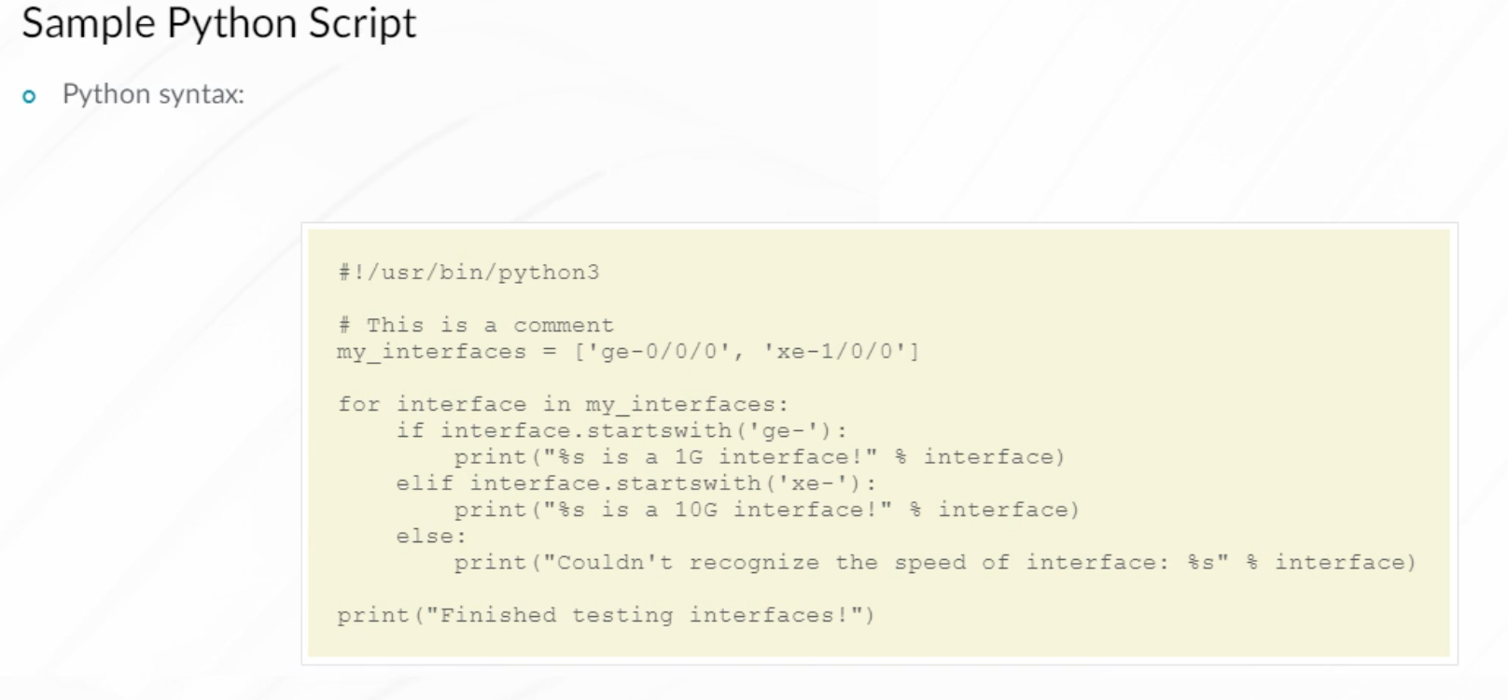

Executing Python code is similar to executing Unix shell scripts. You can call the Python interpreter directly, or if the path to the interpreter is included in the Python code, you can run Python scripts the same way you run Bash scripts.

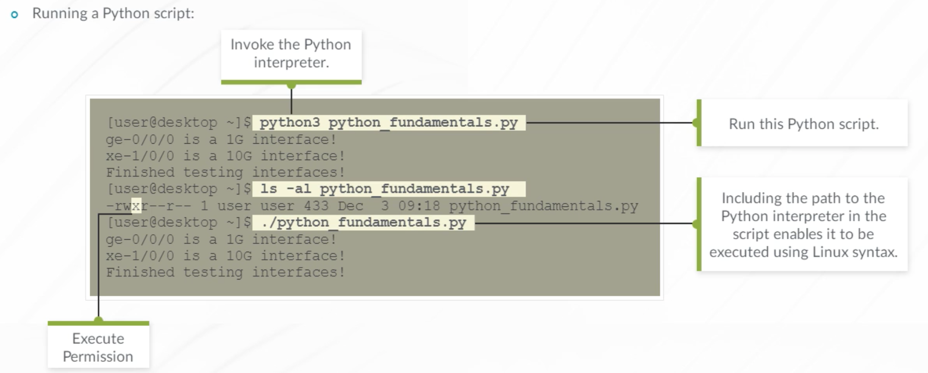

This flow chart demonstrates the actions that are taken when a Python script or program is executed. When Python code is executed, the Python interpreter analyzes the program or script. If there are no syntax issues, the interpreter begins to translate the Python code to byte code. In some scenarios, the Python code is translated and stored as a Python byte code .pyc file. Storing Python modules and packages in this manner speeds up execution because the interpreter doesn’t need to evaluate the Python code every time the module or package is referenced. Finally, the byte code is passed to the Python runtime, known as the Python virtual machine (pvm), that executes the byte-code instructions.

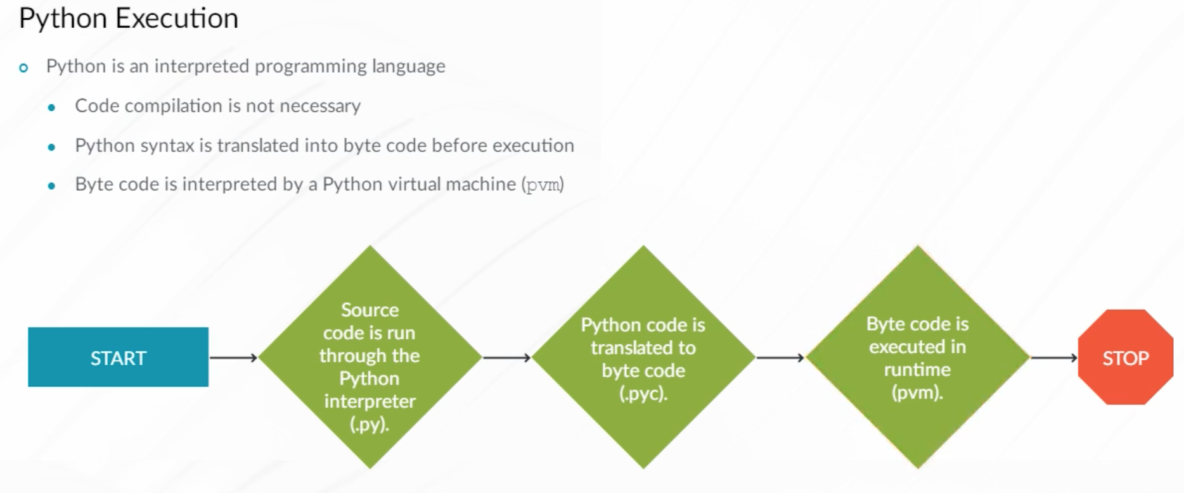

Python provides interactive interpreter sessions in much the same way that the Junos OS CLI provides interactive sessions with the Junos OS. Start the Python interactive interpreter, sometimes called the Python shell, by typing python for a Python version 2 interpreter or python3 to launch a Python version 3 interpreter. If your system has multiple versions of Python installed, you can run a specific Python version by typing python2.7 for Python 2.7 or similarly for other versions. Exit the Python interpreter by typing exit() or Ctrl+d. Use the interactive Python interpreter to perform the same tasks you do in Python scripts. An interactive session with the Python interpreter is useful for short, simple, and familiar tasks. As tasks become more complex, many developers prefer to create Python scripts that, enable the code to be saved for future use, possibly in a version control system (VCS).

In this Python interpreter example, two variables, a and b, are assigned values. The values are then printed on the screen by entering a variable name and pressing Enter. Next, a function named f is defined using the def keyword. The function takes one parameter (or argument) named x. It returns a value of x squared that is tested in the f(a+b) command.

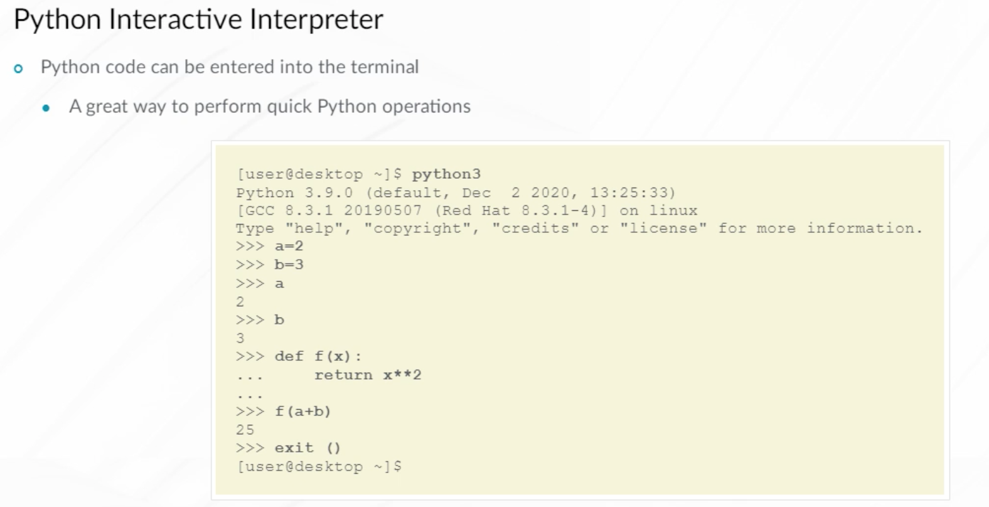

Python operators are used when creating control loops and when working with Python variables. Operators are keywords or symbols that, when combined with data (objects), form expressions. Expressions are used in Python code to create statements that control program execution.

Python supports the following operator types:

* Comparison operators are useful for manipulating flow control when combined with if/elif/else statements. Use the == operator to determine if two variables contain equal values. You can use the == operator to test equivalence between strings, integers, or even dictionaries and lists. The != operator checks if two variables are not equivalent.
* Arithmetic operators are typically used to manipulate numbers. However, in some cases they may operate on other data types as well. The + operator, for example, is used to add two integers or concatenate two strings. The * operator, although typically used to multiply numbers, can also act on strings as shown in the example.
* Assignment operators, such as =, are used when assigning values to variables.
* Bitwise operators, like & (binary AND) and | (binary OR), enable operations on binary numbers.
* Logical operators are useful for flow control.
* Membership operators like in are useful to check containment in a collection, like a Python list or dictionary.

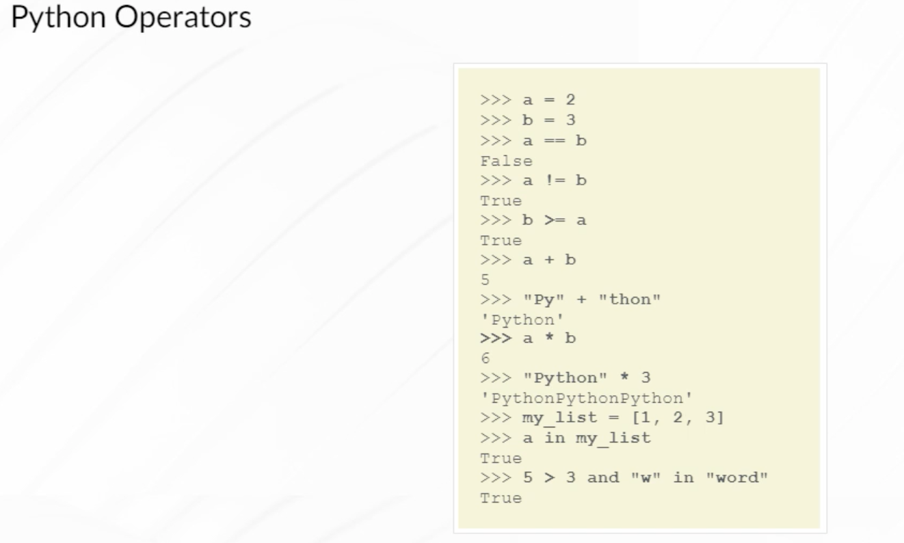

The Python programming language is being actively developed and new features are being added over time. You should be aware of which Python version you are using. Both Python 2 and Python 3 are currently in use, but Python 2 is gradually, and very slowly, going away. The basic examples and activities in this module use Python 3 but they typically work in Python 2.

Changes were introduced in Python3, which are not backwards compatible with Python2, to make the language more consistent.

Some of the changes include:

* The Python 2 print statement has been replaced with the Python 3 print() function. The example shows that print(“Hello”) syntax works the same with both Python 2 and 3 while some more complicated calls work a bit differently. In particular, in print(“Hello”, “World”), Python 2 treats (“Hello”, “World”) as a tuple and outputs accordingly.
* Integer division displays results differently.
* Python3 has improved Unicode support. Python 3 strings are always treated as a sequence of Unicode characters, hence the traditional Python 2 approach of putting the letter u before the string (to indicate Unicode) is not used.

Consult the python.org website for more details on differences between Python versions and how to write Python code for the different interpreters.

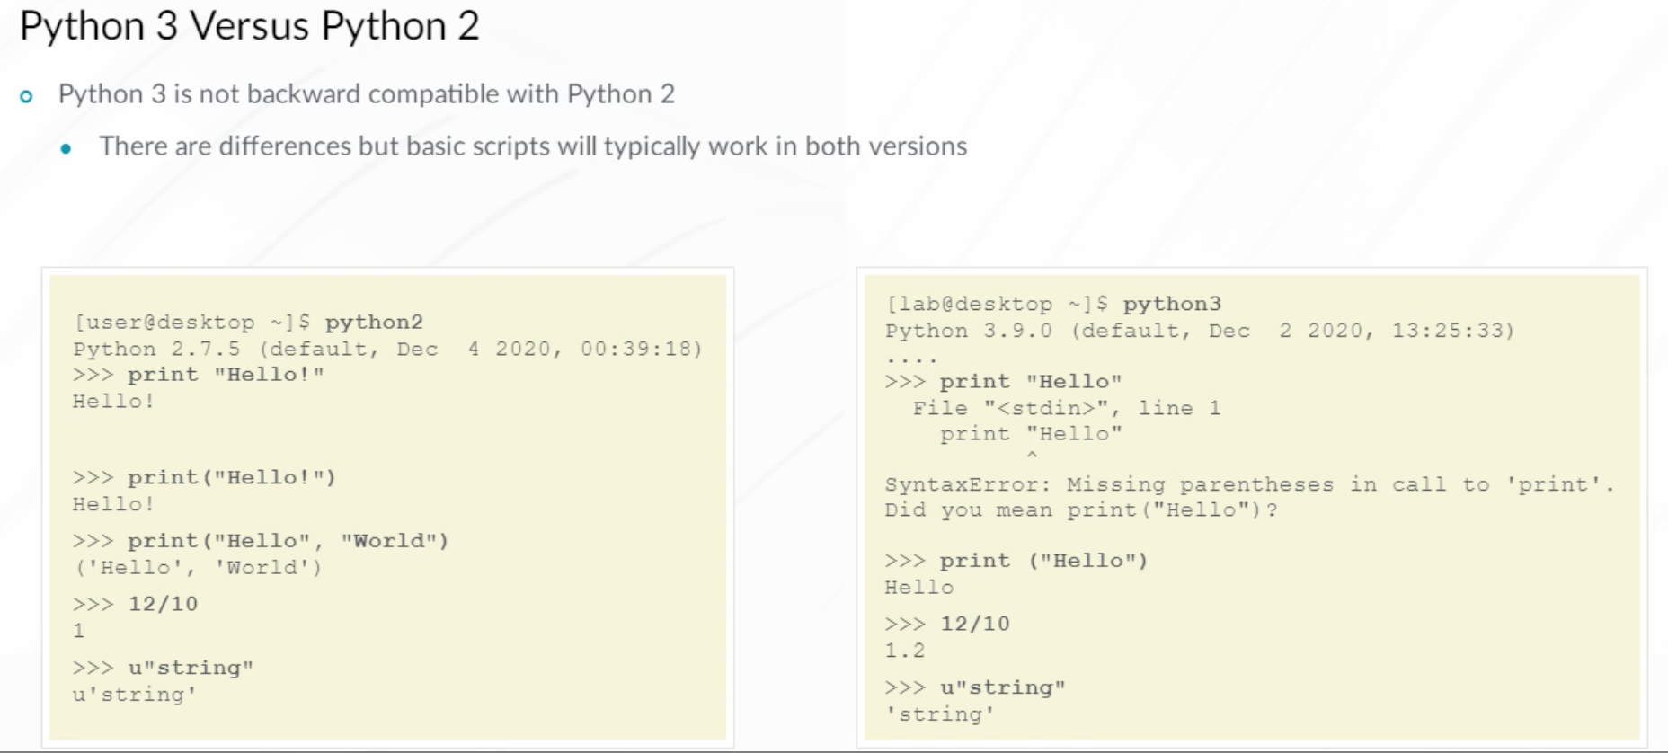

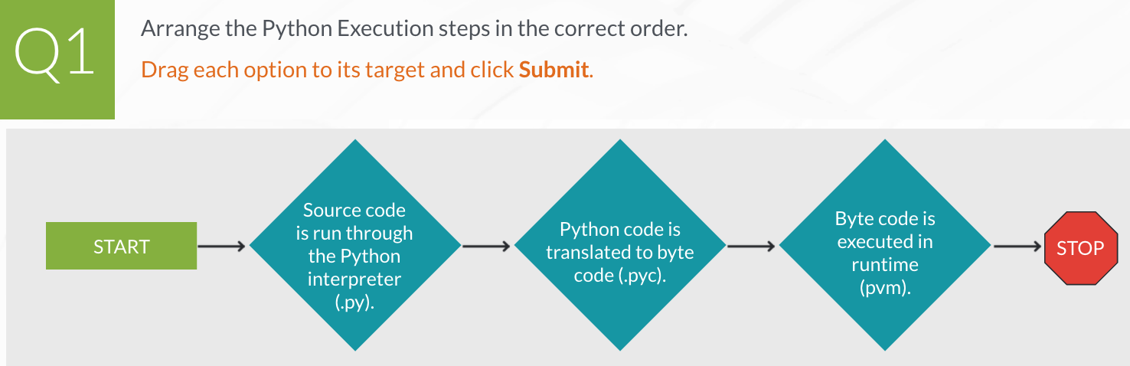

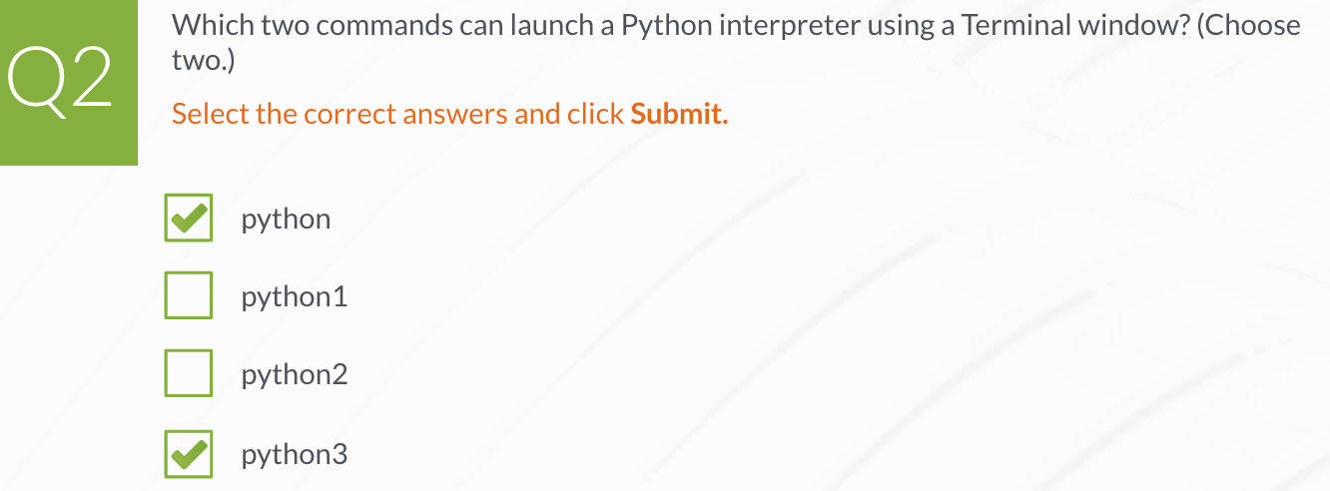

**Python Operations**

Python variables are user-defined names that are references to objects that are stored in memory. In the example, a list containing the numbers [1, 2, 3], is created and assigned to variable x. The list object is stored in memory and x can be used to reference it. The example sets the y variable equal to x, sets 5 as the first character in the list, and demonstrates that x and y are equal.

You might expect y to be 5. However, the x=5 line actually creates a new object identified using a new ID value in memory. The y variable still points to the existing object ID representing a value of 1. The key difference between the two examples is that the x[0]=5 operation modifies the existing object while x=5 operation creates a new one.

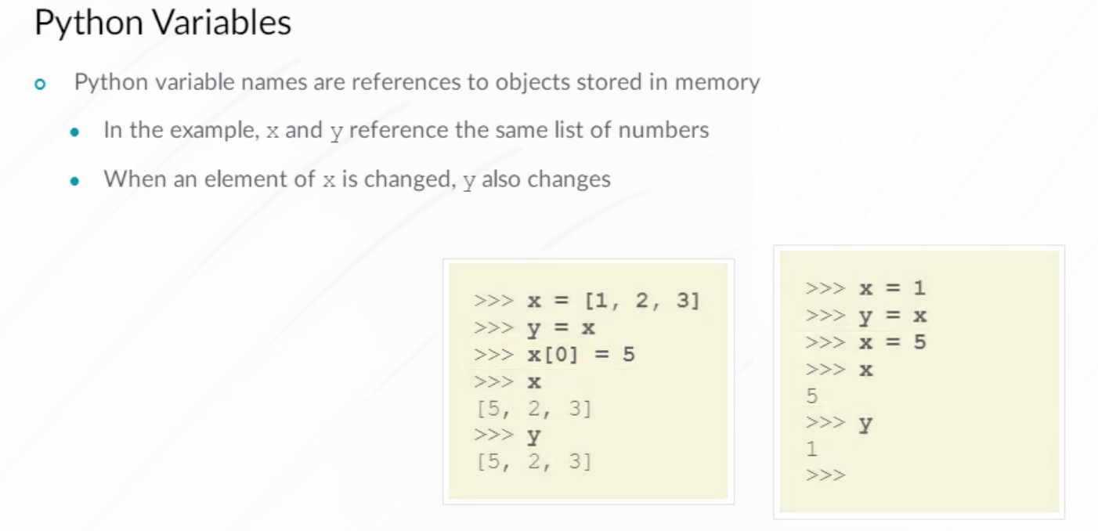

Python does not require you to declare a data type when creating variables. Python determines the variable data type based on the value provided. This example illustrates the use of two different Python variable data types. Using single quotes to assign a value to a variable creates a string type variable that can be accessed using the variable name. A whole number value without special expressions or syntax is considered an integer.

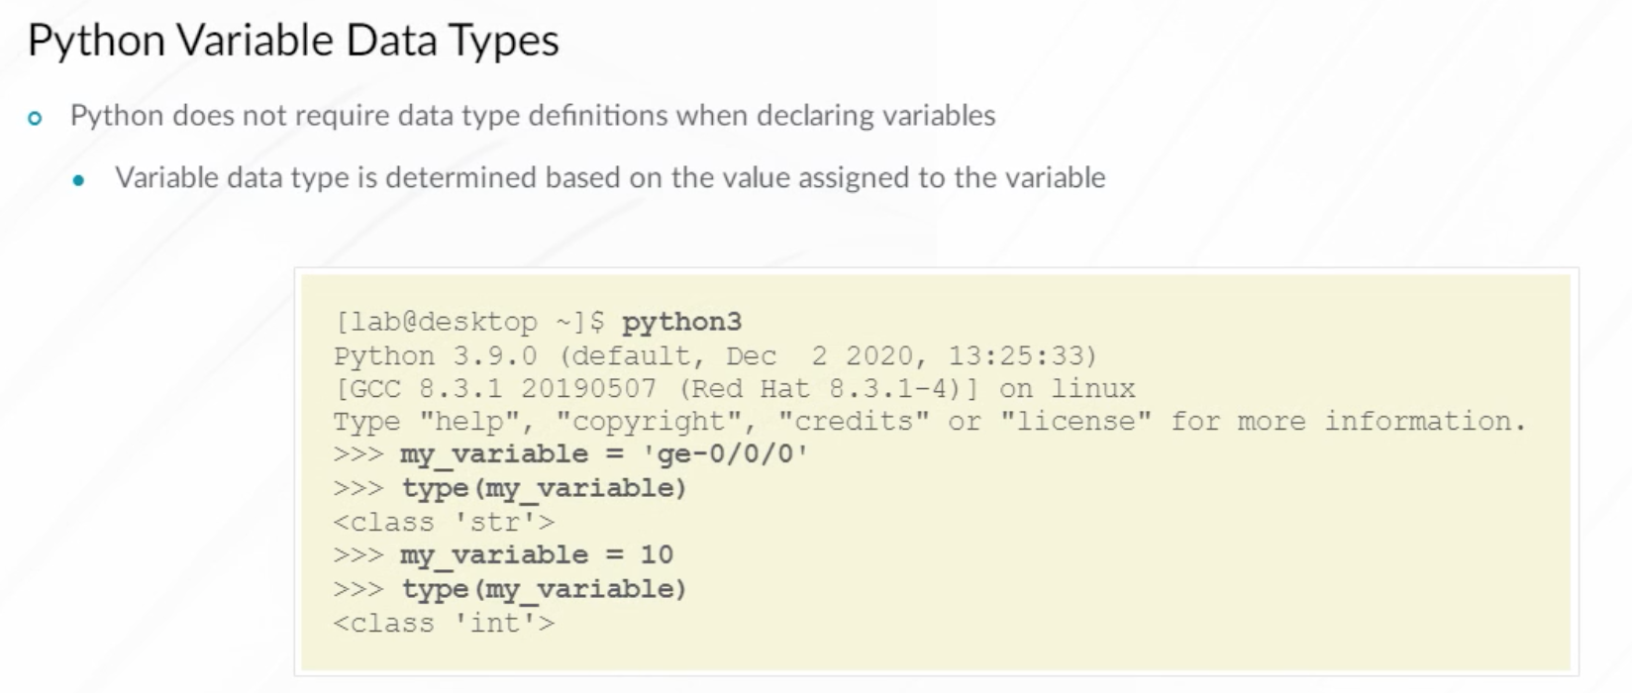

Python represents data as an object and all Python objects are classified as being either mutable or immutable. Mutable data types such as lists and dictionaries, can be modified after they have been created. Immutable objects cannot be changed after they are created. Numbers and strings are examples of immutable data objects.

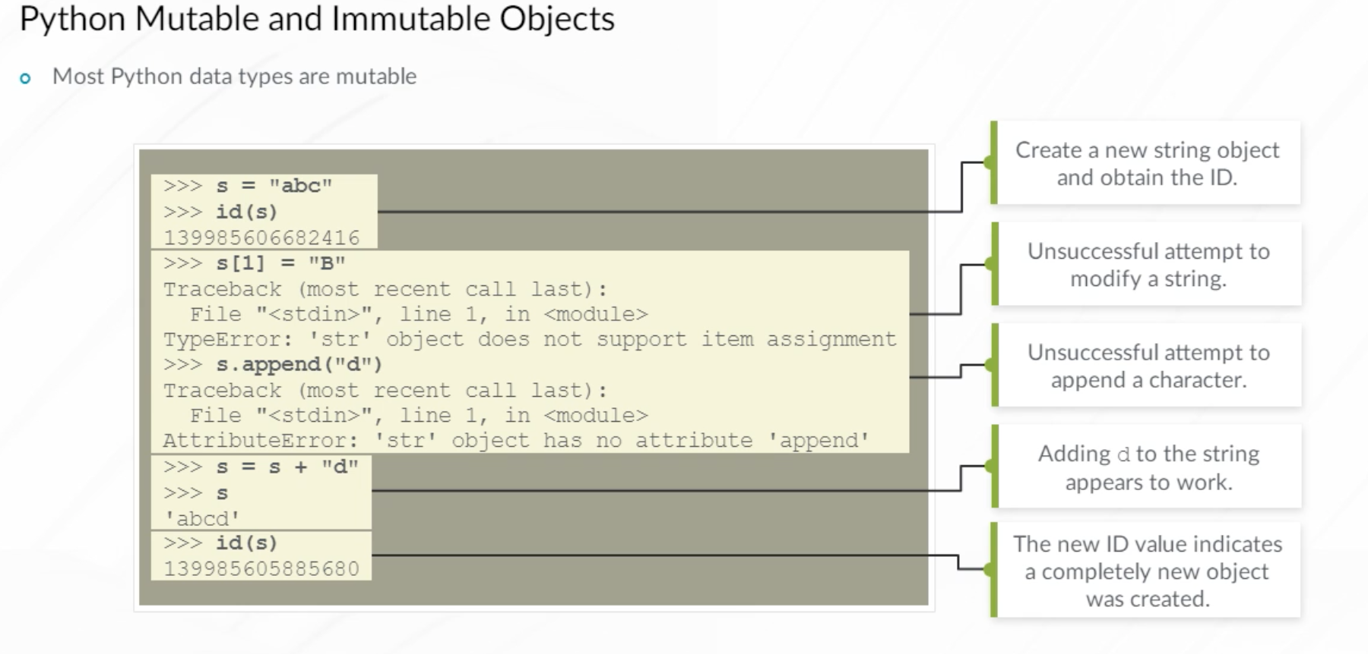

This example uses a number object, the number 3. Once the number object is created, attempting to change it displays the output shown.

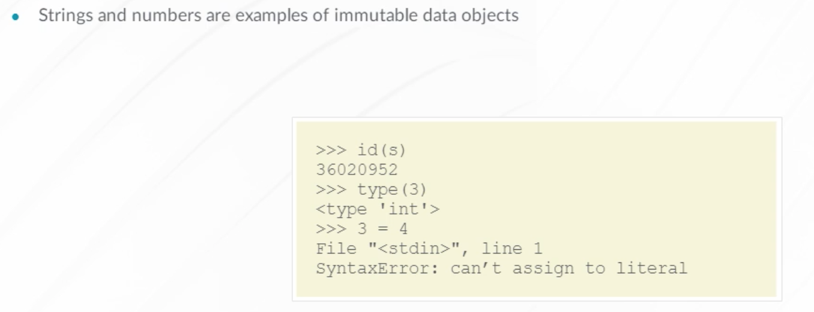

However, a variable pointing to an integer object can easily change its value and begin pointing to a different number object.

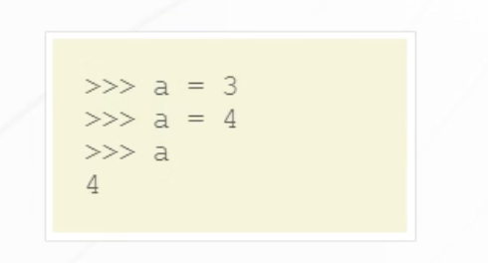

Python does enforce variable scope, sometimes referred to as namespaces. Each Python script or module has a global namespace. Variables defined in the global namespace can be referenced in any portion of the module's code. Variables defined within a Python module function, are only usable within that function. Global variables are usable in any namespace.

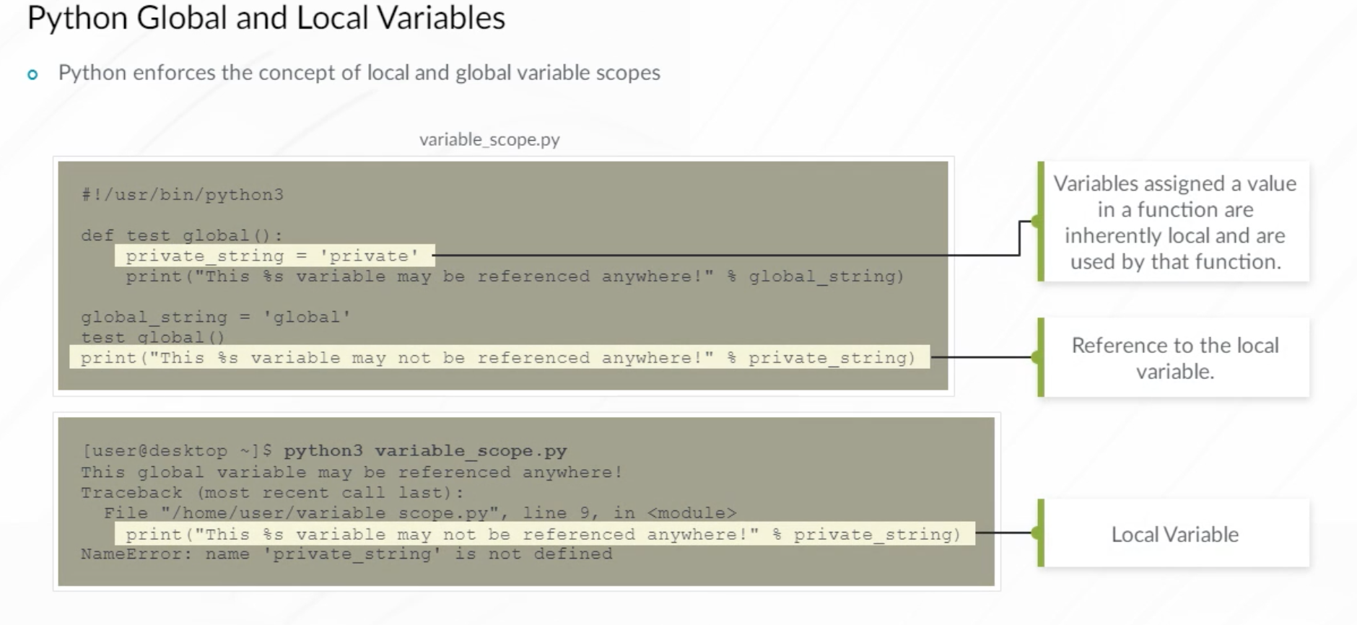

Python variables are referred to using names. Where a Python variable is defined in a script determines where the variable can be used. Blocks of Python code (such as functions and modules) are assigned a unique local namespace. When a variable name is referenced in Python code, the Python interpreter examines the function's local namespace to try and resolve the variable name. If the variable name is not found in the local namespace, the Python interpreter moves outward to any outer functions, then outward to the module's global namespace. Finally, the interpreter checks for any matching built-in Python module names.

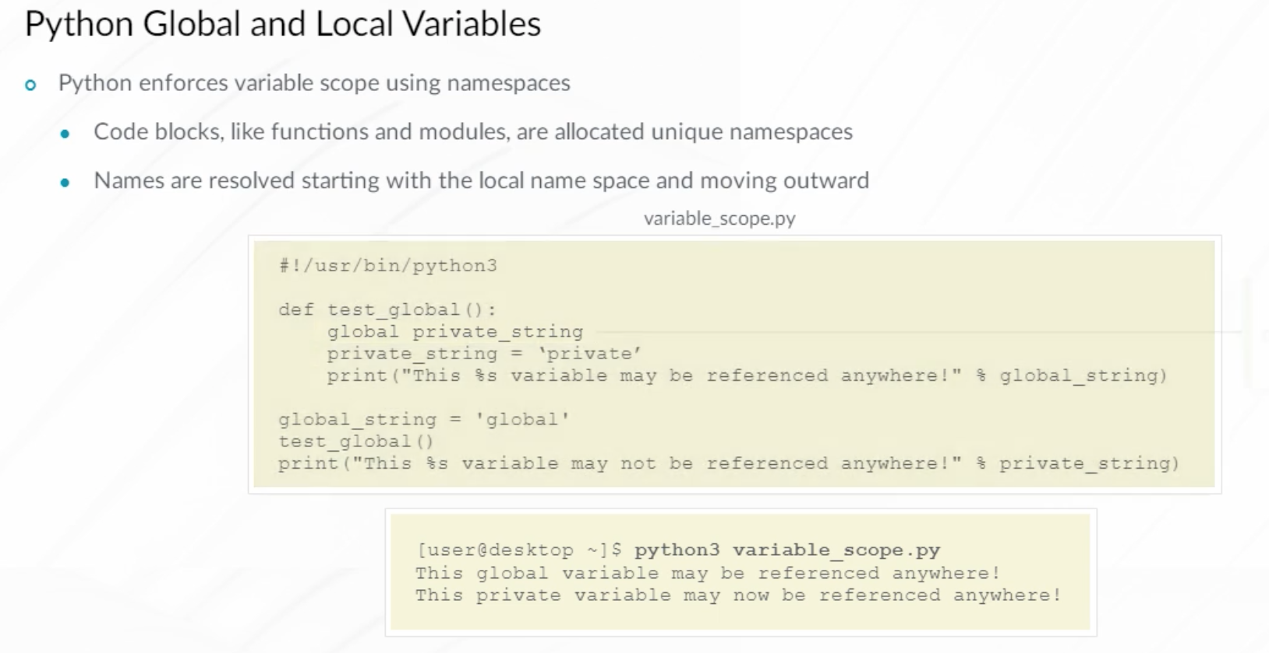

Python supports object-oriented programming. Object-Oriented programming permits you to create objects belonging to various classes. Each object exposes various methods that permit you to work with the object in a manner somewhat similar to how you work with physical objects. Objects are created using object classes which are similar to templates. Object classes define the object and all of its properties and methods.

A physical world object analogy is an automotive factory that has a template of a truck. When the factory produces truck objects, they use the truck template, not the template for a car. You can create custom object classes using Python. But here, you use pre-defined object classes from existing Python libraries like Junos PyEZ.

The syntax for creating an object is shown. The Truck1 = Truck() creates a new instance of a truck object class and saves a reference to the new truck object to the Truck1 variable. Object methods are functions that work with specific object class instances. For example, a truck object may have a drive method. The drive method can be called using Truck1.drive().

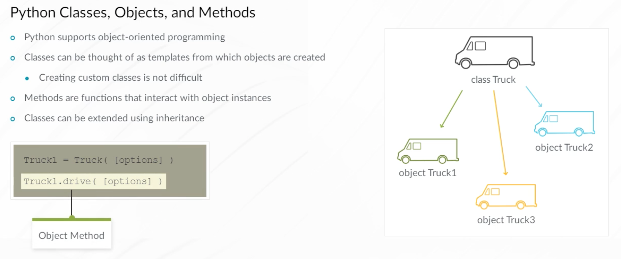

In the example, an empty Python list object is created using z = list(). A list is the name of a built-in Python object class. The z variable is used to reference the new list object. Next, the append() method of the z list object is called three times to add numbers to the end of the list. Finally, the resulting list is printed to the screen. For classes that are not built-in to Python, the convention is that class names start with a capital letter, for example, Truck, Device, and so on.

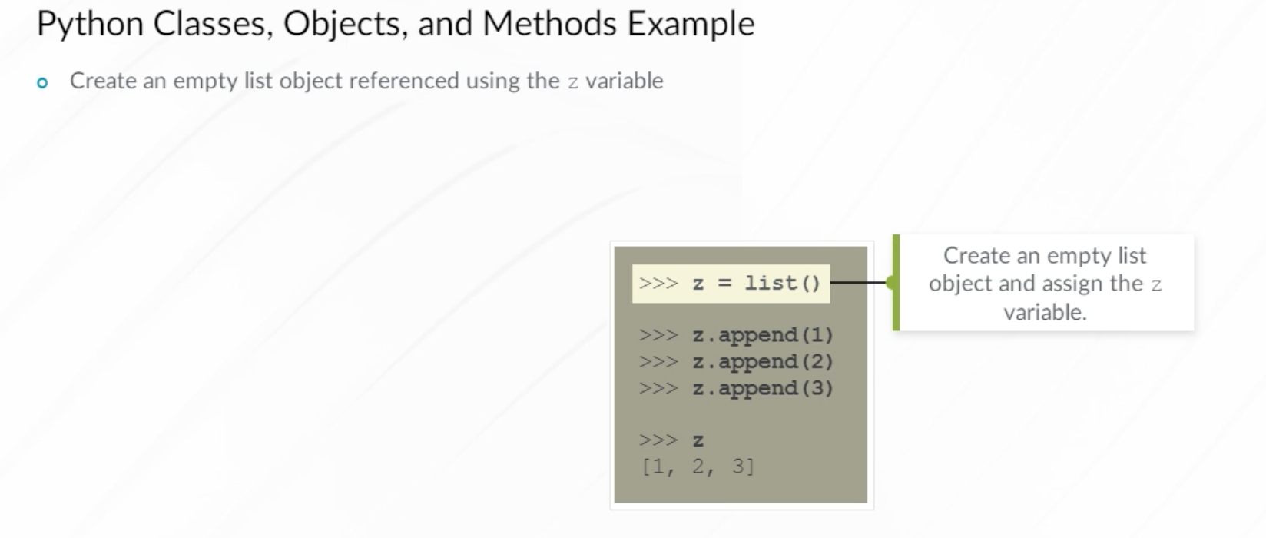

A list in Python is an ordered and, indexed sequence of elements. List elements can include different Python data types. List elements are indexed using numbers starting from 0. Indexing can also use negative values, indicating that counting starts from the right with the last element in the list.

The in operator checks if an element exists in a list. The Python len() function is used to retrieve the list length.

Multiple methods are available to manipulate lists. Some of these methods include:

* append(), which adds an element to the end of a list.
* insert(), which adds an element to an arbitrary position.
* pop(), which extracts and returns the last list element, removing it from the list.
* reverse(), which reverses the elements in the list.
* sort(), which sorts the list.

You can refer to Python documentation for more details on list methods and method parameters.

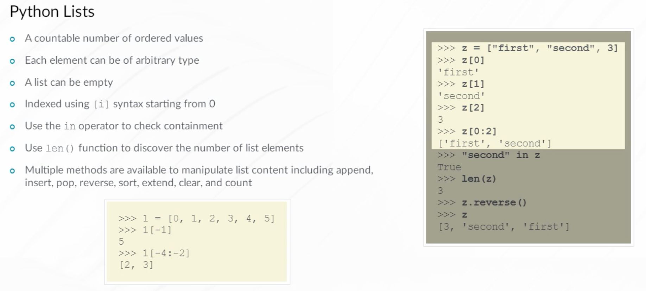

A common programming task is to apply an action to the elements in a list. The example demonstrates performing a nested loop. Someone playing Tic-Tac-Toe recorded the result as a board list (three rows with three character elements each). A nested for loop is used to print the data structure. The end=” ” parameter used with the print() function is specific to Python 3 and indicates Python to print a space after the value instead of creating a new line which is the default. To use the same syntax in Python 2, you would need to import the print_function.

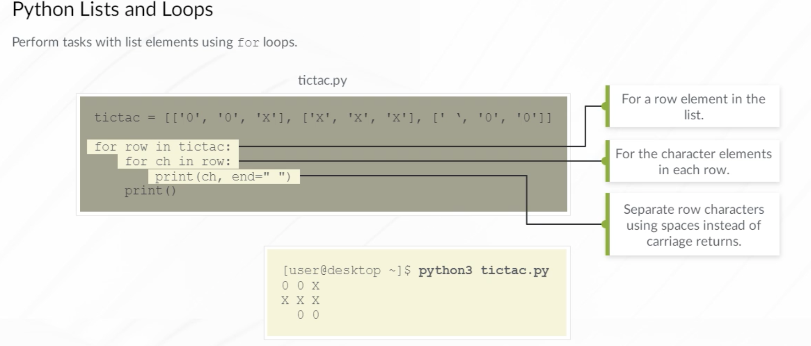

Another Python data type is the tuple. Tuples are similar to lists and have the following characteristics:

* Like lists, tuples contain an ordered sequence of values, and are indexed starting from 0.
* Unlike lists, tuples are immutable. Once you create a tuple object, it cannot be modified. However, it is possible to create tuples that contain references to mutable objects like lists.
* Tuples typically contain a heterogeneous sequence of elements while lists typically comprise homogeneous elements. For example, a tuple may be returned as the result of a database query because the different database table columns contain different data types.
* Tuples use parentheses instead of square brackets.

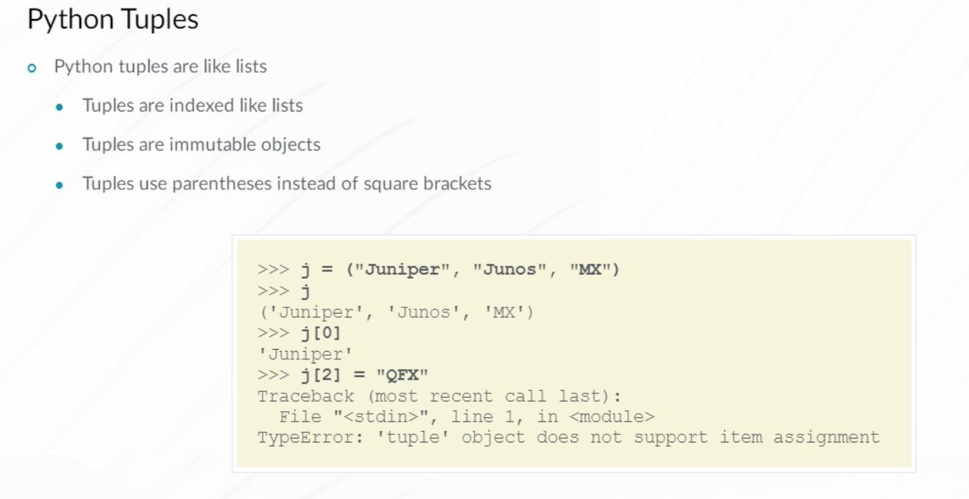

A Python dictionary is an unordered collection of key/value pairs. Because of the specifics of how data from dictionaries is stored, the order of keys in a dictionary is not preserved. Hence the unordered characteristic. This means that when performing a for-each loop over a dictionary’s keys, you should not expect to see the keys returned in the same order in which they were added to the dictionary.

You can check for the presence of a key in a dictionary using the in operator. The value corresponding to a key can be obtained using [key] syntax, and if the key is not present in the dictionary, a Python exception is generated. Another way to check for the presence of a key is the get(key) dictionary method. This method displays None, if the key is not present in the dictionary. To create a new entry in the dictionary, simply assign a value to a non-existing key. To delete a key and its corresponding value from the dictionary, use the del method.

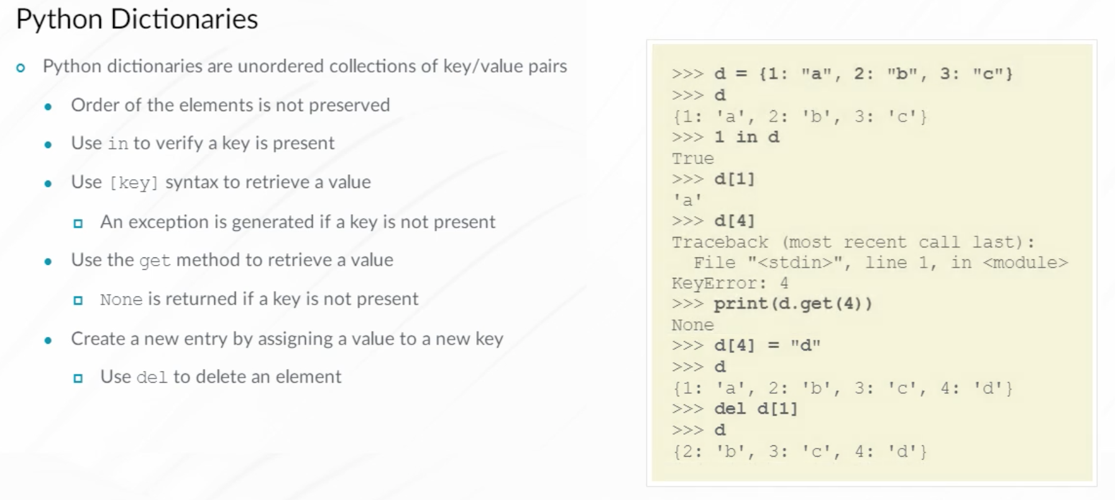

Dictionary values can be any data type, including nested dictionaries and lists. Only certain Python data types can be used as dictionary keys. Dictionary key data types must be immutable objects like numbers, strings, and tuples. Lists are mutable objects and do not qualify to be used as keys. Although uncommon, the data types of keys in the same dictionary can be different.

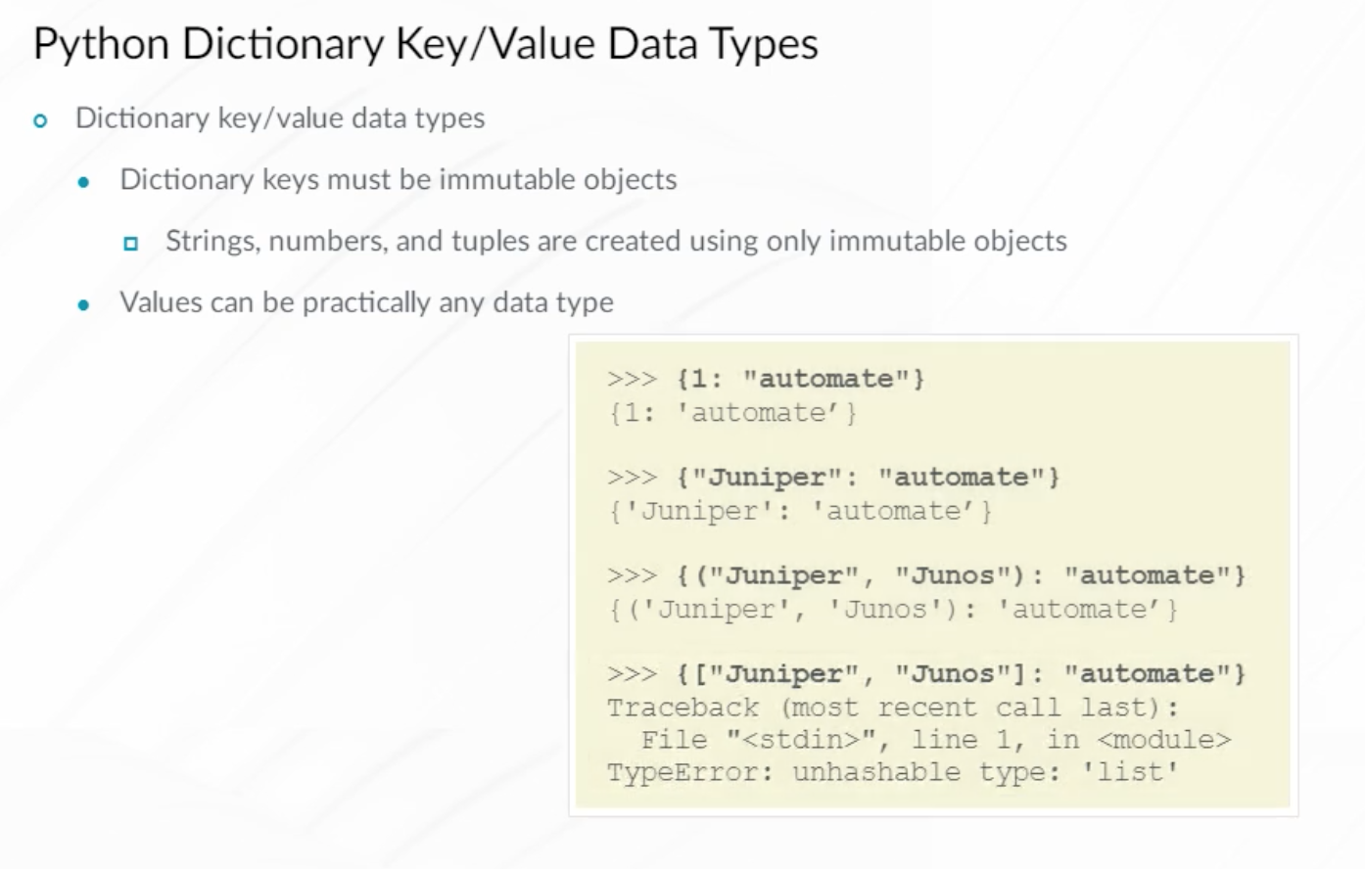

There are multiple ways to iterate over the elements in a dictionary. Two options are shown in the example. Remember, the order in which you retrieve the keys in a dictionary using a for loop is generally not the same order in which the keys were added. Dictionaries are also not sorted in any way by default.

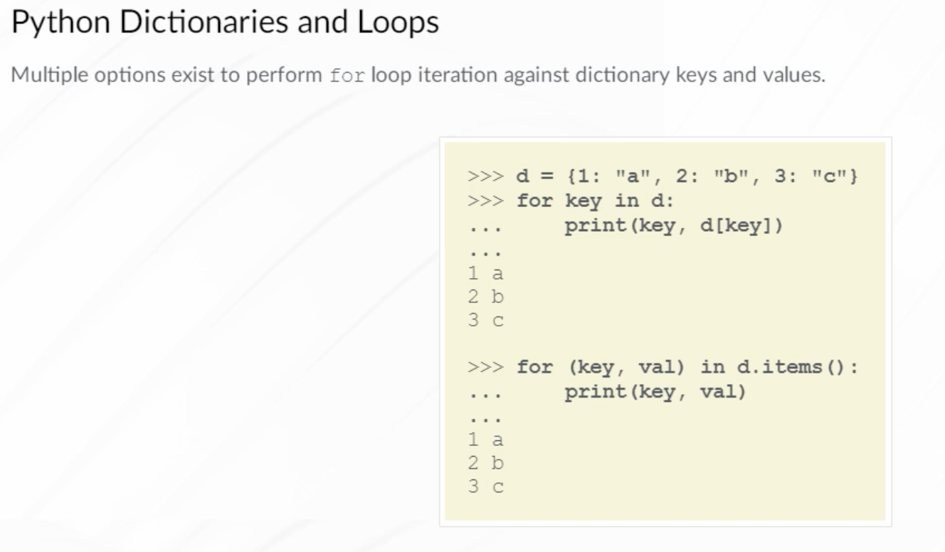

Python sets are unordered collections of unique elements. Similar to dictionary keys, only immutable objects can be used. In contrast to dictionaries, Python set elements only have keys and no values. Mathematical operations like intersections and difference are supported as shown in the example.

Performing an intersection operation on two sets, for example, sets A and B, results in a set that contains all elements of set A that are also present in set B. For example, the intersection of {'c', 'd', 'e'} and {'b', 'd', 'a', 'c'} is {``'d', 'c'}.

The difference between two sets, for example, sets A and B, results in a set of elements that are present in A but not present in B. For example, the difference between {'b', 'd', 'a', 'c'} and {'c', 'd', 'e'} is {``'b', 'a'}.

An A.update(B) method adds all elements of set B to set A. If an element already exists in a set, no action is performed on that element.

Note that the intersection() and difference() methods return new sets, while the update() method modifies the existing set.

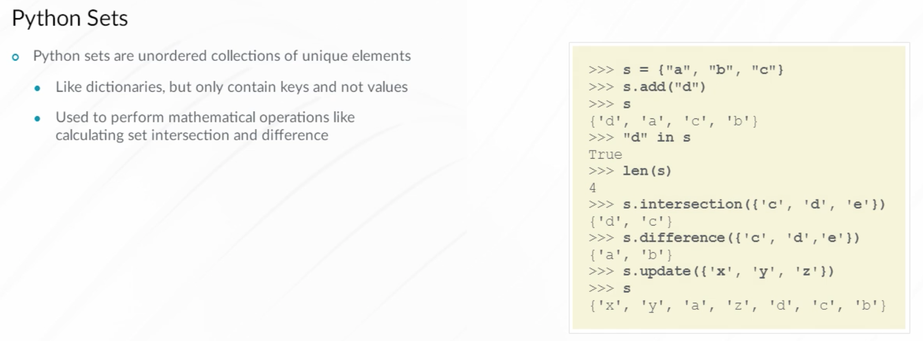

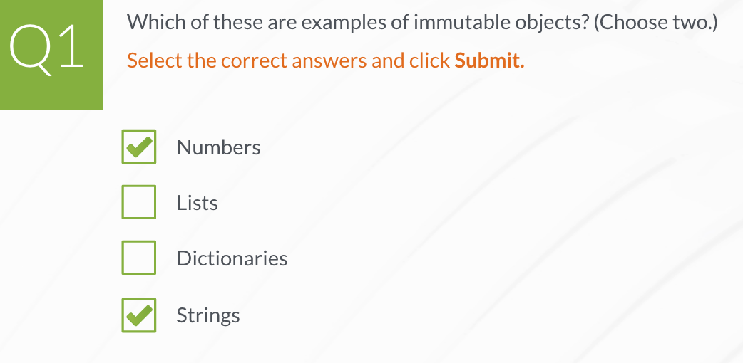

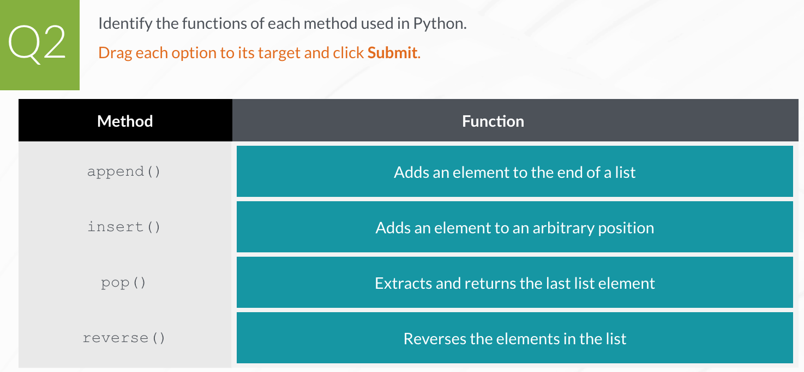

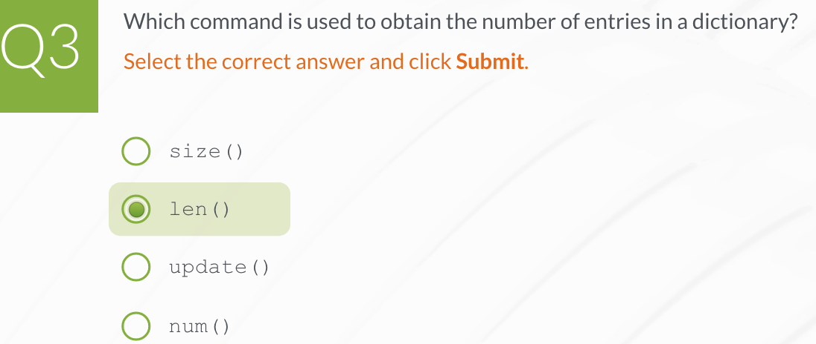

**Installing and Using Python Modules**

A Python module is a single file containing Python code. The module file name is user defined and typically ends in a .py file extension. Organizing Python code in different modules is useful when similar functionality is required by multiple Python scripts. Python modules can import functionality from other modules, facilitating re-use of existing code.

A Python package is a directory containing a collection of Python modules. The Python Standard Library, included as part of a standard Python installation, has multiple packages and modules that greatly extend the functionality of Python. There is also a public central repository for Python packages and modules called the Python Package Index (PyPi). Code residing in this repository is well-documented and can be used for your own projects to extend Python’s functionality. Python has an active developer community and programmers share code that may be useful for your own projects. Don't look to reinvent the wheel. There may be a piece of Python code that is already built that meets your needs.

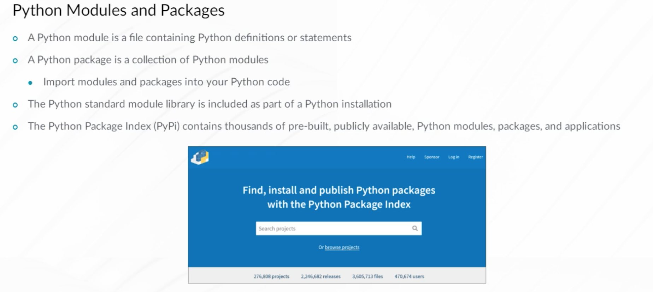

Modules in the Python Package Index are not included in the base Python library. The pip utility, pre-installed on many Linux distributions, is used to install Python Package Index modules and packages. The example demonstrates using pip to install the Python paramiko package.

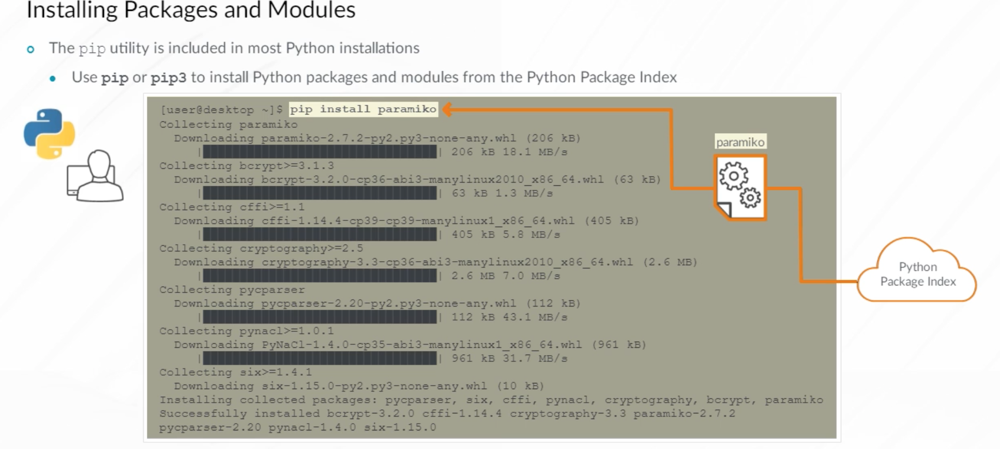

To use the functionality provided by a package or a module, import the package or module using the import keyword, along with the name of the package or module. Once imported, you can reference the objects, methods, and functions defined in that package using the name of the package followed by a dot (.) and the name of a package method.

This example demonstrates using an import statement to import the re (regular expressions) module from the standard Python library. The Python interpreter is now able to use the match function provided by that module using the re.match syntax. As an alternative, you could use the from re import match statement. This imports only the match functionality of the re module and permits you to reference the match() function without including the module name.

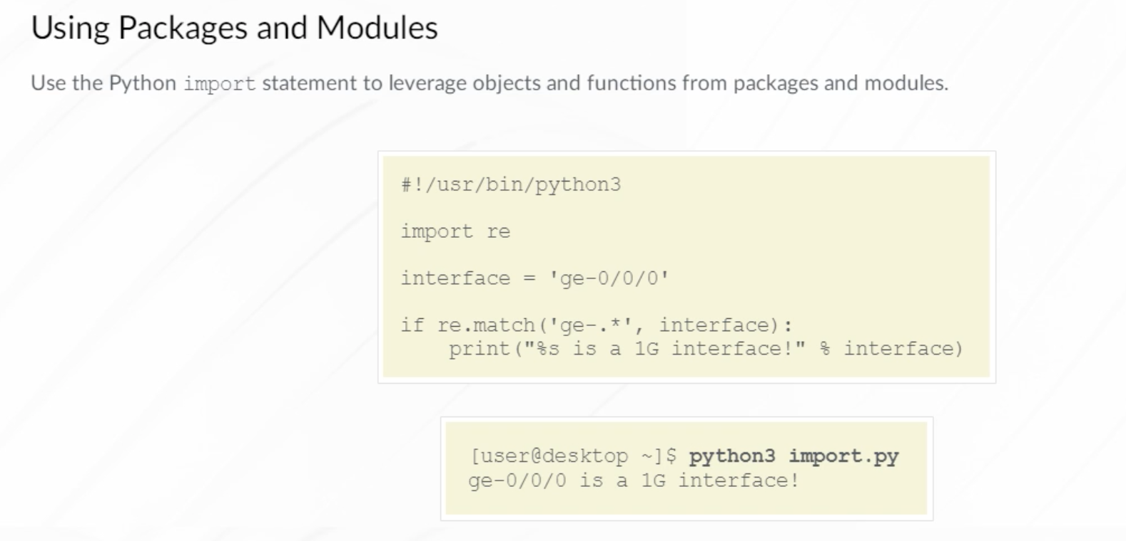

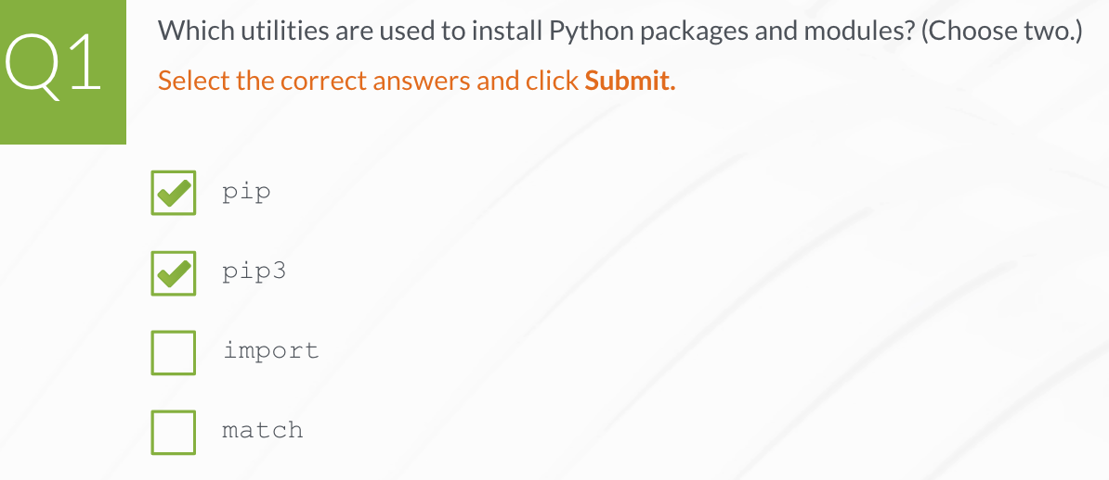

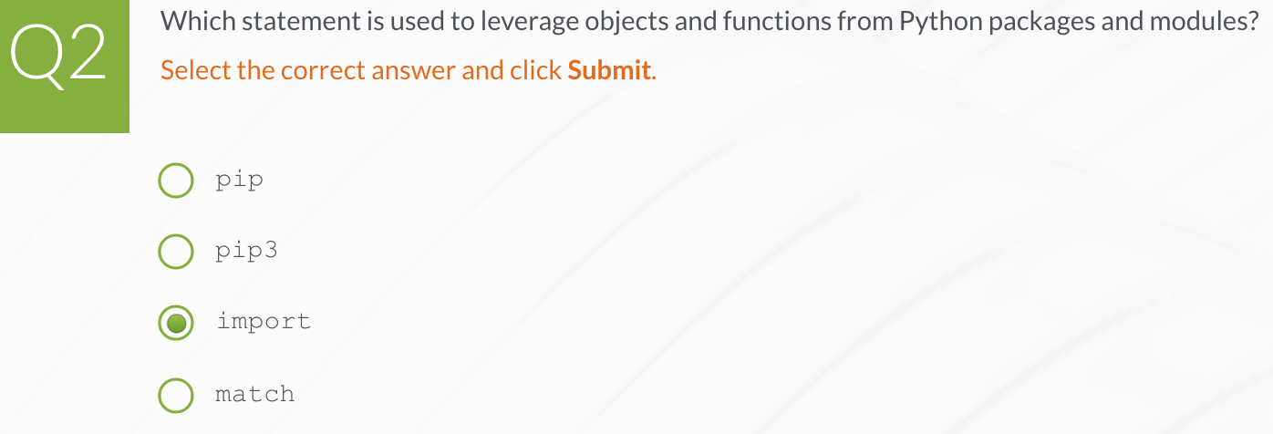

**Executing Python Scripts**

You want to use Python to automate the process used to copy a new software image to Junos devices. The new Junos software image should be copied from your management workstation to the /var/tmp directory on the Junos devices.

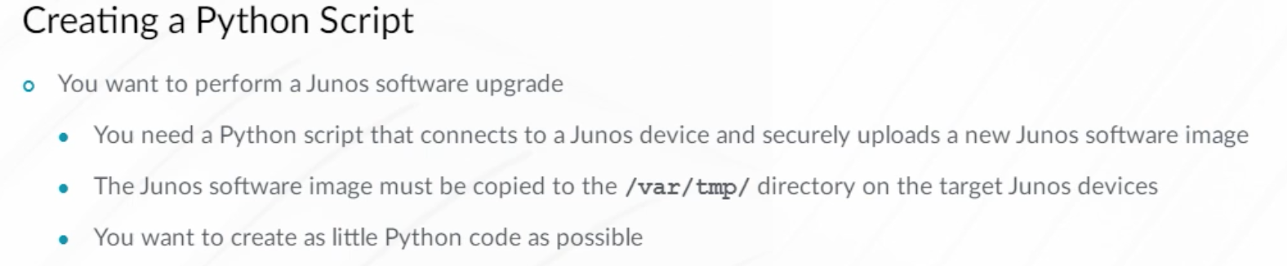

To copy a new software image to a Junos device, several actions must complete successfully. Your Python script must establish a connection to a Junos device, authenticate successfully, securely copy the software image file, and finally close the connection. Each action requires instructions in Python code to complete the task. Writing Python code to accomplish each action requires advanced programming knowledge and a good bit of time.

Remember that Python supports importing pre-existing modules that add additional functionality to your Python code. The Python script used in this example leverages pre-existing modules from the Junos PyEZ library. These pre-existing Python modules can perform each of the actions required to successfully copy a new software image to your Junos devices.

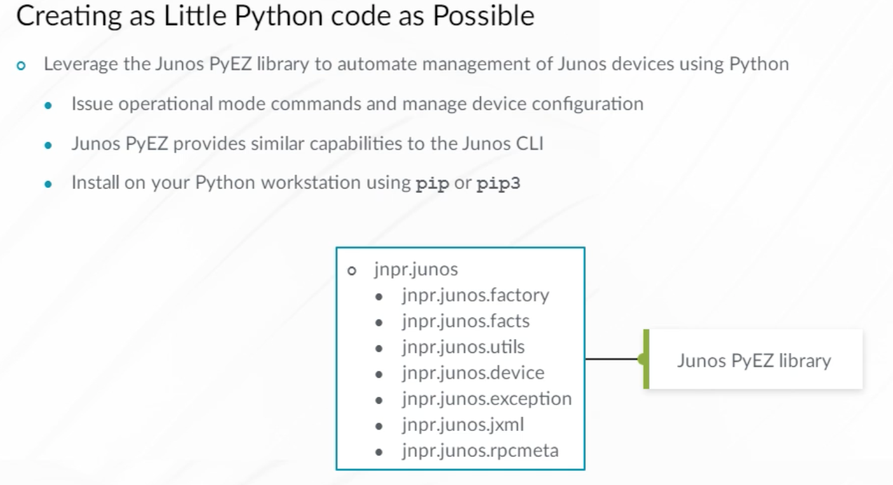

The example Python script imports the Device and SCP modules from the Junos PyEZ library. A device object is created representing the 172.25.11.1 device. Using Python context manager with as syntax automatically opens and closes the connection to the target device. The SCP object establishes an SCP session with the target device and copies a software image file to the /var/tmp directory. The SCP object progress option is included in the script to display output related to the copy process.

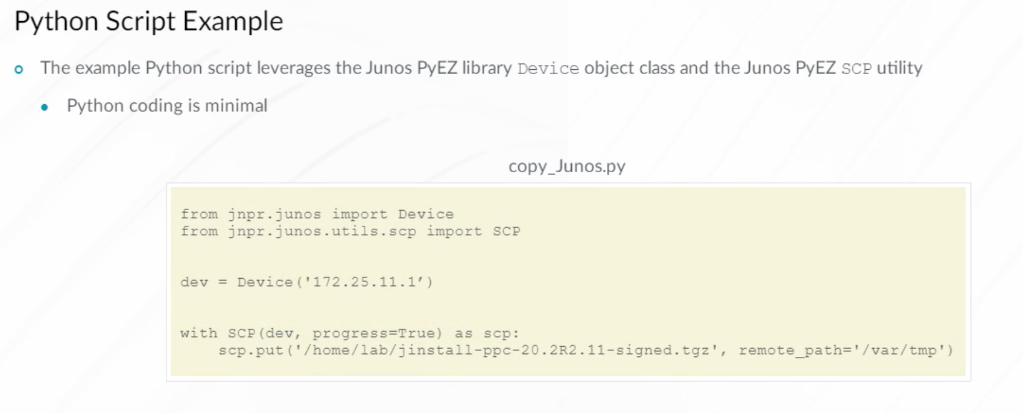

The example script is run. Remember, the SCP object progress option was included in the example Python script. Progress information related to the secure copy operation is displayed in 10 percent increments.

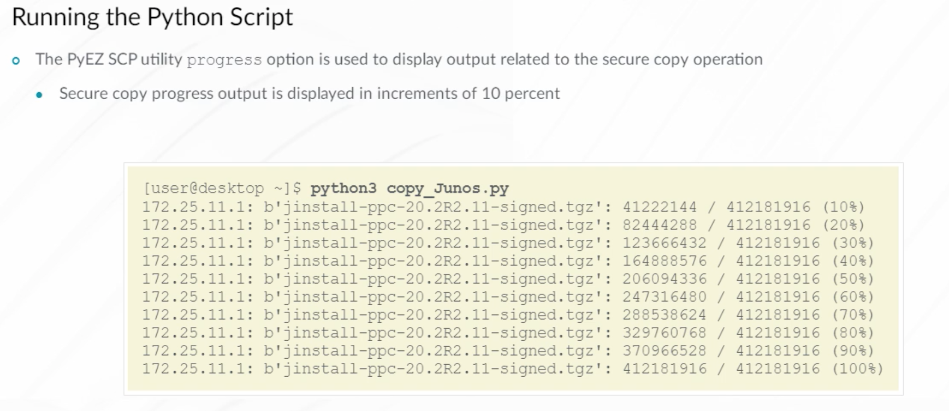

Let's look at another example. You want to verify whether the software image file was successfully copied to a device. This Python example demonstrates importing and using the Junos PyEZ StartShell module to execute a Unix ls command on the /var/tmp directory on the target device. The results are printed on the screen. The opening and closing of the device connection are performed manually.

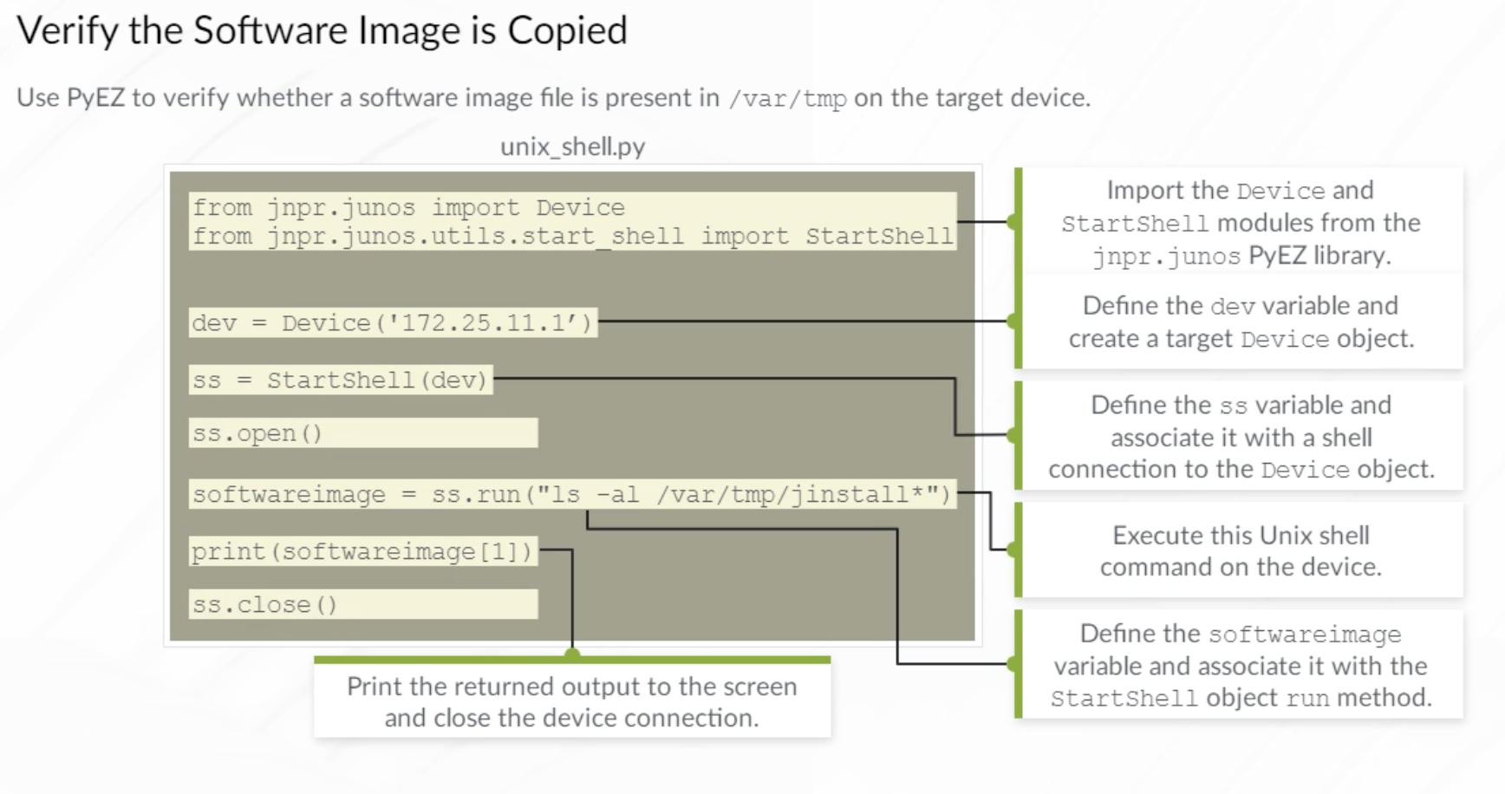

The Python script is executed demonstrating that the software image is present on the target device.

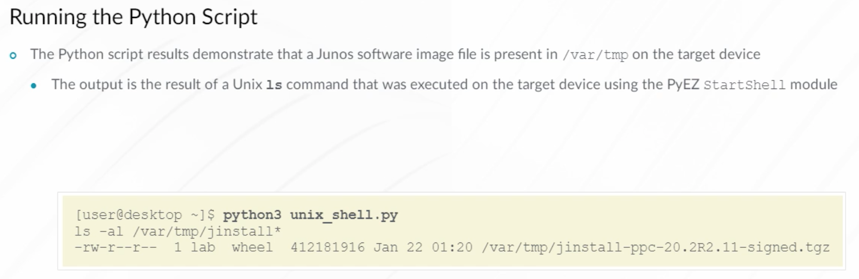

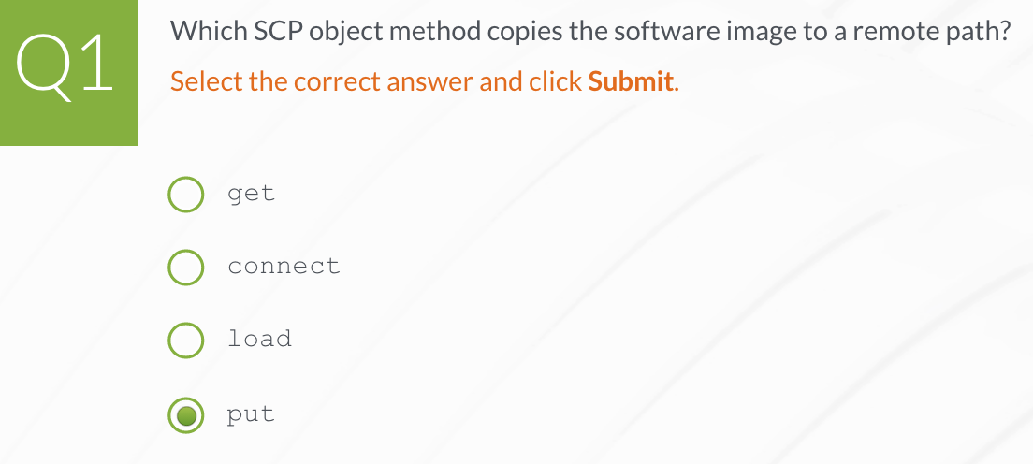

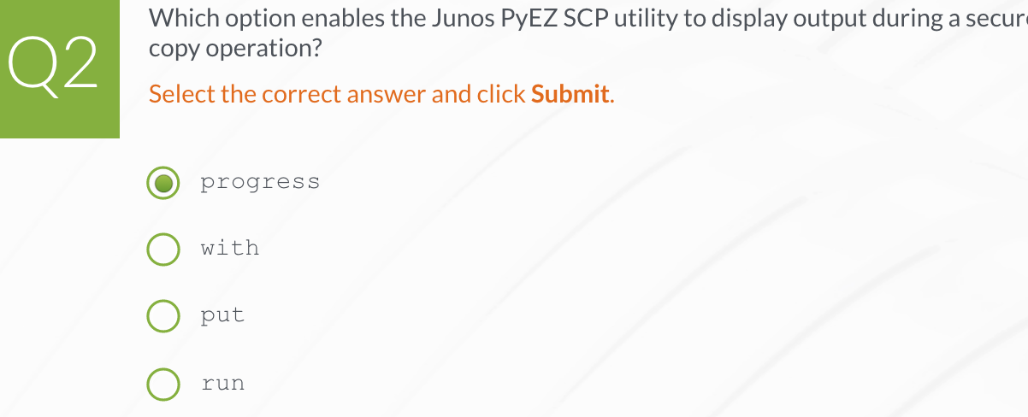

1. **Junos PyEZ operations**

**Junos PyEZ**

Junos PyEZ is a Python microframework used to manage and automate Junos platforms. A microframework is a package or library providing code that is useful for other larger applications. Junos PyEZ is designed to provide the same capabilities as the Junos CLI and to make automating and managing Junos devices using Python easy.

Extensive Junos knowledge is not necessary. Junos PyEZ libraries are also leveraged by automation systems like Ansible and Salt as well as the Juniper Snapshot Administrator in Python (JSNAPy) tool.

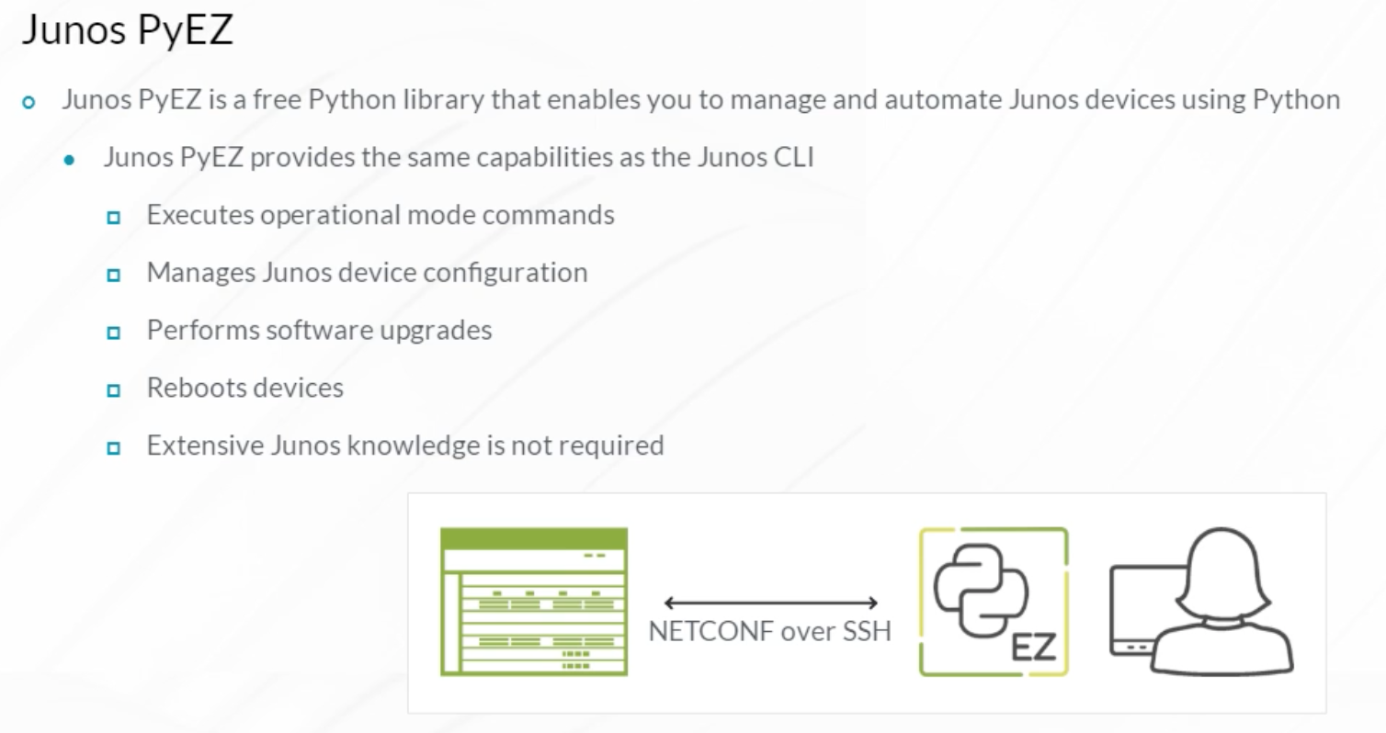

Junos PyEZ consists of the jnpr.junos Python package. A Python package is a collection of modules that provide methods, functions, and classes to use when creating custom Python scripts and programs. Junos PyEZ is Apache 2.0 open-source licensed and supports Python 2.7 or 3.4 or newer. Source code is available at the **GitHub** website. You can access the website from the Reference Links document. Junos 11.4 or later is recommended. Starting with Junos 16.1R3, Python and Junos PyEZ are also available for on-box scripting, such as commit, op, and event scripts.

There are a number of relevant modules. Some of the main ones are discussed here:

* The device module provides Python code capable of connecting to Junos platforms and printing device facts.
* The utils module consists of Python utilities used to manage device configuration, securely copy files, perform file system operations, and install Junos software.
* The command and ops module provides the predefined tables and views used to extract specific information from the operational mode output returned from devices.
* The resources module provides the predefined tables and views used to configure specific device resources.
* The exceptions module provides Python exception handling capabilities.

This module uses PyEZ 2.5.4. Updated releases are frequently made available. Check the documents at the **Junos PyEZ’s documentation** page or follow **Juniper’s GitHub** page for the latest information. You can access the webpage from the Reference Links document.

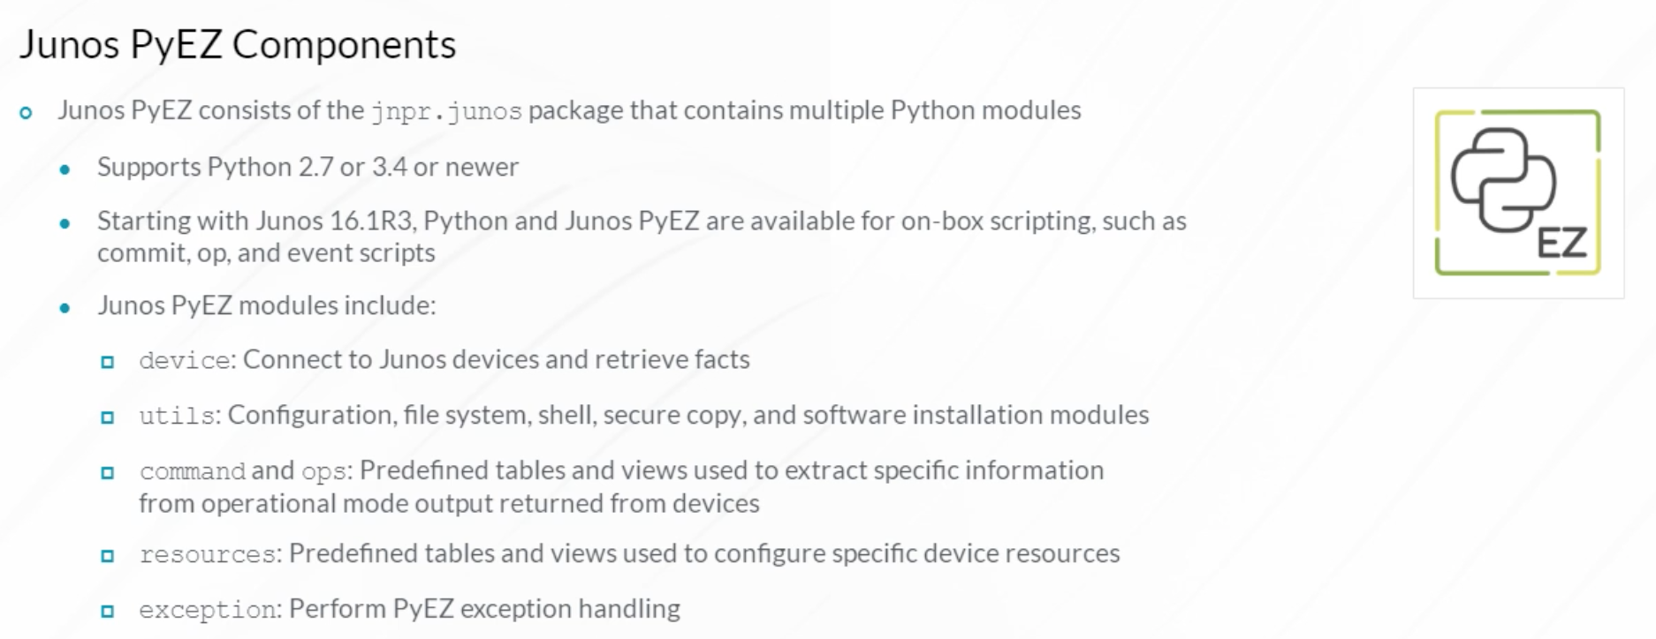

The Junos PyEZ package contains modules and sub-modules. The utils module is a directory with a number of Python sub-modules that are useful for performing functions on Junos platforms. The syntax and APIs for the modules are similar. Some of the modules available in the utils directory include:

* config, which performs Junos device configuration operations.
* fs, which manages the Junos file system.
* scp, which securely transfers files such as software images and logs.
* ftp, which has capabilities similar to scp using the FTP protocol.
* start_shell, which accesses a device Unix or Junos shell.
* sw, which performs automated software upgrades.

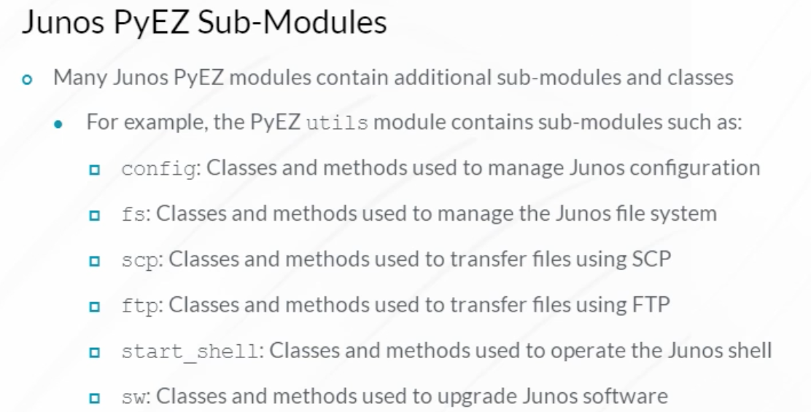

This example uses the Python 3 pip3 utility to install Junos PyEZ on a CentOS Linux workstation. Note that windows, OS X, and FreeBSD are also supported. The package is named junos-eznc. To verify the installed version of Junos PyEZ, issue a pip3 list | grep junos-eznc command from the workstation Terminal prompt. If you are using Python 2, substitute pip for pip3.

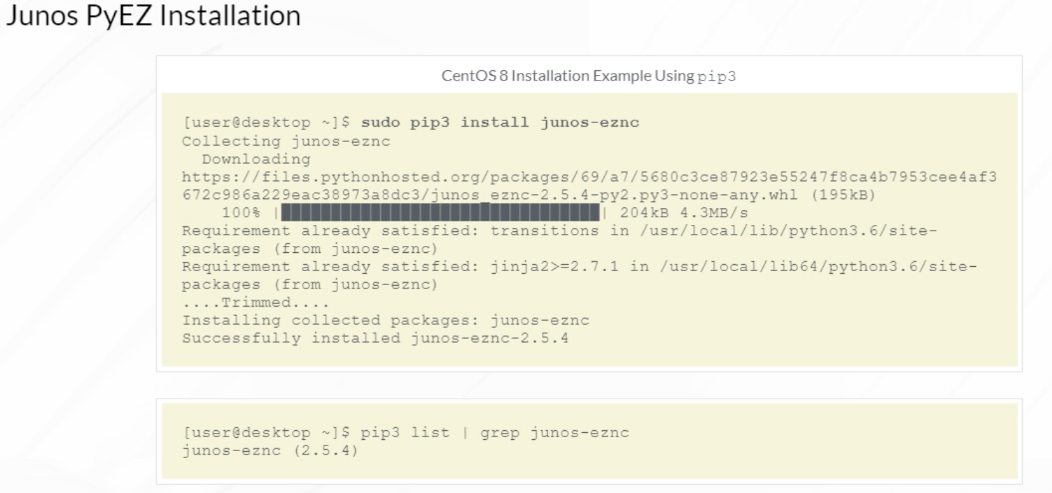

There are prerequisite software packages and libraries that must be installed before the Junos PyEZ package. Here are the packages and libraries required to install Junos PyEZ on a CentOS Linux host:

* pip
* gcc
* python-devel
* libxml2-devel
* libxslt-dev
* libssl-dev
* libffi-devel
* openssl-dev
* redhat-rpm-config

You can view the details for each package/library in the Resources section of this module.

Refer to the Junos PyEZ Developers Guide for software prerequisites for a particular operating system.

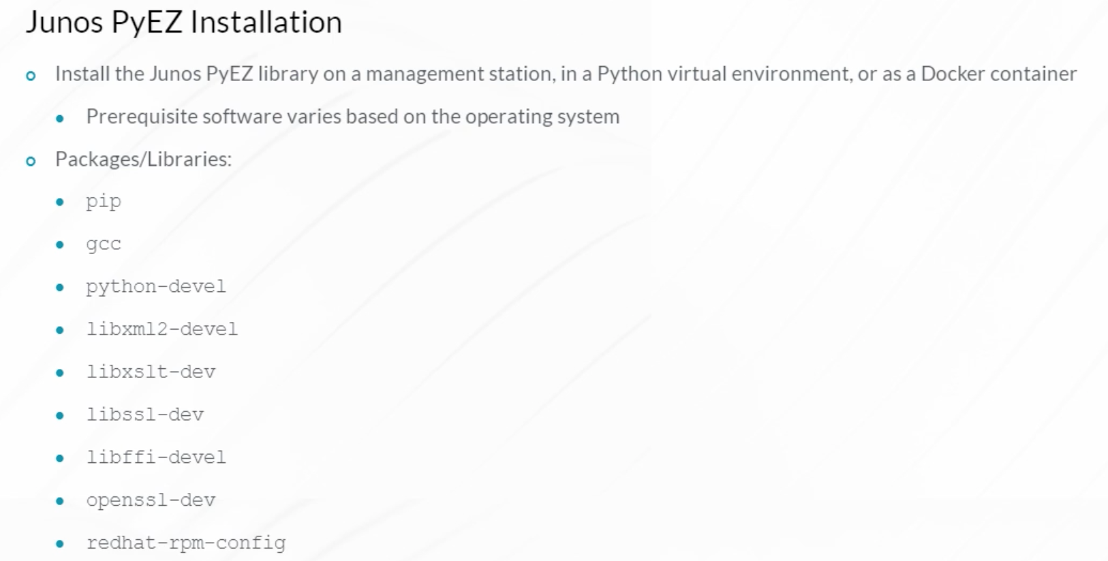

Junos PyEZ was originally developed to run over a Network Configuration Protocol (NETCONF) connection. Since the release of Junos PyEZ 2.2.0, it can also connect to devices using Telnet and serial console connections. NETCONF over SSH is the default and most common connection method but a console or Telnet connection through a terminal server can be useful for Junos devices in a factory-default configuration state. Junos PyEZ versions 2.2.0 and later also support device-initiated connections to facilitate management of devices that do not support inbound connections or are behind a firewall.

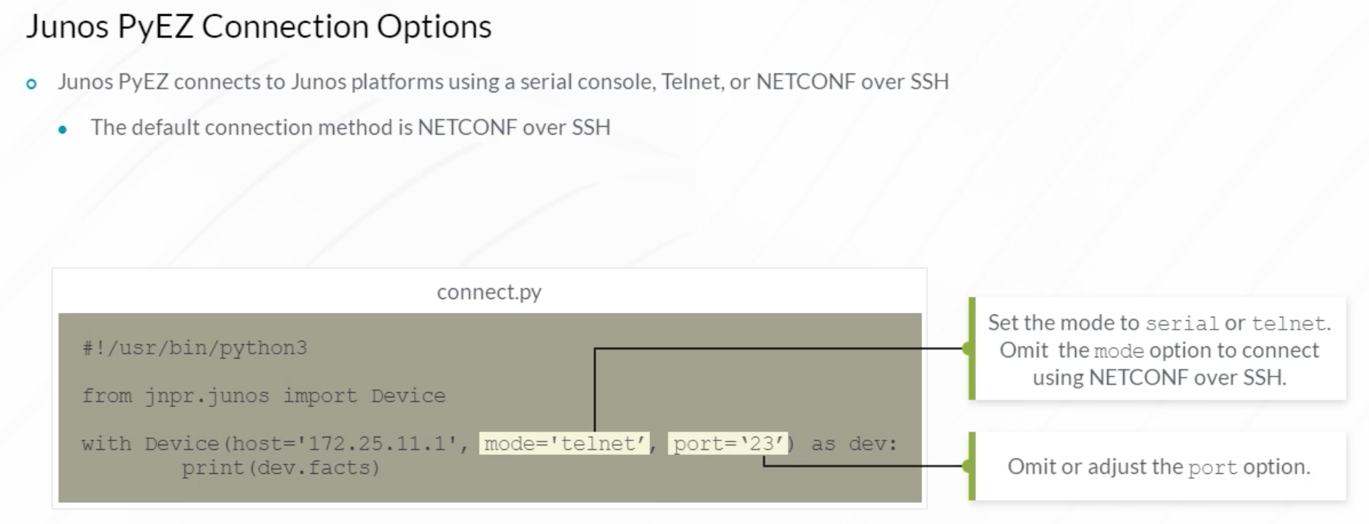

Remote management protocols are configured on Junos devices to enable remote Junos PyEZ connections. By default, Junos PyEZ connects to devices using NETCONF over SSH on TCP port 830. The TCP port used for a NETCONF connection can be changed using Junos device configuration settings. The example demonstrates enabling NETCONF over SSH. If necessary, the Telnet protocol can be enabled.

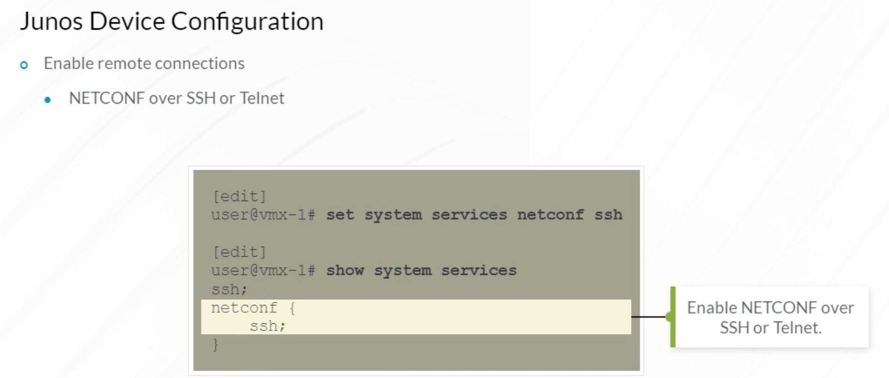

Connecting to Junos devices requires authentication. When a Junos PyEZ Python script attempts to connect to a device and perform actions, it must authenticate using an account with sufficient permissions to perform those actions. The Junos operating system uses login classes to enforce administrator privileges and permissions. The Junos built-in super-user login class provides sufficient permissions for Junos PyEZ to perform all supported operations. If you prefer to use a more restrictive account, create a custom login class with the appropriate permissions, and assign the account used for PyEZ connections to the new login class.

The example shows configuring a user named lab. The lab user account is associated with the built-in super-user login class, and is configured to support authenticating with a username and password as well as a public key. Public key authentication is recommended because it is the most secure and convenient method.

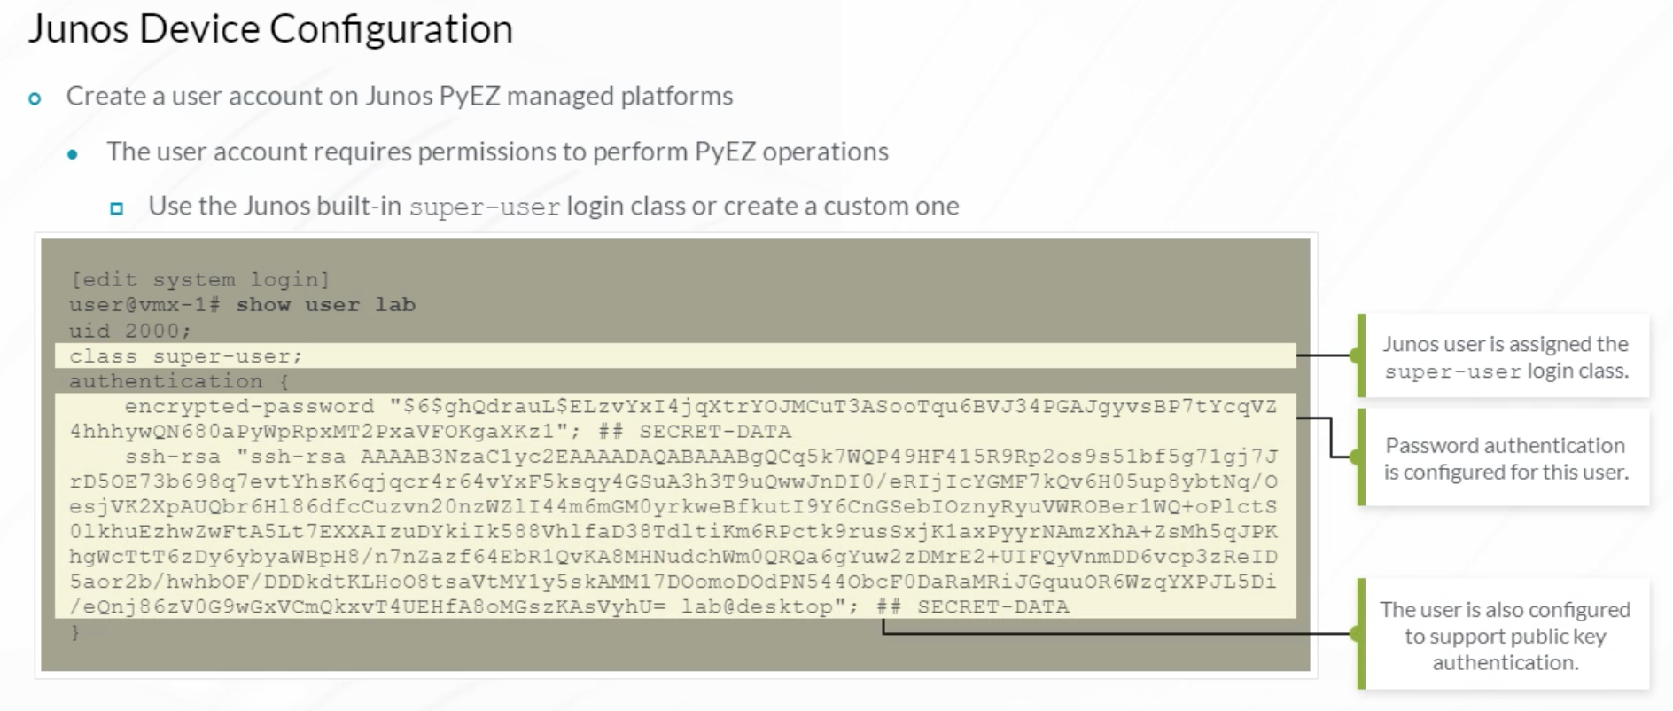

Now that the Junos devices are configured, and Junos PyEZ is installed on your workstation, you can begin the process of managing the devices using Python code. This example demonstrates a Python script that leverages the Junos PyEZ package. The Python script imports the Junos PyEZ device object class from the jnpr.junos module. A variable named (dev) is created to represent a connection to the target host. The device open and close methods are used to establish and terminate the NETCONF/SSH connection with the target device. The device object facts method is called to print facts about the target device to the screen.

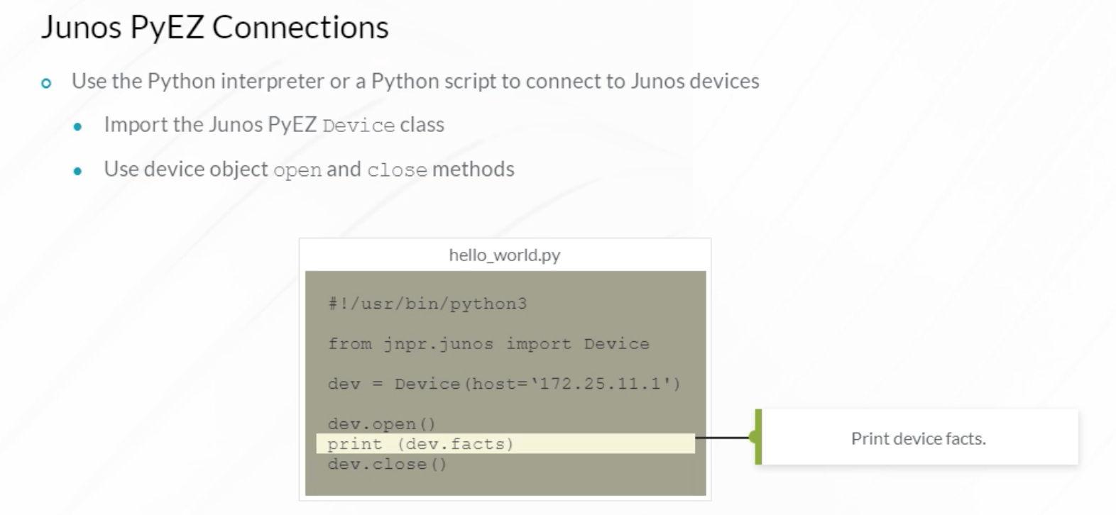

Device facts output includes information such as the device model, software version, serial number, and so on. All of the scripts given here were developed using Python 3. The scripts should function identically in Python 2. The script authenticates with the Junos device using the Junos PyEZ default method of SSH public-key authentication.

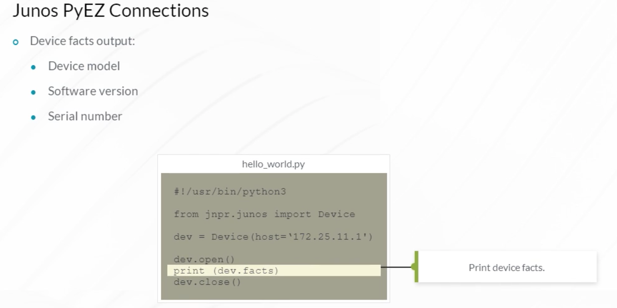

Except for lab and testing purposes, it is recommended that you do not store device usernames and passwords in Python scripts. In a production environment, use SSH public-key authentication.

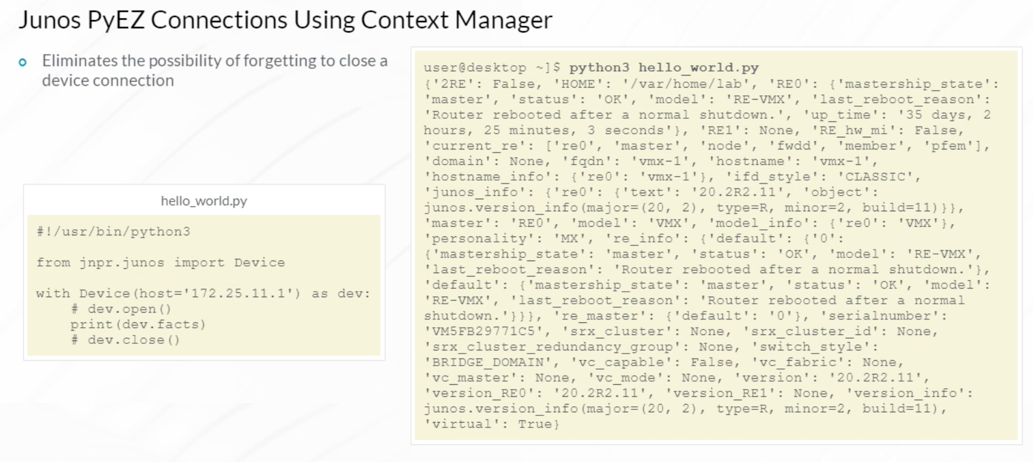

This example demonstrates a slightly different method of writing the same Python script. You can simplify scripting the Junos device connection by leveraging Python’s context manager protocol syntax. The Python context manager protocol includes __enter__() and __exit__() methods that are called automatically when using Python with/as syntax.

For a device class object, the __enter__() method opens the connection and the __exit__() method closes it automatically so you do not have to call the device open() and close() methods explicitly. This eliminates the possibility of forgetting to close a device connection. Note in the example that the print(dev.facts) function must be indented in relation to the with/as statement to demonstrate the nesting of that block of code. Similar automatic open and close functionality can also be achieved using Python try/except/finally statements.

Storing usernames and passwords in scripts is discouraged for security reasons. The most convenient and secure method to authenticate device connections is using public keys. To authenticate using public keys, a public/private key pair is generated on the management workstation. The public key is copied to the managed Junos devices and automatically used during the PyEZ device connection process to authenticate the connecting user.

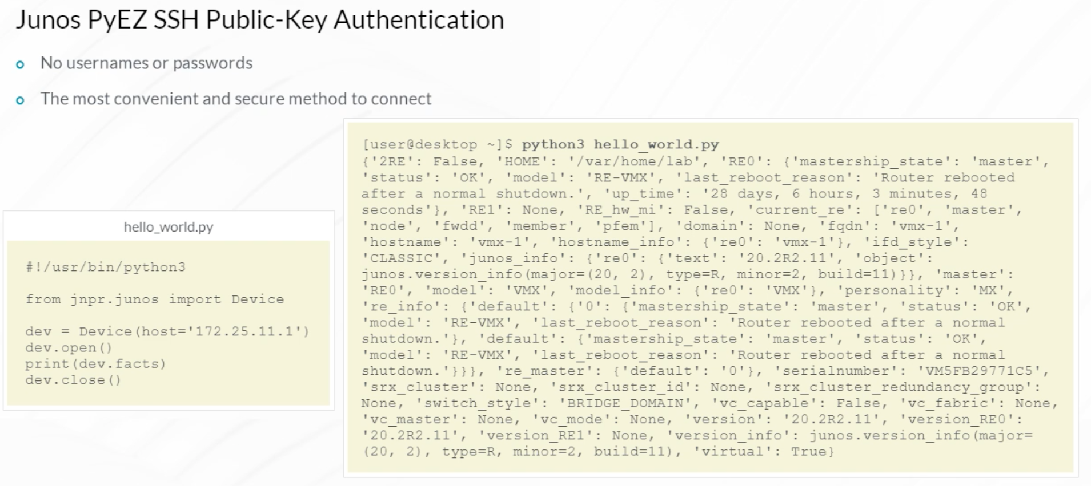

Once you have determined a user account on the Linux management host that will be used to log in to the Junos devices, generate a new public/private key pair for that user. As shown in this example, the ssh-keygen utility is used to generate a public/private key pair that can be used to authenticate during the SSH device connection process. There is an option to add a passphrase that is used to protect the SSH private key. You can also specify the key filename. After generating the SSH private/public key pair, copy the public key to every Junos device with which the management host will interface.

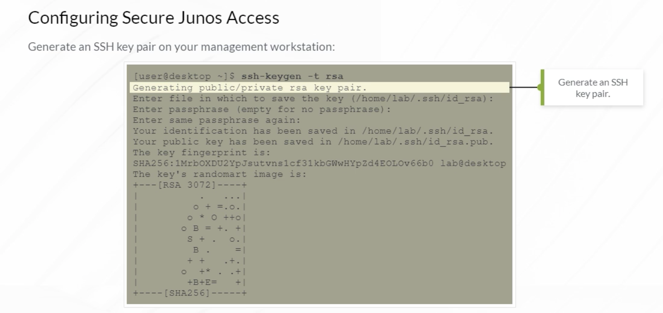

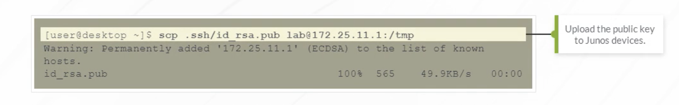

Configure the authorization and authentication parameters for the Junos user account on all relevant devices. Instead of enabling plain-text (username and password) authentication, configure SSH public-key-based authentication by specifying the file path of the public key that was copied to the device.

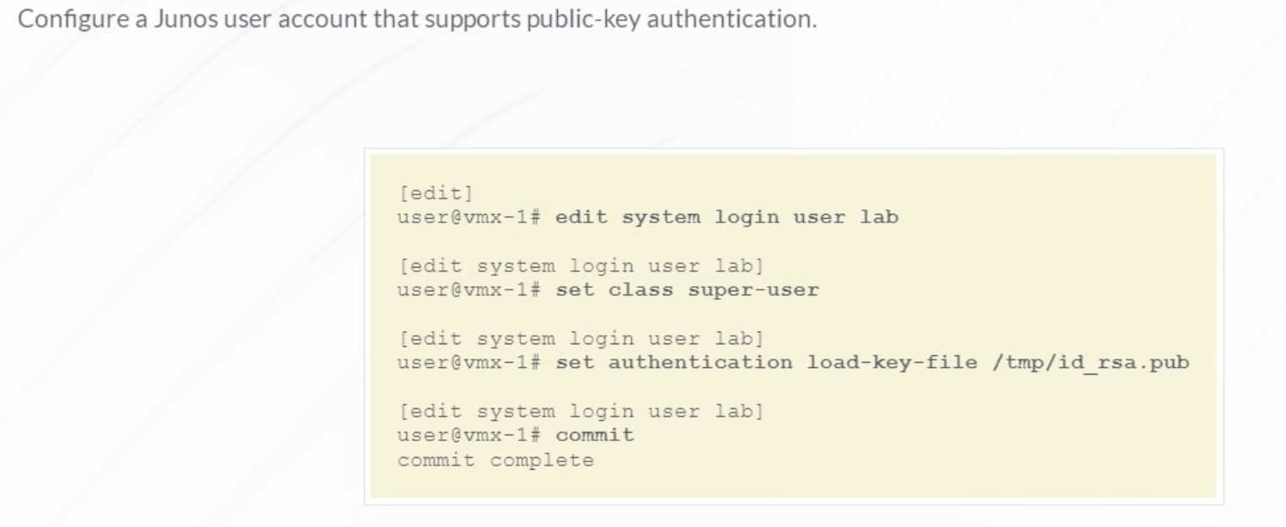

Verify that the administrator workstation is able to connect to the Junos devices without being prompted for a password. In the first example, a private key passphrase was not specified when the key pair was generated, so authentication happens automatically. The second example demonstrates entering a private key passphrase that was defined when the key pair was generated. You are prompted to enter the passphrase to decrypt the private key for authentication. This is a more secure method for storing the private key, but the tradeoff is that you have to enter the passphrase every time you run the script, which is not very helpful for automation.

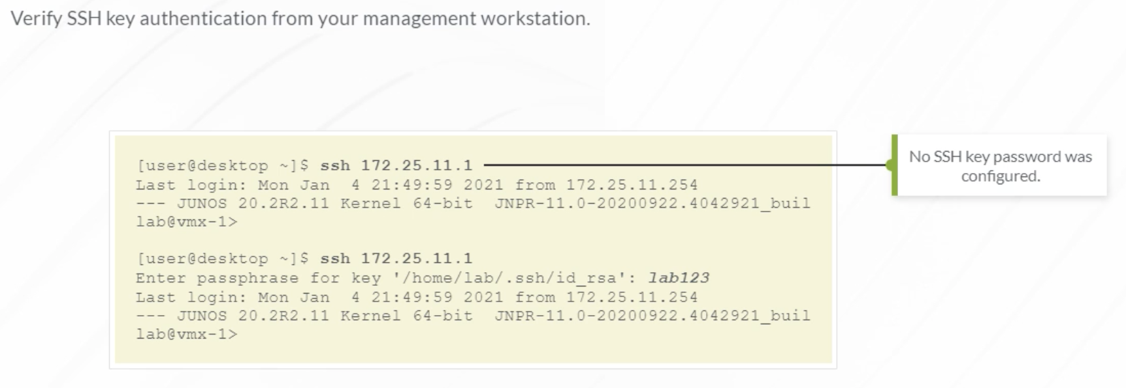

When using non-password-protected key pairs, the connection automatically uses the key pair associated with the logged in user for authentication. Since no key pair password is configured, authentication is automatic. When using password-protected SSH key pairs, the Python getpass module is used to generate a prompt for the user to enter the key passphrase. The prompt is for the SSH key passphrase rather than a user login password. If you did not configure an SSH key passphrase when the SSH keys were generated, you can omit the passwd argument.

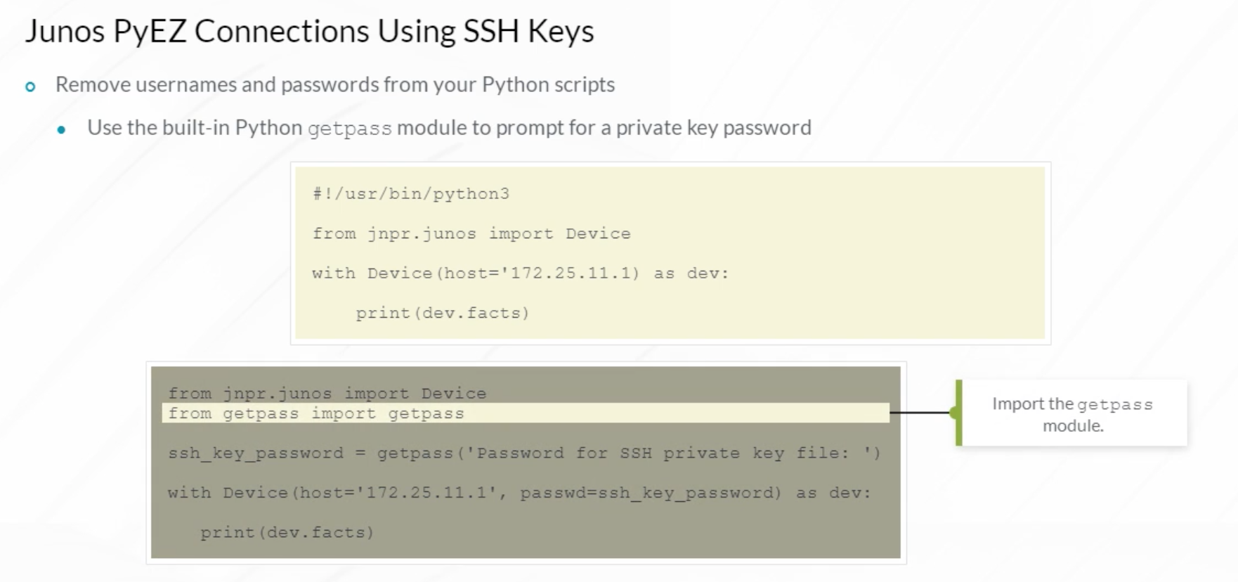

As mentioned earlier, storing usernames and passwords in Python scripts is not secure. If public key authentication is not an option, you can configure a Python script that prompts a user for credentials when the Python script is run. Import the built-in Python getpass module and define login prompt variables. Reference the login prompt variables in the connection portion of the script. When the script is run, the user is presented with username and password prompts during authentication.

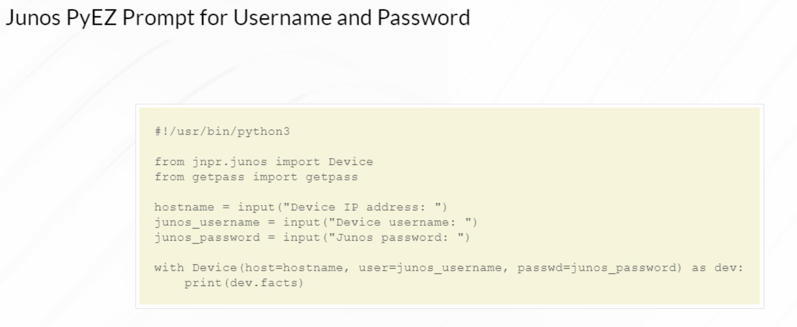

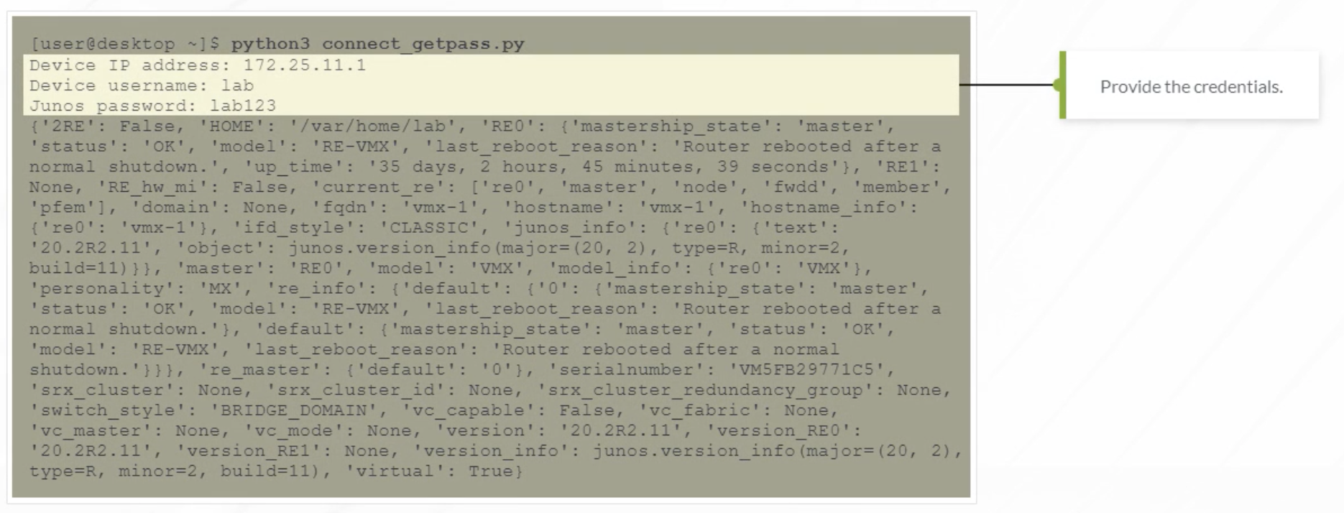

Storing usernames and passwords in Python scripts is not secure. However, for lab and testing purposes, this example demonstrates doing just that. The user and passwd options provide the ability to store authentication credentials in the Python script. When the Python script is run, the included credentials are used for authentication.

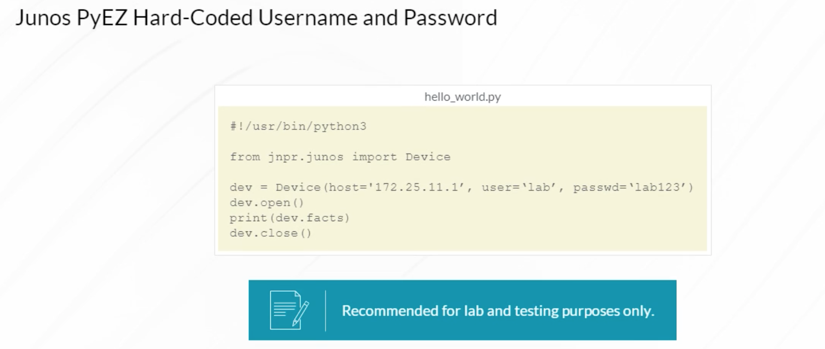

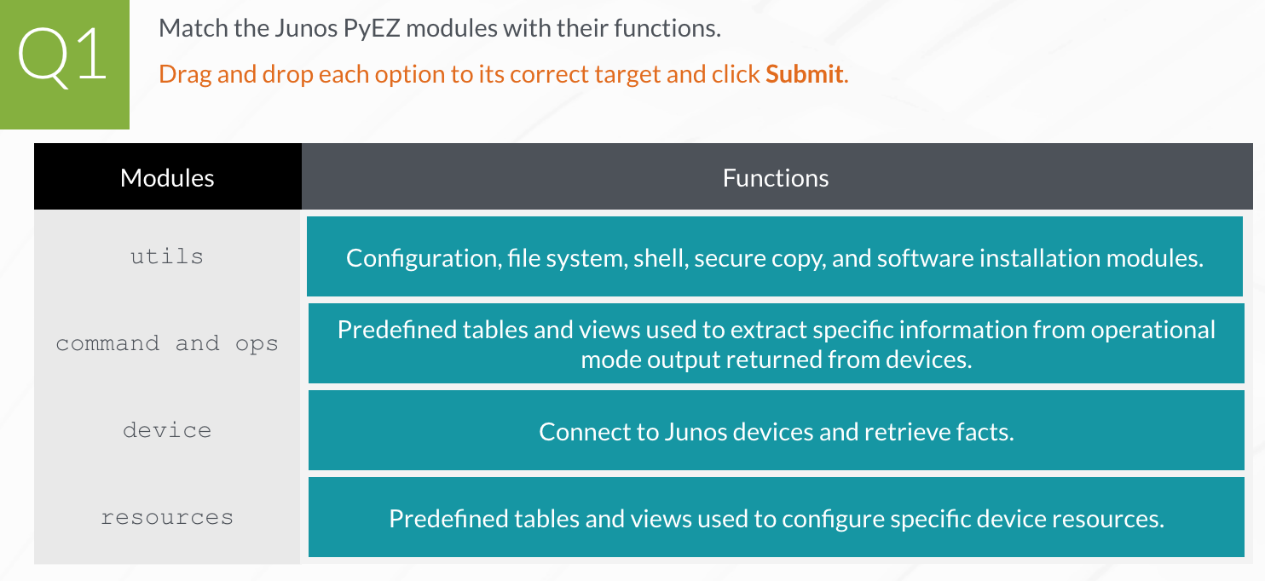

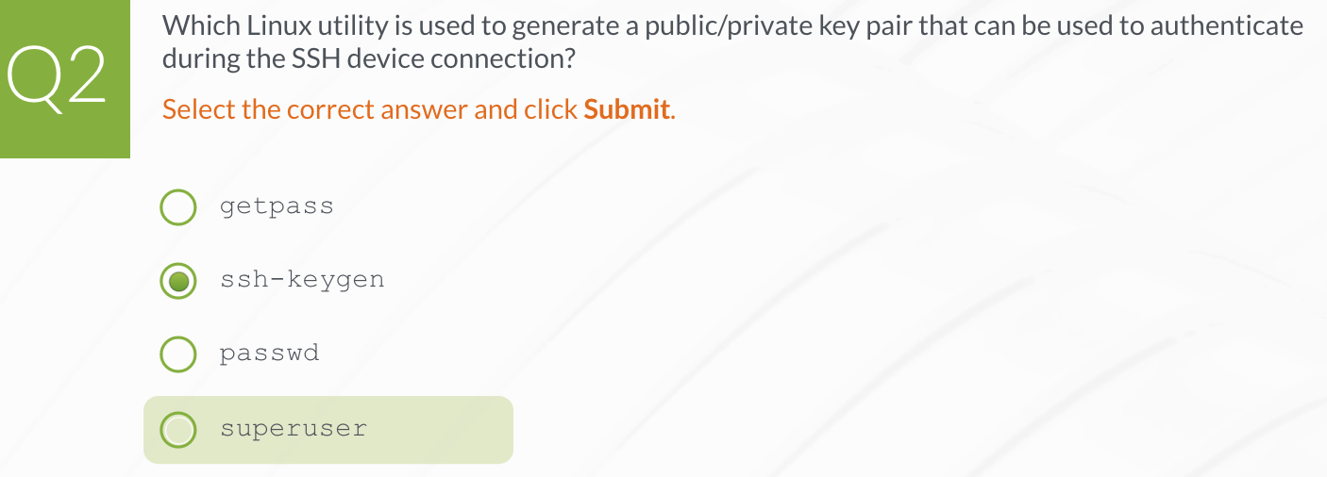

**Junos PyEZ device operations**

1. **Junos PyEZ configuration**
2. **JSON and YAML**
3. **Junos REST API**
4. **Introduction to Junos**
5. **Introduction to Ansible**